

Abacus
Commissioner’s Directions for Conduct and Complaint Management, and Compliance Review



Author: Professional Standards
This version: August 2026 – A26273176

Contents
Definitions 7
Acronyms 12
1. OBJECTIVES & PRINCIPLES 13
1.1. Objectives 13
1.2. Values 15
1.3. The Public Interest & Community Confidence 17
1.4. Legislative Framework 18
1.5. Procedural Fairness 19
1.6. Conflict of Interest 19
1.7. Confidentiality 21
1.8. Standards of Proof 21
1.9. Balance of Probabilities Further Explained 22
2 THE CODE OF CONDUCT & EXAMPLES 25
2.1. Behave Honestly and with Integrity 25
2.2. Act with Due Care and Diligence 26
2.3. Comply with the Police Manual, Lawful Directions / Lawful Orders of a Senior Officer 26
2.4. Maintain Appropriate Confidentiality 27
2.5. Disclose and Avoid Conflicts of Interest 28
2.6. Use Police Resources Properly 29
2.7. Not to Provide False or Misleading Information 29
2.8. Not to Use Information, Duties, Status, Power, or Authority Improperly 29
2.9. Not to Access Information to Which Not Entitled 30
2.10. Not to Destroy, Damage, Alter, Erase Official Documents, Records or Entries 31
2.11. Not to Conduct self or Act in Manner Prejudicial to, or Likely to Bring Discredit on, Tasmania Police 31
2.12. Victimisation Of, or Discrimination Against, Officers Who Report Breaches 32
2.13. Compliance with Any Other Prescribed Conduct Requirement 32
3 PROCESS OVERVIEW 34
3.1. Flowchart Overview 34
3.2. Types of Matters Reported under Abacus 35
3.3. IAPro™ and BlueTeam™ Report Names and Levels 36
3.4. Timeframes for Resolution 41
3.5. Delegated Authority from Commissioner 42
3.6. Overview of Abacus Outcomes 45
3.7. Early Identification 46
3.8. Continuing Professional Development (CPD) 46
3.9. Organisational Learning 49
4 INTERNALLY RAISED MATTERS & COMPLIANCE REVIEW 50
4.1. Members’ Obligation to Report Alleged Breaches of Code of Conduct involving other members 50
4.2. ‘Whistle-blowers’ - Alternative Complaint Mechanism 51
4.3. Voluntary Disclosures 52
4.4. Family & Sexual Violence Involving Police 54
4.5. Breach of the TPM and other Policies 55
4.6. Breach of Road Safety (Alcohol and Drugs) Act 1970 55
4.7. Academic Misconduct 59
4.8. Overview of Compliance Review 61
4.9. Use of Force 61
4.10. Firearm Discharge 64
4.11. Deaths or Life-Threatening Injury in Custody 64
4.12. Police Vehicle Pursuits 64
4.13. Police Vehicle Crashes 65
4.14. Commissioner’s Directions for Alcohol and Drug Testing 65
5 RECEIVING, REGISTERING & CATEGORISING ABACUS MATTERS 66
5.1. Registration Flowchart Overview 66
5.2. Rights of Complainants 67
5.3. Receiving Complaints 67
5.4. Complaints Received by Mail 68
5.5. Notification to the Integrity Commission by Tasmania Police 69
5.6. Offences Committed by Members of other Police Services 69
5.7. Is Immediate Action Required? 69
5.8. Registration on BlueTeam™ 70
5.9. Initial Categorisation by Registering Member 70
5.10. How does Abacus Relate to other Reporting Requirements? 70
5.11. Acceptable Formats for Complaints 72
5.12. Basic Information Required from Complainants 72
5.13. Complaints by Proxy (Third Party) 73
5.14. Complaints Made More Than 6 Months after Conduct became known to Complainant 73
5.15. Complaint from a Charged Person 74
5.16. Complaint from an Intoxicated Person 74
5.17. Complaint from a Person Behaving Unreasonably 75
5.18. Forensic Exhibits from Complainants 77
5.19. Supplementary Information from Complainants 77
5.20. Complaints from Informants (Human Sources) 77
5.21. Complaints Received through Other Avenues 77
5.22. Alternative Complaint Agencies 78
5.23. Complaints or IRM against State Service Employees (SSEs) 79
5.24. Withdrawal of Complaints 80
5.25. Special Assistance Required by Complainants or Witnesses 80
5.26. Deciding if a Complaint will be Investigated 81
5.27. False Complaints against Police 81
6 Diversity and Inclusion Principles 82
6.1. Diversity and Inclusion Principles 82
6.2. Complaints against police 82
6.3. Complaints about Tasmania Police State Service Employees 82
6.4. Process Overview 82
6.5. Categorisation of DAI matters 85
6.6. Finalisation of all Discrimination, Prohibited Conduct and Bullying matters 85
6.7. Diversity and Inclusion Registered Information reports 86
6.8. Information to be supplied to Diversity and Inclusion Coordinator 87
6.9. Members Rights and Obligations 87
6.10. Confidentiality and Record Keeping 87
7 RESPONSIBILITIES IN THE REGISTRATION PROCESS 88
7.1. Alternative Resolution Options 88
7.2. Receiving Member 88
7.3. Supervisor’s Preliminary Assessment 88
7.4. Supervisor’s Validation of Registration 88
7.5. Managers’ Responsibilities 89
7.6. Professional Standards’ Responsibilities 94
7.7. Interim Administrative Measures 95
8. MEMBERS’ OBLIGATIONS, RIGHTS AND WELLBEING 97
8.1. Confidentiality 97
8.2. Members’ Obligations 97
8.3. Obligations for Members Subject to Other Legal Proceedings 98
8.4. Police as Complainants or Informants 98
8.5. Finalisation of Code of Conduct or Criminal/Summary matters where members are under medical treatment 99
8.6. Subject Officers’ Rights and Obligations 100
8.7. Witness Officers’ Rights and Obligations 107
8.8. Members’ Rights and Obligations in Complaints Investigated by Other Agencies 109
8.9. Members Accessing Own IAPro™ Holdings 112
8.10. Wellbeing Protocol 112
8.11. Family Violence Leave 115
8.12. Workers Compensation Matters 116
8.13. Wellbeing Support Client Confidentiality and Services 116
9 ALTERNATIVE RESOLUTION OPTIONS & APOLOGIES 119
9.1. Managerial Resolution (Level 1 only) 119
9.2. Informal Resolution (Level 1 and Level 2 only) 119
9.3. Formal Resolution (Level 1 and Level 2 only) 120
9.4. Apologies 122
10 THE INQUIRY / INVESTIGATION PROCESS 125
10.1. Process Summary 125
10.2. Timeframes 125
10.3. Nature of Inquiry / Investigation: Code of Conduct or Criminal? 126
10.4. Expected Extent of Inquiry or Investigation 126
10.5. Contact with Subject Officer and Complainant 128
10.6. Methods of Obtaining Subject Officer and Witness Accounts 130
10.7. Inquirer / Investigator Absence 130
10.8. Obtaining Specific Advice 131
10.9. Integrity Testing 131
10.10. Requiring Financial Statements 132
10.11. Impact of Court Proceedings 132
11 PROVISIONAL REPORT BY INQUIRER / INVESTIGATOR 134
11.1. Responsibilities of Inquirer / Investigator 134
11.2. Inquiry / Investigation Outcomes 136
11.3. Provisional Report Structure 137
11.4. Determination Notice 142
11.5. Other Inquirer / Investigator Action 143
12 AUTHORISATION & FINALISATION 144
12.1. Flowchart Summary 144
12.2. Process Summary 144
12.3. Responsibilities of Authoriser 145
12.4. Delivery of Documents to Subject Officer 147
12.5. Subject Officer Response 147
12.6. Right to Information 148
12.7. Final Report and Final Determination Notice 149
12.8. Notification of Outcome – Complaints and ED 149
12.9. Notification of Outcome – IRM and Compliance Review 150
12.10. Notification to Media 150
12.11. Filing of Determination Notice 151
12.12. File Closure Checklist 151
13 EXPLANATION OF SECTION 43(3) ACTIONS 152
13.1. Legislation 152
13.2. Summary Tables 152
13.3. Counselling – section 43(3)(a) Action 154
13.4. Reprimand – section 43(3)(b) Action 154
13.5. Impose a fine – section 43(3)(c) Action 155
13.6. Reduced Remuneration – section 43(3)(d) Action 156
13.7. Reassign Duties – section 43(3)(e) Action 157
13.8. Transfer – section 43(3)(f) Action 158
13.9. Place on Probation – section 43(3)(g) Action 158
13.10. Demotion – section 43(3)(h) Action 158
13.11. Termination – section 43(3)(i) Action 159
13.12. Commissioned Officer Probation, Demotion, Termination – section 43(3)(j) Action 159
13.13. Commissioner’s Loss of Confidence in a Member - s30(1) and s31(1) 159
14 REVIEW OF DECISIONS 160
14.1. Summary Table 160
14.2. Abacus Grievance Procedures 160
14.3. External Review of Decisions 162
15 USE OF INFORMATION, DATA COLLECTION & REPORTING 164
15.1. Right to Information - Members of the Public 164
15.2. Confidentiality of IAPro™ / BlueTeam™ Records 164
15.3. HP Records Manager 164
15.4. Impact on Courses, Transfer, Promotion and Medals 164
15.5. Information Provided to Potential Employers 164
15.6. Using Data for Accountability and Continuous Improvement 165
15.7. Abacus Performance Report to Deputy Commissioner 166
15.8. Abacus Review 167
15.9. Integrity Commission Audits & Notifications 167
15.10. Document Information 168
16 APPENDICES 169
16.1. Appendix A - Abacus Flowchart 169
16.2. Appendix B – Outcomes Matrix 170
16.3. Appendix C – Provisional Report Example 171
16.4. Appendix D – Determination Report Example 175

Definitions
Abacus | The all-encompassing name for the Tasmania Police Commissioner’s Directions relating to conduct, complaint management and compliance review.
apology | Refer to Apologies.
authoriser | The Authoriser is a member of or above the rank of Inspector who reviews a matter at the point of Provisional Finding for the purpose of checking and endorsing (or otherwise) the conduct of the inquiry / investigation. The Authoriser is responsible for:  - a Provisional Determination if proposed action is within the scope of their delegation; or  - a recommendation to their manager if proposed action is outside the scope of their delegation.
balance of probabilities | The balance of probabilities means more probable than not. Refer to 1.9 Balance Of Probabilities.
BlueTeam™ | The user interface of the IAPro™ software which members use to register Abacus matters and inquirers / investigators use to manage Abacus matters allocated to them.
coaching | A method of Continuing Professional Development (CPD) involving the further development of mental and / or physical skills in a member that is intended to help them learn, rather than be taught.
Code of Conduct | Contained in section 42 of the Police Service Act 2003.
complaint | An expression of dissatisfaction from any person regarding the conduct of one or more members of Tasmania Police. For the purpose of this document ‘complaint’ means a complaint under Division 2 of Part 3 of the Police Service Act 2003. It does not include internally raised matters or compliance review matters.
compliance | Review of matters to ensure adherence to organisational instructions, directions, orders and procedures.
conciliation | Informal resolution or formal resolution
conduct | A mode of behaviour considered against expected standards. It includes any act or omission, both on-duty and off-duty.
conduct history | All Determination Notices issued to a member, held in the member’s human resources folder on HP Records Manager.
Continuing Professional Development (CPD) | A range of options for supervisors to educate, support and develop members. Options include mentoring, training, addressing a knowledge or skills gap, targeted supervision, guidance, coaching, retraining, individually tailored development activities, work diaries, wellbeing, personal development. CPD does not form part of a member’s conduct history.
determination notice | A document formally recording that a determination has been made that a member has breached a provision of the Code of Conduct. The notice may or may not include a decision to take an action under section 43(3) of the Police Service Act 2003. It is a formal outcome that forms part of a member’s conduct history. A determination notice attached to a Provisional Report is deemed to be provisional unless the subject officer converts it to a final determination notice by signing it or acknowledging it formally.
due credit | Leniency in decision-making in consideration of a member’s own actions towards resolving a matter (such as making an apology or a voluntary disclosure or being frank in accepting they were in the wrong).
EIPro™ | A software interface that connects to data held in IAPro™ that enables early identification of members who have attracted higher numbers of complaints or other Abacus matters; or repeatedly attract a particular type of complaint as compared to other members in the same work area.
formal resolution | A process where the complainant and subject officer are involved in the resolution of a matter without a formal inquiry/investigation taking place and without there being a determination as to whether the Code of Conduct was breached. The parties agree to resolve the matter even if their views differ. More information is available at Formal Resolution.
FVMS | Family Violence Management System – in Abacus this refers to family violence matters involving members.
guidance | A method of Continuing Professional Development which may be given orally or in writing and is intended to influence and direct a member’s conduct and performance.
IAPro™ | The software used as a database and case management system for the recording and management of Abacus matters. It is a stand-alone system and no information contained in IAPro™ is linked to any other information system. It has two interfaces that connect to the data contained within it – BlueTeam™ and EIPro™.
individually tailored development activity | A method of Continuing Professional Development where a program is specifically designed to best benefit and develop the individual member to whom it is applied.
informal resolution | A method of resolving a Complaint 1, DAI, IRM1, Complaint 2, or IRM2 matter where all parties are in agreement to a proposed outcome (such as CPD). The resolver can be a supervisor.
inquirer | The member tasked with making inquiries into a Complaint 2, IRM2, or Pursuit 2. This role is undertaken by a member of or above the rank of Sergeant and is allocated by the relevant District Commander.
inquiry | A probe or examination to a lesser extent than an investigation. An inquiry is to be proportionate.
internally raised  matter (IRM) | A matter initiated by a member (including a peer or senior officer) regarding a Code of Conduct breach; or reported to facilitate performance management; or determined during investigative activities or otherwise identified internally within Tasmania Police. It does not include a complaint made by a member against another member (e.g. for stealing or assault) as that would constitute a complaint. Three levels of IRM apply: IRM1, 2 & 3.
investigator | The member tasked with investigating a Complaint 3, IRM3, or Pursuit 3. This role is undertaken by a member of or above the rank of Sergeant and is allocated by the relevant District Commander. In most cases the investigator will be a member of Professional Standards.
investigation | The resolution of a Complaint 3, IRM3, or Pursuit 3 matter through proportionate investigation and reporting. It is more extensive than an inquiry.
knowledge gap | A gap which has been identified between the knowledge a member possesses and the knowledge needed to effectively discharge the duties of a police officer.
level 1 matter | A collective term for Complaint 1 and IRM1.
level 2 matter | A collective term for Complaint 2 and IRM2.
level 3 matter | A collective term for Complaint 3 and IRM3.
manager | A member of or above the rank of inspector. It includes a member acting at that rank.
managerial resolution | The resolution of minor matters in the district by a member’s supervisor or manager. It empowers supervisors and managers to manage conduct and performance issues at the lowest level with a focus on professional development. It is suitable for Complaint 1, DAI and IRM 1 matters and may involve Continuing Professional Development.
mentoring | A Continuing Professional Development where a subject officer is partnered with another member for a finite period of time with the purpose of improving the subject officer’s skills, knowledge and conduct.
member | A currently serving police officer, trainee or junior constable of Tasmania Police including officers on secondment. It includes all Special Constables but does not include Ancillary Constables. It includes people who were a police officer at the time the conduct occurred.
minor-moderate injury | An injury such as bruising, cuts or grazes, concussion, minor fracture or hospitalisation up to 24 hours.
offence | An alleged offence that does not amount to a serious offence or crime.
organisational learning | Retaining and applying knowledge gained from the collective experience of the organisation to improve the service delivery of the organisation over time.
preliminary assessment | Undertaken by a supervisor or manager following registration of a matter on BlueTeam™. It may involve fact checks on Tasmania Police information systems and speaking with the parties. A preliminary assessment does not amount to an inquiry or investigation. The purpose of preliminary assessment is to assist with the prompt categorisation of the matter and assist with early resolution of minor matters.
procedural fairness | Also known as natural justice, it is the right of all parties to a fair process (including the complainant and the subject officer). It is not concerned with whether or not the outcome is fair. More information is at Procedural Fairness.
provisional determination | As a result of the Provisional Finding, this is a brief statement containing a preliminary determination about whether or not a member breached a provision of the Code of Conduct; and the provisional outcome (if any) for the member such as section 43(3) Actions and / or CPD. Where it is provisionally determined that a member breached the Code of Conduct they may receive a Provisional Determination Notice.
provisional finding | This relates to level 2 and 3 matters only. A Provisional Finding follows the conclusion of an Inquiry / Investigation. It is an appraisal of the allegations and a preliminary decision about the member’s conduct. Any Provisional Finding is based on the balance of probabilities. Notification to members of a Provisional Finding is a measurable point in the Abacus process (see chart under Resolution Timeframes).
pursuit 1 | Defined at pursuit 1 and detailed instruction provided at Part 14.14 of the TPM.
pursuit 2 | Defined at pursuit 2 and detailed instruction provided at Part 14.14 of the TPM.
pursuit 3 | Defined at pursuit 3 and detailed instruction provided at Part 14.14 of the TPM.
reconsideration request | Written request for review of a level 1 matter. Review is limited to procedural fairness or CPD. Limited review is also available in respect of decisions relating to CPD or medals in Level 2 and 3 matters.
Registered Information | A category for matters containing no specific allegation, or a generalised allegation with insufficient information to classify further.
registration | The process of entering a new matter on IAPro™ or BlueTeam™. To achieve the objective of timely resolution, it is a measurable point in the Abacus process (refer to chart under Resolution Timeframes).
retraining | A form of CPD where a member, who has been previously trained in an area of knowledge or skill, undergoes additional training after a deficiency in skill/knowledge has been identified.
section 43(3) action | Actions that the Commissioner (or delegate) may take following a determination that a member breached a provision of the Code of Conduct. Refer to section 43(3) Actions for a comprehensive explanation.
serious offence or crime | An alleged offence or crime that presents a significant risk to the reputation of Tasmania Police or involves an allegation of corruption; and if proved would warrant termination of employment.
significant injury | A physical injury such as a significant fracture (e.g. limb, skull, spine, but not finger); multiple moderate injuries; loss or permanent limitation on use of an organ or system; or hospitalisation exceeding 24 hours.
skills gap | Where a member has insufficient skill in an area of police procedure to enable that member to effectively perform their duties as a police officer. Once identified, any such gap is to be corrected by CPD measures.
subject officer | A member who is identified at any point in an Abacus matter as the member who is the subject of allegation(s) in a complaint, Diversity and Inclusion matter or internally raised matter. Note: the IAPro™ system refers to a subject officer as an ‘involved officer’.
supervisor | A sergeant or member acting in that rank, including those undertaking Shift In Charge or Higher Duties as per the Police Award.
targeted supervision | Supervision, conducted as part of CPD, designed to correct specific deficiencies in an individual member
training | Where it has been identified that a member has a gap in their skills or knowledge, education and guidance provided, as part of CPD, to overcome that gap.
voluntary disclosure | A member reporting a matter on BlueTeam™ in which they are the subject officer; for example, reporting a conflict of interest, a breach of the Code of Conduct, declarable association or advising they are the subject of civil or other legal proceedings.
wellbeing | The network of services and facilities available to ensure all members are treated fairly and their support needs are catered for.
working day | This does not mean Monday to Friday 8am-4pm – it refers to days when members are rostered to duty. It accounts for shift work and rostered days off.
work diary | A record of activities a member is required to complete, as part of CPD, to track their progress towards overcoming any knowledge or skills gaps.

Acronyms
AVL | Automatic Vehicle Location
BAS | Breath Analysis Section
BES | Business and Executive Services
CPD | Continuing Professional Development
DAI | Diversity and Inclusion
DORS | Drug Offence Reporting System
DPFEM | Department of Police, Fire and Emergency Management
DPP | Director of Public Prosecutions
EI | Early Identification
ESCAD | Emergency Services Computer Aided Dispatch
FVMS | Family Violence Management System
FVO | Family Violence Order
IPR | Individual Performance Report
IRM | Internally Raised Matter
LGBTI | Lesbian, Gay, Bisexual, Transgender and Intersex
OC | Oleoresin Capsicum
OLC | Online Charging
ORS | Offence Reporting System 2
OSU | Operational Skills Unit
PID | Public Interest Disclosure
PFVO | Police Family Violence Order
PIN | Police Infringement Notice
PMP | Performance Management Plan
PRB | Police Review Board
RDS | Radio Dispatch Services
SSE | State service employee
TCRS | Traffic Crash Reporting System
TOIL | Time off in lieu
TPM | Tasmania Police Manual
UOFR | Use of Force Report
VID | Vehicle Immobilisation Device

References to the ‘Commissioner’ are the Commissioner of Police.
Unless otherwise stated, references to legislation are Tasmanian legislation.

OBJECTIVES & PRINCIPLES

Objectives
Under section 43(1) of the Police Service Act 2003 the Commissioner must establish procedures for the investigation into any alleged breach of a provision of the Code of Conduct by a police officer. The procedures established by the Commissioner are contained within this document, ‘Abacus - Commissioner’s Directions for Conduct and Complaint Management, and Compliance Review’. Members must comply with these Directions.
Abacus applies to members but not to state service employees (SSEs) of the Department of Police, Fire and Emergency Management (DPFEM). Matters relating to SSEs employed within Tasmania Police business units are directed to the Deputy Commissioner for referral to Business and Executive Services (BES). They are managed through a separate framework.
Abacus is a centralised reference document that brings together all of the information relevant to the management of conduct, complaints, and compliance matters. It is publicly available to ensure transparency and clarity for both members and the public. It will be amended as required to ensure the information is contemporary.
A challenge for Tasmania Police is to balance the rights and responsibilities of members and the organisation in employment-related decisions, while maintaining high standards of service delivery to the public. Frank and fearless decisions rely on a core set of ethics that is clearly understood and consistently applied. The objectives of Abacus are to have a conduct, complaint, and compliance system that is:
better for the public and members
  - timely resolution
  - transparency of procedures
  - improved contact and follow-up
better for all members
  - individual professional development
  - fair decisions
  - clear procedures
  - prevention of future problems
  - active participation by members in conduct and complaint management
better for supervisors and managers
  - empowers supervisors and managers
  - devolved decision-making
  - leadership development
better for inquirers / investigators
  - streamlined, proportionate investigating and reporting
  - clear expectations
  - separation of minor, peripheral matters from main investigation for quick resolution
better for Tasmania Police
  - a more consistent approach and equitable application across the State
  - organisational learning
  - effective risk identification and management
  - centralised database allowing more efficient data analysis and auditing
  - enhanced capability to contribute data for inter-jurisdictional research

What is Abacus?

Complaint Matters
Policing, like any service to the public, attracts complaints. The unique nature of policing involves resolving emotionally charged incidents and crises every day. Complaints arise from only a small proportion of interactions with the community. A robust and accountable complaints system is the hallmark of a corruption-free policing service and is the key to organisational learning and development. However, complaint numbers alone are an inadequate guide to measuring community satisfaction levels.
Abacus is designed to ensure that matters are dealt with at the earliest opportunity and by the appropriate level of the organisation. This is in everybody’s interests; complainants, the community, subject officers and Tasmania Police.

Internally Raised Matters
Abacus also provides procedures for the management of breaches of the Code of Conduct and other matters that do not arise from complaints. The management of internally raised matters (IRM) through Abacus provides supervisors with a toolkit of options for addressing conduct and performance problems, preventing their continuance and initiating Continuing Professional Development (CPD) for members. This assists supervisors to perform the pivotal task of personnel management. Transparency in these procedures – and the rationale underpinning decisions – is fairer for members.

Compliance Review Matters
High-risk and hands-on activities are necessary for the delivery of policing services, including use of force and vehicle pursuits. Such activities need checks and balances for public confidence and identification of any legislative, policy or training gaps. The compliance review aspect of Abacus means that these activities are centrally recorded and follow a consistent reporting process. Compliance review also helps to identify opportunities for organisational learning.
Compliance Review matters are assessed for adherence to instructions, directions, orders and procedures. If, after preliminary assessment, a possible breach of the Code of Conduct is identified, the matter will be managed in the same manner as an ‘internally raised matter’.

Unifying Matters
Complaints are reported to Tasmania Police from a range of sources including private citizens and their representatives, other police, other Government agencies and Members of Parliament. Methods of complaints include in person and by telephone, letter or e-mail (see also acceptable formats for complaints).
Complaints can generally be categorised as relating to:
  - the conduct of members
  - a policy or process
  - interpretations of the law
All Abacus matters are recorded on IAPro™ / BlueTeam™. The following diagram shows the link between the Abacus types and the IAPro™ / BlueTeam™ categories.
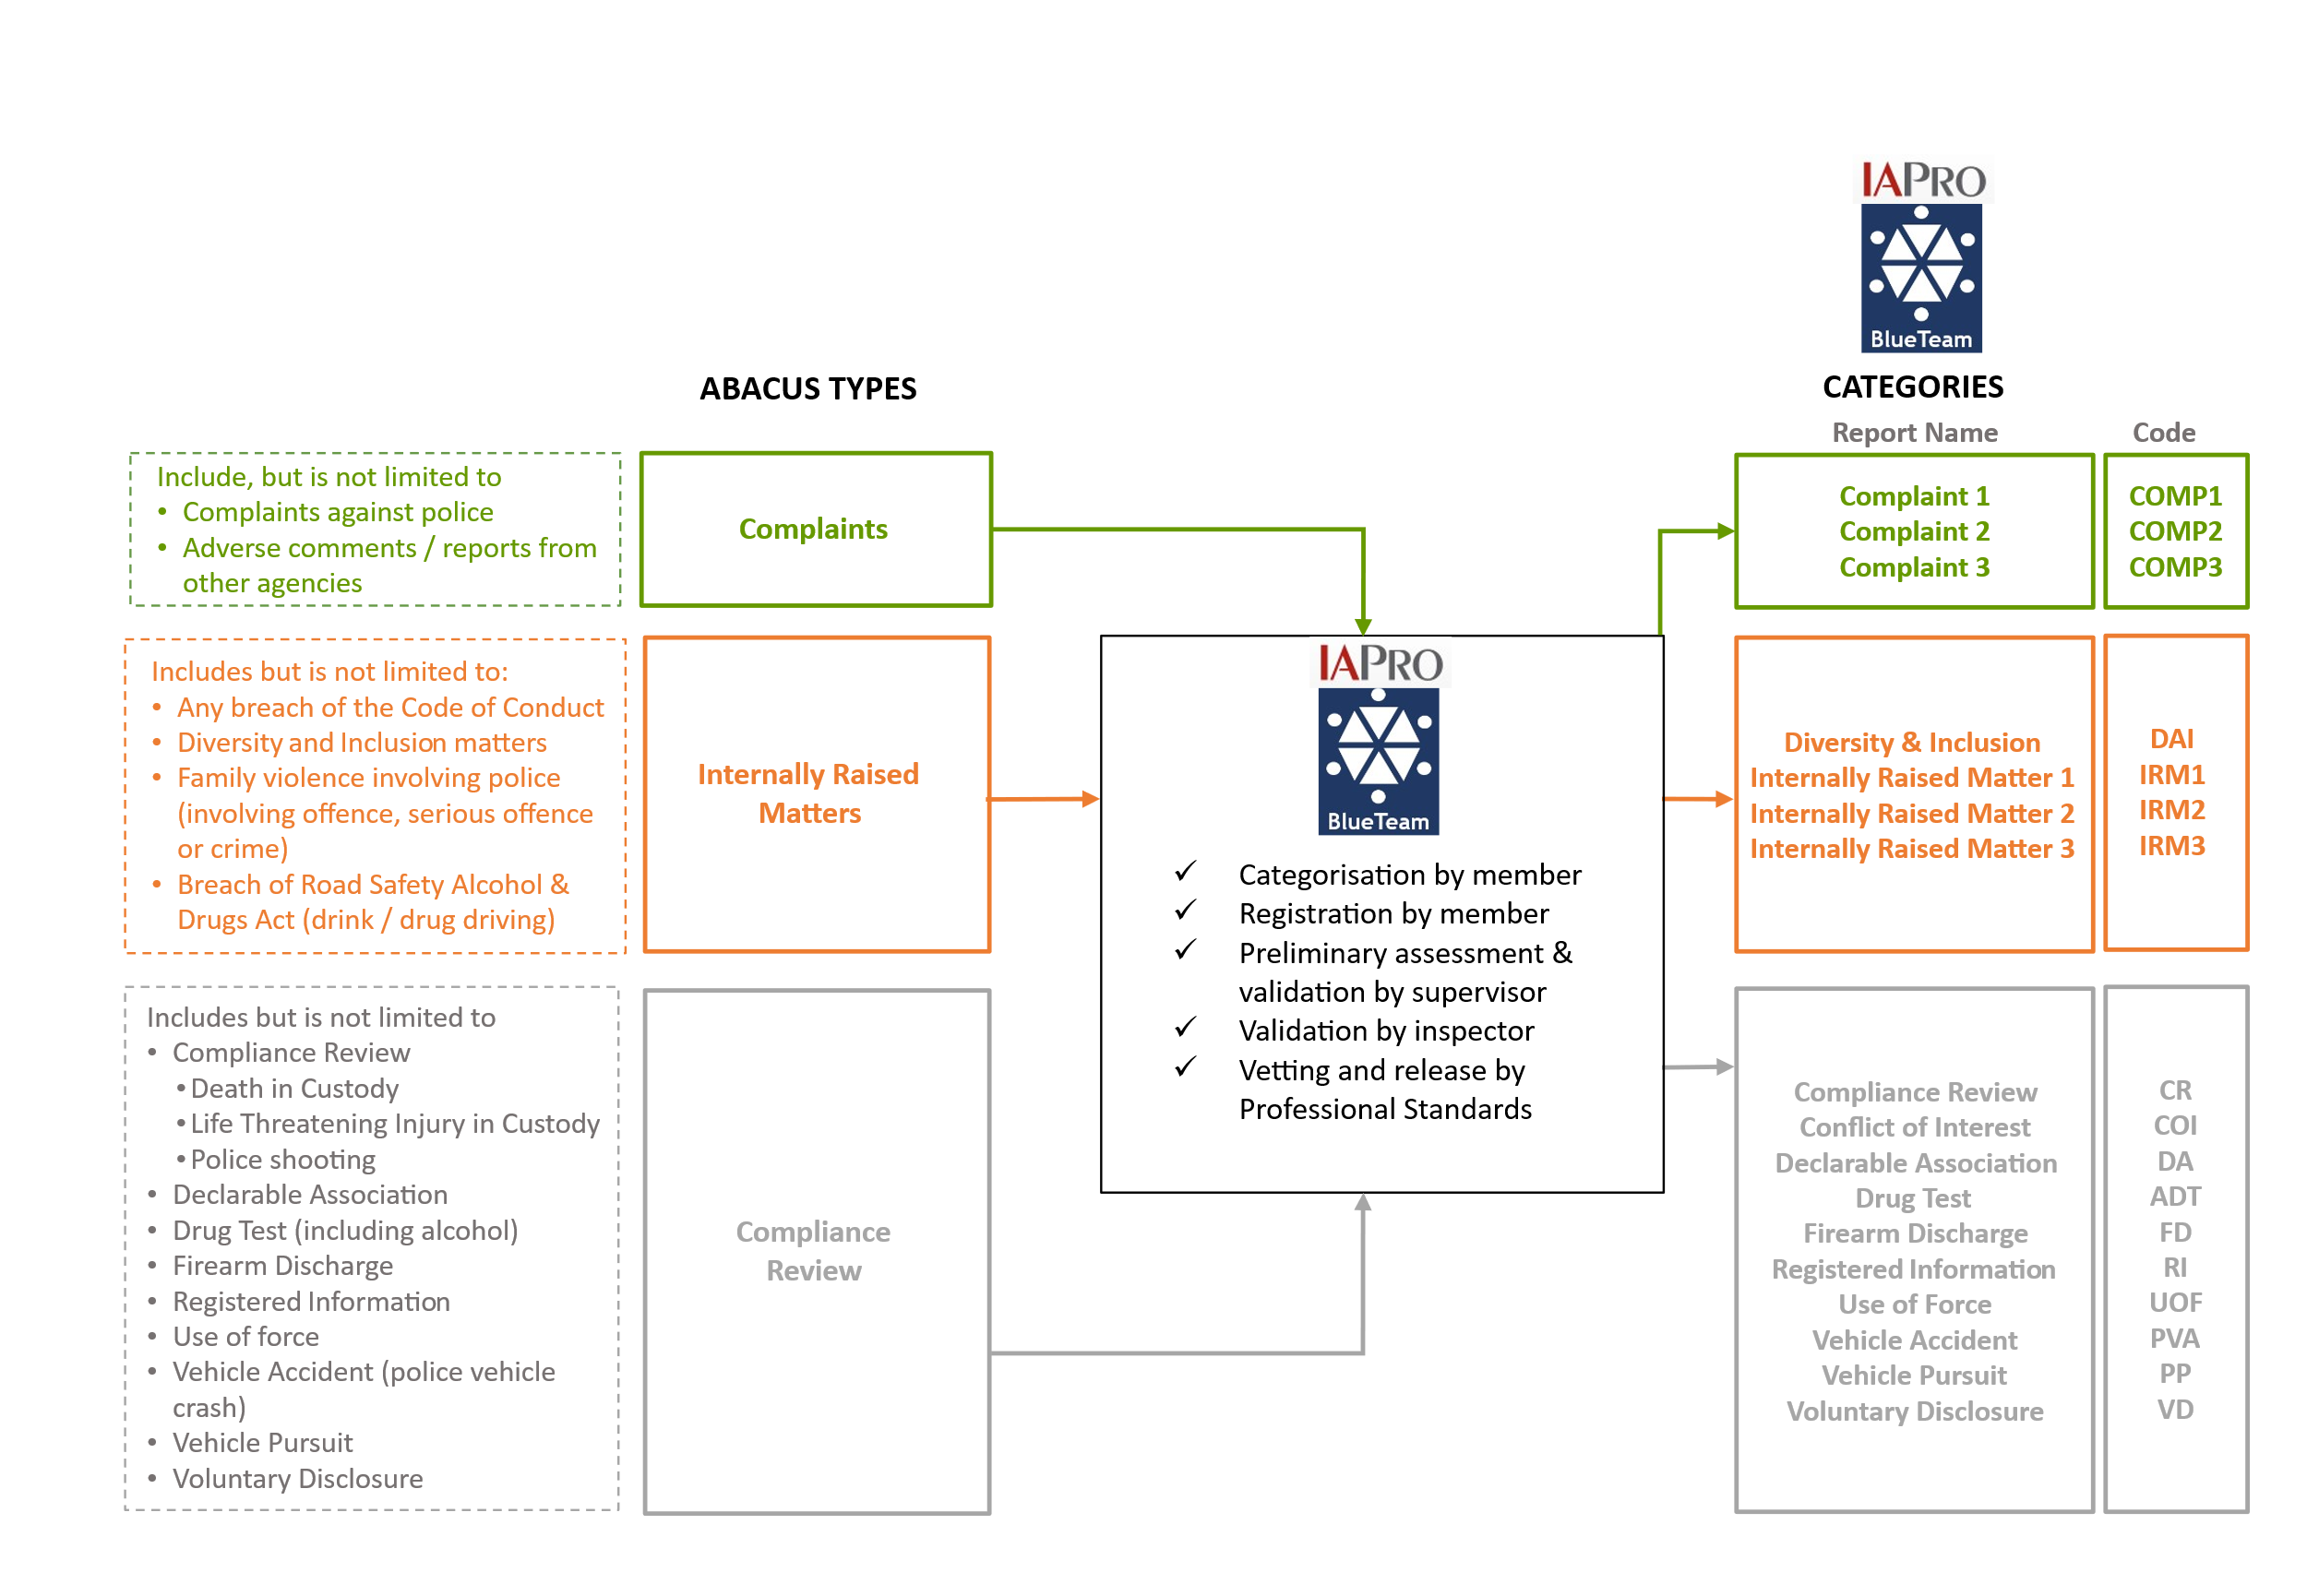

Values
Tasmania Police is committed to the Tasmania Police Values, Police Officer Oath / Affirmation, the Australia New Zealand Police Integrity Principles and the SELF Test. These are described below.

Tasmania Police Values
Our four Values are:
- Accountability: We are accountable for what we do and how we do it. We reflect and learn.
- Integrity: We are professional, honest and ethical in our conduct. We do the right thing.
- Respect: We value contribution and diversity, irrespective of role or status. We treat people with respect.
- Support: We are committed to supporting others. We listen and respond.
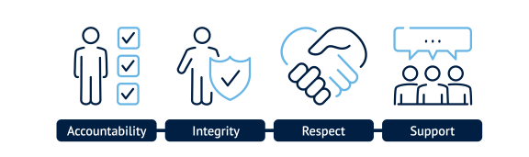
Tasmania Police Values are the foundation for the types of ethical behaviour expected from members. This behaviour is demonstrated in all aspects of work including the delivery of services to the community and in interactions with each other. All Abacus matters will require consideration of the extent to which a member’s conduct is inconsistent with one or more of the organisation’s values. It is important to remember that “the standard you walk past is the standard you accept”.

Police Officer Oath / Affirmation
Parts 3 and 4 of Schedule 1 of the Police Service Act 2003 contain the Police Officer Oath and Affirmation. This reflects all members’ individual commitment to the community of Tasmania:
I, (name), swear/affirm that I will faithfully execute the office of police officer in Tasmania, and that to the best of my power, without favour or affection, malice or ill-will, will cause the peace to be kept and preserved and prevent all offences against persons and properties in Tasmania, and that to the best of my ability, skill and knowledge will discharge all the duties of a police officer according to law. [So help me God.]

Australia New Zealand Police Integrity Principles
Tasmania Police endorses the Australia New Zealand Police Integrity Principles.
These integrity principles underpin all decisions and actions undertaken by police organisations and their employees. Police employees who conduct themselves with integrity ensure continued public confidence in police organisations by making decisions that are professional, honest, consistent and transparent.

SELF Test
The SELF Test is a simple tool for ethical decision-making:
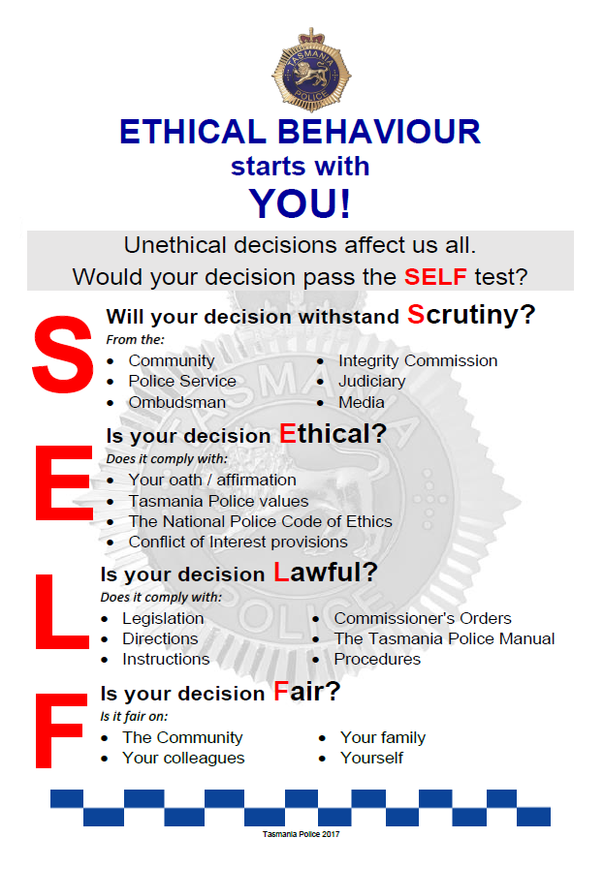

The Public Interest & Community Confidence
The term ‘public interest’ has been described as considerations affecting the good order and functioning of the community and government affairs, for the well-being of citizens. It is also expressed as ‘for the common good’. What is in the public interest is incapable of precise definition as there is no single or absolute public interest; it can be easier to generalise about what is not in the public interest rather than what is in the public interest.
Public interest is an ideal that is central to the concept of democratic government and administration. Acting in the public interest means carrying out official duties for the benefit of the public served by Tasmania Police, in a fair and unbiased way, and making decisions that are not affected by self-interest, private affiliations or the likelihood of personal gain or loss.
The public interest, and community confidence in Tasmania Police, is underpinned by confidence in an effective and transparent conduct, complaint and compliance review system.

Legislative Framework
These procedures are framed by the Police Service Act 2003. Sections 42 and 43 contain the Code of Conduct and actions relating to breaches. Sections 44 to 47 cover complaints against police; dismissal, conciliation, and investigation of complaints; and determination to take action against breaches of the Code of Conduct.
Allegations involving the commission of an offence, serious offence or a crime by a member will be investigated under the relevant legislation (e.g. Road Safety (Alcohol and Drugs) Act 1970, Police Offences Act 1935, Criminal Code). This is in addition to being considered as a potential breach of the Code of Conduct.
These procedures also relate to other legislation and inter-departmental agreements, including (but not limited to):
- Anti-Discrimination Act 1998
- Integrity Commission Act 2009
- Judicial Review Act 2000
- Personal Information Protection Act 2004
- Public Interest Disclosure Act 2002
- Ombudsman Act 1978
- Right to Information Act 2009
- Work Health and Safety Act 2012
- numerous memoranda of understanding
Abacus interrelates with:
- the Tasmania Police Manual (TPM)
- Tasmania Police orders, directions, procedures and instructions
- DPFEM policies.

Procedural Fairness
The principles of procedural fairness apply to all Abacus matters.
Procedural fairness relates to the process used by decision-makers as compared with the outcome of the decision – it is better to give too much procedural fairness than too little. It is usually applied to administrative or workplace decisions rather than court decisions (courts apply natural justice principles, which are similar). A procedurally fair process has:
- opportunity for a person to put their case forward
- lack of bias in the decision-maker
- inquiry into credible, relevant and disputed matters
- evidence to support a decision based on the balance of probabilities
- no unnecessary delay
It is equally important that Abacus is as fair to complainants as it is to members. A fair process for all includes accessibility to make a complaint, transparency of Abacus procedures, regular updates (unless provision of updates hinders evidence gathering) and communication of findings to both parties. Members and complainants are more likely to support a system if they feel it is fair. Even if they disagree with the outcome they are more likely to accept it if they feel the process has been fair.
The member has a right for their reply to be received and considered before a final decision is made. Hearing both sides of the story is critical to good and ethical decision-making. However, procedural fairness does not entitle the member to test all of the evidence or to test the processes and methods of the investigation. More information is under The Inquiry / Investigation Process.
Level 1 Abacus matters are dealt with informally and locally and there are no disciplinary outcomes (only CPD opportunities). In practice this means that minor matters such as incivility can be dealt with quickly as there is no investigation or lengthy process. Dealing with minor matters proportionately is fairer for everybody and allows for appropriate resources to be allocated for the timely resolution of more serious matters. Procedural fairness for level 1 matters includes complainants and members being spoken to, however the resolution is not weighed down by adversarial processes.
For level 2 and 3 Abacus matters, unless it is prejudicial to the handling or outcome of an inquiry / investigation or there is an overriding public interest, the member should be informed of the matter by the inquiring / investigating officer as soon as practicable following registration on IAPro™ or BlueTeam™. The member should be informed of the case to answer and given an opportunity to reply before a decision is made that may adversely affect them, including section 43(3) Actions under the Police Service Act 2003.

Conflict of Interest
All members involved in any Abacus process must carefully assess whether a conflict of interest exists. Conflicts of interest fall within three categories:
actual an actual conflict of interest arises when there is a conflict relating to the members current actions or decisions. An actual conflict of interest can be managed and monitored to prevent a conflict of interest contravention occurring.
perceived a perceived conflict of interest occurs when a reasonable person, properly informed, would consider that a member’s personal interests could improperly influence or may have improperly influenced that member in the performance of their duty.
potential a potential conflict of interest exists where the personal interests of a member could influence their duties in the future. The interest may currently exist but have no impact upon the performance of the member’s duties at the present time. A potential conflict of interest can be monitored to reduce the likelihood of it becoming an actual conflict of interest.
It is not always possible to avoid a conflict of interest and a conflict of interest is not necessarily unethical or wrong. The important thing is to identify the conflict, disclose it, and then manage it or avoid it if possible.
If the member receiving an Abacus complaint or IRM believes they have a conflict of interest, they must continue to take the complaint and register it on BlueTeam™, making a note of the conflict in the entry.
If a subject officer believes that an inquirer / investigator or authoriser has a conflict of interest that should preclude them from involvement in the matter, they must provide written advice detailing the conflict.
If a supervisor or manager is engaged in a managerial resolution of a level 1 matter, they must consider whether a conflict of interest exists and if so, record it on the relevant BlueTeam™ matter. If they are of the view that the conflict precludes them from resolving the matter they must advise their manager.
If an inquirer/investigator identifies a conflict of interest at any stage in the Abacus inquiry / investigation process (levels 2 and 3) they must inform the authoriser. Similarly, the authoriser must notify their manager if they have a conflict of interest in an Abacus matter. Members have a duty, under section 42(5) of the Police Service Act 2003 to disclose, and take reasonable steps to avoid, any conflict of interest in connection with his or her duties.
At the conclusion of the process a section is included in relevant templates where the inquirer / investigator and authoriser are required to make a declaration in relation to conflicts of interest.
The supervisor or manager who is informed of a conflict of interest must assess the circumstances and determine an appropriate course of action. A matter may be reassigned if required, however this is not the default course of action and should only occur when the conflict of interest would compromise procedural fairness. The supervisor or manager must update the BlueTeam™ running sheet to record the advice and the directions given to the notifying member. Part 1.47 (Conflict of Interest) of the TPM provides further information.
Members must not perform the role of inquirer / investigator or authoriser in a matter where they are a subject officer or witness officer as this is an insurmountable conflict of interest.

Confidentiality
All members involved in the management and resolution of Abacus matters must maintain appropriate confidentiality. The ‘Need to Know Principle’ applies to these procedures, i.e. information should only be available to those who need to access that information to do their work. It is accepted that in some circumstances this will mean that members are required to notify a senior officer/s, Wellbeing Support, a support person, and/or the Police Association of Tasmania. As with other Tasmania Police systems, use of IAPro™ is auditable. A usage log is attached to every IAPro™ matter and every access is recorded.
Abacus matters and outcomes are inherently personal. It is in the interests of all parties, including complainants and subject officers, that confidentiality is maintained. Members are reminded that a specific confidentiality provision exists in the Code of Conduct, namely section 42(4) of the Police Service Act 2003:
a police officer must maintain appropriate confidentiality about any dealing made and information gained in the course of his or her duties in the Police Service.
Any breach of this provision will be viewed as serious and will be dealt with as a fresh Abacus matter.
In some cases, the need for confidentiality may extend to not identifying the complainant to subject officers and witnesses. They also may not be provided with full copies of a complaint, statutory declaration or transcribed interview. Reasons for this include protecting the complainant and any other member against whom allegations may have been made.
Anonymised information may be reported under authorisation from the Deputy Commissioner or Professional Standards Commander for the purpose of organisational learning.

Standards of Proof
The standard of proof for Code of Conduct matters is the balance of probabilities. If a matter is dealt with by a Magistrates Court or Supreme Court then the standard of proof is beyond reasonable doubt.
Depending on the nature of an allegation, an Abacus matter may be dealt with:
- by managerial resolution; or
- as a potential breach of the Code of Conduct; or
- as a potential offence, serious offence or crime; or
- as both a potential breach of the Code of Conduct and as a potential offence, serious crime or crime.
The reason that different approaches may be taken is because the Code of Conduct exists to facilitate discipline within Tasmania Police and to ensure that appropriate standards are maintained. This is in accordance with the Commissioner’s legislated obligations for the efficient, effective and economic management and superintendence of Tasmania Police.
The approaches are further explained below.

Managerial Resolution
Abacus decisions relating to level 1 matters are made on the balance of probabilities which means more probable than not. They are not dealt with as potential breaches of the Code of Conduct, however there is still a decision about whether or not the alleged behaviour from the subject officer occurred. If so, the subject officer should be given CPD or the matter may be resolved by informal resolution or formal resolution.
If the matter is resolved by informal resolution the outcome is recorded as ‘informal resolution’.
If the matter is resolved by formal resolution then the matter is recorded as ‘formal resolution’.

Potential breach of the Code of Conduct
As above, Abacus decisions relating to breaches of the Code of Conduct are made on the balance of probabilities which means more probable than not. It is accepted across Australia that this standard of proof (the ‘civil’ standard) is to be applied to internal disciplinary matters.

Potential offence, serious offence or crime
The criminal standard of proof, beyond reasonable doubt, applies to matters where a member is being prosecuted.

Potential breach of Code of Conduct & potential offence, serious offence or crime
It is important that members understand that an inquiry/investigation into whether or not a member has committed an offence, serious offence or crime may also involve consideration of whether or not that member has breached the Code of Conduct. Any prosecution will apply the criminal standard of proof, beyond reasonable doubt. Whether or not the member is convicted of the prosecution, any identified Code of Conduct breach will be separately determined on the balance of probabilities.

Balance of Probabilities Further Explained
The balance of probabilities means more probable than not. The decision-maker must determine whether or not the behaviour occurred using that standard of proof. The decision-maker’s task must be performed without prejudice or preconceived ideas. They may be guided by many factors including:
- any corroborative evidence
- any contemporaneous documentation or records
- any circumstantial evidence tending to support one account over another
- the overall impression presented by witnesses, the complainant and the member
- the motivations of witnesses including the complainant.

Example
- Senior Constable X’s sibling makes a complaint that Senior Constable X looked up their police record because Senior Constable X revealed specific information about the sibling’s drug conviction, which led to a confrontation
- the sibling has barely had any dealings with police but there is one Atlas report about ice usage
- when questioned, Senior Constable X informs the inquiring officer that they did not access their sibling’s Compass record, nor did they request any other member to access the record
- an audit reveals that a colleague in Senior Constable X’s small work area accessed Senior Constable X’s sibling’s Atlas record on the same day of the confrontation
- the colleague agreed that they themselves did not have any work-related purpose in accessing the sibling’s record and did so on request of another member but cannot recall which member
- the allegation, taking in to account all of the above, is more probable than not and on the balance of probabilities the allegation is proved
In situations where the only evidence is one person’s word against another’s, the balance of probabilities standard of proof is not met and the allegation is not proved.
Example
- a member of the public reports that Constable G called them an offensive name
- Constable G denies the allegation
- there are no witnesses or any other evidence identified
- on the balance of probabilities the allegation is not proved
While the balance of probabilities means more probable than not, the test in the Briginshaw case emphasises that for serious allegations the decision-maker must closely scrutinise the evidence on the balance of probabilities not just by applying a mere mechanical comparison of probabilities, but rather by feeling persuaded that the alleged behaviour occurred. Unclear testimony or circumstantial, uncorroborated or inexact evidence would warrant a closer scrutiny to determine if there is anything else to substantiate the allegations. If no further evidence is identified, then on the balance of probabilities it did not occur.
Serious allegations are those where there is a significant amount at stake for the member (e.g. allegations that may amount to demotion or termination of employment). The more serious the allegation and potential consequences, the stronger the evidence is required for the decision-maker to be satisfied, on the balance of probabilities, that the incident occurred. The diagram below provides an illustration of this.
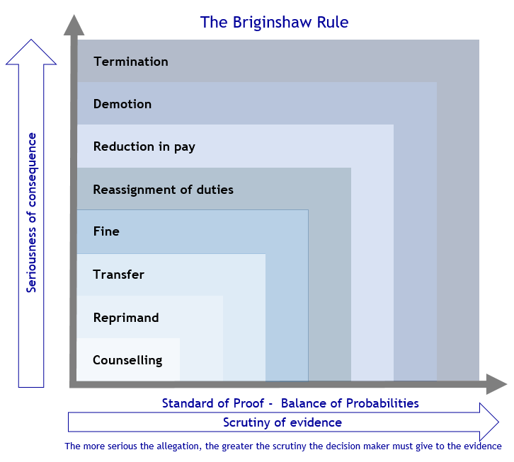
Example
- it is reported that members in police station ‘A’ have a feeling that Sergeant P is stealing from their social club. Money is missing but there is no conclusive evidence of Sergeant P being involved
- for unrelated reasons Sergeant P elects to transfer to police station ‘B’. The social club at this station has not had any problem of missing money
- items cease to go missing from police station ‘A’
- items start to go missing from police station ‘B’
- Sergeant P is investigated for stealing from the social club at police station ‘B’
- an audit is conducted of stock and cash at 3pm and the cash is marked
- a further audit is conducted at 7pm and there is a deficit of one $20 note
- swipe card access is checked and Sergeant P is the only person to have been present in the timeframe
- when interviewed at 7.10pm Sergeant P denies stealing $20 from the social club but is in possession of his swipe card
- the marked $20 is recovered on the ground next to Sergeant P’s private vehicle
- the allegation is made out on the balance of probabilities because while much of the evidence is circumstantial, taken together and on close scrutiny the standard of proof is satisfied

THE CODE OF CONDUCT & EXAMPLES
The Code of Conduct provides part of a framework to guide police behaviour. Whilst our actions should be directed to ensuring that we adhere to our Oath / Affirmation, the Australia New Zealand Police Integrity Principles, and Tasmania Police Values, our individual performance is measured against the Code of Conduct. The Code of Conduct applies to members both on-duty and off-duty.
This chapter contains each sub-section of the Code of Conduct and provides examples of behaviours that would be considered a breach of the relevant sub-section. Some of these examples apply to more than one sub-section. As the Code of Conduct is contained in section 42 of the Police Service Act 2003 the references below relate to that part of the legislation.
Members have obligations in relation to any breach of the Code of Conduct. Those obligations are contained within Part 13 of the Tasmania Police Manual. They are:
ORDER
A member who becomes aware of another member
- committing a serious offence or crime; or
- committing a breach of the Code of Conduct
must report the matter immediately to a senior officer. The senior officer is to direct the informing member to register the matter on BlueTeam™; or register it themselves. Registration is to occur prior to the conclusion of duty that shift, unless the matter is able to be dealt with as provided for in Abacus 4.1.1 Discretionary Action for minor internally raised matters or victimisation/discrimination of police complainants

ORDER
Any member who is
- proceeded against for any offence (other than a parking offence) or a serious offence or crime (including whilst interstate or overseas); or
- proceeded against civilly; or
- subject to bankruptcy proceedings
must immediately inform a senior officer and register the matter on BlueTeam™ as an Registered Information report. The Registered Information report may be recategorised as appropriate.

Behave Honestly and with Integrity
42(1) A police officer must behave honestly and with integrity in the course of his or her duties in the Police Service.
Members must be truthful, fair and impartial and act ethically at all times. This applies equally to whether they are dealing with another member, a relative or a person in the community. Adherence to the Police Officer Oath / Affirmation, Australia New Zealand Police Integrity Principles and Tasmania Police Values will support members to act with honesty and integrity in their duties.
Additionally, members must always exercise their legislative powers responsibly and uphold the law without any bias, favour or affection to any person or group.
Examples of failing to act with honesty and integrity include:
- lying or omitting information
- taking items of property without lawful justification (which may lead to a stealing investigation)
- requesting another member ‘go easy’ with an investigation concerning a friend or family member
- failing to report incidents where required (e.g. a police vehicle crash)
- altering or manufacturing evidence to strengthen a case where a conviction may not otherwise be achieved (known as ‘noble cause’ corruption)
- conducting a pre-interview discussion with a suspect in contravention of legislation and the Tasmania Police Manual (TPM)
- adding investigation notes to an offence report indicating that certain inquiries have been undertaken when they have not

Act with Due Care and Diligence
42(2) A police officer must act with care and diligence in the course of his or her duties in the Police Service.
Members must act with professionalism at all times and be trustworthy, committed, competent and accountable. Members must pay attention to the duties they are undertaking and complete them to the best of their abilities and in accordance with the law.
Examples of failing to act with care and diligence include:
- failing to submit a prosecution file prior to a court date, or at all (i.e. statute of limitations may expire)
- failing to enter property items into the relevant property book
- losing items of seized property or exhibits
- negligence in respect to the loss or damage of Tasmania Police assets
- failing to investigate reported crime or offences appropriately
- inadequate and unsatisfactory supervision or management
- failing to provide medical assistance to a person in custody

Comply with the Police Manual, Lawful Directions / Lawful Orders of a Senior Officer
42(3) A police officer must comply with –
(a) all orders in the Police Manual; and
(b) any lawful direction or lawful order given by a senior officer.
The TPM is a compendium of orders, procedures, directions and instructions to assist members of Tasmania Police in fulfilling their responsibilities. Under section 42(3)(a) parliament has legislated that every officer has a duty at law to obey all TPM orders. TPM orders are displayed distinctly with a clear heading ‘Order’. A failure to comply with other aspects of the TPM (e.g. directions, procedures and instructions) may warrant action under section 42(2) or section 42(11).
A lawful order or lawful direction may be made verbally or in writing. It includes any direction that is explicitly stated to a member as a “direction” and any order that is explicitly stated to a member as an “order” by a senior officer. It does not include orders in the TPM however includes all other lawful orders and lawful directions that may be given by a senior officer. The direction or order must not contravene any legislation.
Under the Act a senior officer means a member who is determined under section 5 to be senior to another member. Section 5 contains the order of seniority as follows:
a) police officers in the order set out in sections 4(2)(a-h) [see next list]
b) as between two police officers of different ranks, the police officer with the higher rank
c) as between two police officers of the same rank, as determined by the Commissioner
d) as between trainees, junior constables and police officers, as determined by the Commissioner
The order set out in sections 4(2)(a-h) is:
a) Commissioner
b) Deputy Commissioner
c) Assistant Commissioner
d) Commander
e) Inspector
f) Sergeant
g) Constable
h) Special Constable
Examples of failing to comply with all orders in the TPM include:
- failing to immediately report to a senior officer that they have become aware of another member committing a breach of the Code of Conduct or an offence, serious offence or crime
- failing to notify a supervisor, divisional inspector or duty inspector of an unintentional firearm discharge or submit a Use of Force report as required prior to concluding duty
- using excessive force in the performance of duty
- insubordination
Examples of failing to comply with a lawful direction or lawful order include:
- witness officer failing to answer questions lawfully asked by a senior officer (if directed to do so), during an internal investigation
- refusing to return to duty (if directed to do so), by a senior officer

Maintain Appropriate Confidentiality
42(4) A police officer must maintain appropriate confidentiality about any dealing made and information gained in the course of his or her duties in the Police Service.
Inappropriate use of information gained in the course of employment exposes both members and Tasmania Police to the potential for real harm. The community expects that members will handle and manage confidential information appropriately.
Legal requirements exist for Tasmania Police to maintain confidentiality of its activities and information holdings. Information may only be disclosed where legislation, policy or procedure authorises its release. When any doubt exists members must obtain advice from a supervisor or manager.
Examples of failing to maintain appropriate confidentiality include:
- disclosing details of an individual’s prior convictions to a person who is not authorised to receive it
- disclosing details of a police operation to a person subject to an investigation
- checking police systems for a friend who is wanting to contact a former partner and releasing a mobile phone number or address to the friend
- accessing police systems for contact details of people to be invited to a high school reunion
- alerting the media to involvement of a high profile person in a police investigation or incident, or gossiping about such individuals in family or social settings
- disclosing information gained in the course of duty on social media, including posting photos taken at crime or accident scenes or posting comments about an individual’s criminal history

Disclose and Avoid Conflicts of Interest
42(5) A police officer must disclose, and take reasonable steps to avoid, any conflict of interest in connection with his or her duties in the Police Service.
In order to maintain community confidence and transparency, members must be able to identify and manage any conflict or potential conflict of interest. Conflicts of interest may be actual, perceived or potential. For more information refer to Conflicts of Interest and to the Part 1.47 (Conflict of Interest) and Part 1.48 (Declarable Associations) of the TPM.
Members must discharge duties impartially and avoid becoming directly involved in any police matters concerning a friend, family member or a person with whom they have, or have had, an intimate relationship (including colleagues). In recognition of these risks members must identify whether or not a conflict of interest or a declarable association exists. Depending on the circumstances the conflict of interest or declarable association does not necessarily have to be avoided, but it must be identified and managed in consultation with a supervisor or manager.
Examples
- inquiring with another member about an investigation of a crime/offence reported by or involving a family member or friend
- engaging in unauthorised secondary employment in a debt-recovery role (where it could be perceived the member is accessing police data to assist that work)
- affiliating with a community group where there is an expectation to ignore breaches of the liquor licence legislation
- commencing a friendship or intimate relationship with a registered informant
- accepting free tickets to a sporting match from a contractor without approval (and assuming that submission of the relevant gifts and benefits form will obviate ethical decision-making)
- accepting a discount at a fishing supplies shop after recently investigating a stealing from that business

Use Police Resources Properly
42(6) A police officer must use the resources of the Police Service in a proper manner.
Members are provided with a wide range of resources enabling them to carry out duties in a safe and efficient manner. Members are held accountable for their use of resources, which includes computer equipment, telephones, vehicles, vessels, firearms and uniform items.
Examples of improper use of police resources include:
- the unauthorised use of a police vehicle or vessel
- giving away, selling or attempting to sell police uniform items (including obsolete items) unless approved by the Commissioner
- using a Tasmania Police fuel card to purchase fuel for a non-police vehicle or to purchase other items for any other purpose (e.g. buying tools to work on a police vehicle)

Not to Provide False or Misleading Information
42(7) A police officer, in connection with his or her duties in the Police Service, must not -
(a) knowingly provide false or misleading information; or
(b) omit to provide any matter knowing that without that matter the information is misleading.
Members must not intentionally or deliberately provide any information which they know to be false or misleading. They must not ignore, overlook or neglect to provide any material or information knowing that the failure will cause a person to be misled.
Examples of knowingly provide false or misleading information include:
- providing false information to investigators during an internal investigation, knowing that information to be false
- deliberately providing false claims in respect to payment for overtime
- deliberately providing misleading information in a report to a senior member
- deliberately entering misleading information into police systems

Not to Use Information, Duties, Status, Power, or Authority Improperly
42(8) A police officer must not make improper use of –
(a) information gained in the course of his or her duties in the Police Service; or
(b) the duties, status, power or authority of the police officer – in order to gain, or seek to gain, a gift, benefit or advantage for the police officer or for any other person.
Community confidence requires members to properly safeguard information that they gain in the course of their duties. Members must not use any information gained in their employment for personal advantage or the advantage of any other person.
Examples of improper use of information and position include:
- disclosing the identity of a suspected paedophile on a ‘private’ social media account
- producing a police identification badge to gain free entry to a nightclub while off-duty
- using their status as a police officer to obtain information from another agency (e.g. obtaining information from housing or welfare authorities regarding a neighbour with whom they are in dispute)
- receiving a firearm that has been surrendered for destruction and redirecting it to a firearms dealer so that the member may purchase it
- using their power or status as a police officer to sexually exploit a vulnerable person met in the course of duty (‘predatory behaviour’)

Not to Access Information to Which Not Entitled
42(9) A police officer must not access any information to which the police officer is not entitled to have access.
Members have access to a range of confidential information that is not accessible to the general community. Members must only access information if it is a direct requirement of their work responsibilities. Members must not access any records relating to themselves, family members, friends or business associates. If any doubt exists members must seek advice from a supervisor or manager. It is preferred that a member not be granted permission unless there is an exceptional circumstance – and only then if the supervisor or manager is not in a position to access the record themselves. Where permission is granted the member (and supervisor or manager providing permission) should record this in a notebook and/or in the Reason for Access.
Examples of access to information without entitlement include:
- searching Atlas for any intelligence relating to themselves, their siblings, children or any other relatives
- conducting an OLC search of a prominent member of the community, for curiosity reasons
- accessing a relative’s record to ascertain how many demerit points they have
- checking registration details of an offending vehicle for a friend who has been involved in a crash
- checking intelligence holdings regarding a prospective tenant or landlord
- searching for a new partner’s name in the Family Violence Management System

Not to Destroy, Damage, Alter, Erase Official Documents, Records or Entries
42(10) A police officer must not destroy, damage, alter or erase any official document, record or entry without the approval of the Commissioner.
Members must not tamper with, or dispose of, any official record except as approved. This includes written documents, recorded material (e.g. DVDs) and computer records (including emails in certain circumstances). This may also constitute an offence under the Police Offences Act 1935 or a crime under the Criminal Code.
Examples of unlawful dealing with records include:
- shredding or disposing of documents that a member has failed to act upon in a timely manner, rather than risk criticism or discipline for late submission
- falsifying date and time entries in a bail register (sign-in book)
- falsifying date and time entries in a register for an unmarked police vehicle
- recording incorrect data in a Time Off In Lieu (TOIL) register
- altering or erasing data on police reports or systems

Not to Conduct self or Act in Manner Prejudicial to, or Likely to Bring Discredit on, Tasmania Police
42(11) A police officer must not, at any time, conduct himself or herself or act in a manner that is likely –
(a) to be prejudicial to the Police Service; or
(b) to bring discredit on the Police Service.
The Tasmanian community expects that police officers will always act and behave in an appropriate manner, regardless of the circumstances they are confronted with. These standards of behaviour are higher than what is expected elsewhere within the community.
To be prejudicial means to cause detriment or damage, affect unfavourably, or cause injury or impairment.
To bring discredit means to destroy confidence in, or injure the reputation of, or bring into disrepute.
Members must always be mindful of their conduct. The Police Service Act 2003 enables any person to make a complaint about a member, whether on-duty or off-duty.
Examples of conduct likely to be prejudicial or bring discredit to the Police Service include where a member, on-duty or off-duty is:
- making disparaging remarks to the media concerning a new policy introduced by Tasmania Police
- driving an unregistered motor vehicle
- verbally abusing a member of the public
- deliberately acting beyond a member’s powers (e.g. issuing an instruction that a member is not empowered to issue)
- breaching any law
- failing to comply with Commonwealth legislation or court orders (e.g. failing to submit tax returns)
- engaging in the vilification or discrimination of individuals or other sections of the community, including online
- sexually harassing another member

Victimisation Of, or Discrimination Against, Officers Who Report Breaches
42(12) A police officer must not victimise or discriminate against another police officer because that other police officer has reported a breach of a provision of the code of conduct.
Members must report any breach of the Code of Conduct that they witness or receive information about to a senior officer and take action as required by Part 13 of the TPM. Should a member who makes such a report be subjected to any form of abuse, harassment, persecution or ill-treatment by any other member as a result of that report, it would amount to a breach of this section of the Code of Conduct.
Examples of victimising or discriminating against a member include:
- making inappropriate comments about the member (irrespective of whether the member is actually present or not). This includes comments made on social media
- ostracising or excluding the member in the work environment
- directly or indirectly sending offensive e-mails or SMS messages to the member
- refusing to work with the member
- limiting the member’s opportunity for advancement, secondments or other workplace opportunities

Compliance with Any Other Prescribed Conduct Requirement
42(13) A police officer must comply with any other prescribed conduct requirement.
Prescribed conduct requirements are contained within the Police Service Act 2003 and other legislation. The examples provided are from the Police Service Act 2003.
Examples of prescribed conduct requirements include:
Duties of Police Officers
35 (2) A police officer –
(a) must undertake the duties assigned to him or her; and
(b) must comply with any lawful direction or lawful order of a senior officer.
False or misleading statements
81 (1) A person, in making an application for appointment or promotion or providing any information relating to the application, must not –
(a) make a statement knowing it to be false or misleading; or
(b) omit any matter knowing that without that matter the application or information is misleading.

Liability for lost or damaged equipment
Members are financially liable if they lose or damage any equipment that is issued to them. This is in addition to any breach of the Code of Conduct which may result from the loss of damage. The liability arises under s87 of the Police Service Act 2003 which states:
87 (1) A police officer or a person who has ceased to be a police officer who has lost or damaged any equipment issued to him or her –
(a) must report that loss or damage; and
(b) is liable for that loss or damage if unable to account satisfactorily to the Commissioner for that loss or damage.
(2) If a liability arises under subsection (1), the Commissioner, by notice in writing, is to inform the police officer or person of –
(a) the costs to be paid in respect of the loss or damage; and
(b) the method of payment; and
(c) the period within which the payment must be made.

PROCESS OVERVIEW

Flowchart Overview
An overview of the Abacus process is represented in the flowchart below:
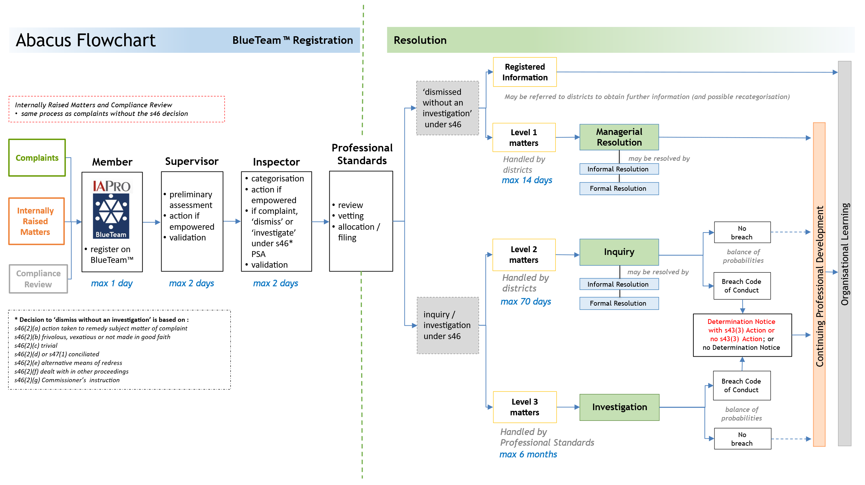
A larger version is available at Appendix A.
An overview of timeframes and authorisation levels for level 2 and level 3 matters is in the matrix below. A larger version is available at Appendix B.
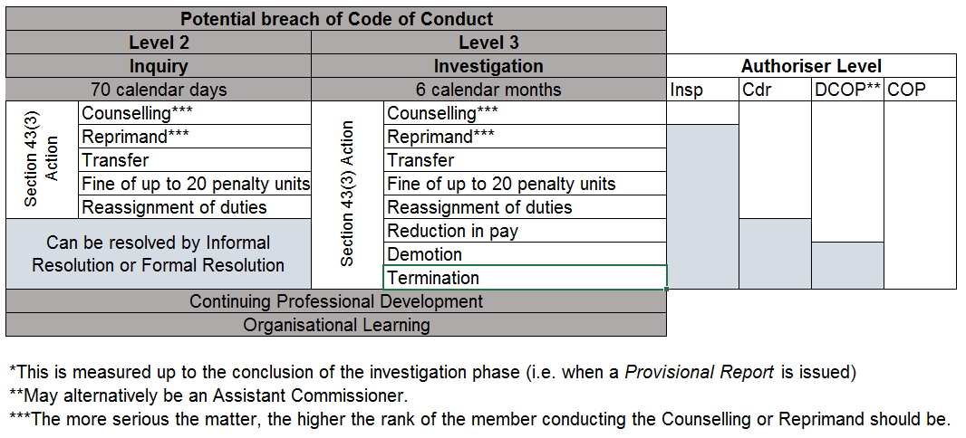

Types of Matters Reported under Abacus
There are three main types of matters registered in Abacus, as shown in the table below:
TYPES | EXAMPLES

Complaints | All external complaints (alleged offences, serious offences, crimes and Code of Conduct breaches)
Complaints | Adverse comments / reports from other agencies
Complaints | Family violence matters involving police (reported externally or involving a complaint)

Internally Raised Matters | Academic misconduct (identified internally)
Internally Raised Matters | Alleged breaches of the Code of Conduct
Internally Raised Matters | Alleged offences (e.g. road safety offences)
Internally Raised Matters | Diversity and Inclusion Matters (not amounting to a complaint)
Internally Raised Matters | Family violence matters involving police and including an offence, serious offence or crime (identified internally and not involving a complaint)

Compliance Review | Commissioner’s Directions for Alcohol and Drug Testing
Compliance Review | Death and life-threatening injury in custody
Compliance Review | Firearm discharges
Compliance Review | Police vehicle crashes
Compliance Review | Pursuits
Compliance Review | Use of force
The registration process for all types follows the process at Receiving and Registering Complaints.

Determining the Appropriate Abacus Category
Members registering a matter on BlueTeam™ will need to determine the appropriate category. Once categorised the system only facilitates changes to categorisation within IAPro™ (which can only be done by Professional Standards), therefore if supervisors and managers validating the matter believe it should have a different category they should note this on BlueTeam™ as it is routed to Professional Standards. Managers have a greater responsibility in giving fuller consideration to the categorisation (refer Managers’ Responsibilities). Where any doubt exists Professional Standards can assist.
The available categories are listed at 3.3.

Recategorisation
At any stage of the Abacus process (up to the point of members being informed of the Provisional Finding) matters may be recategorised on the basis of new evidence or information received. Reasons for recategorisation must be recorded on BlueTeam™. If a matter has already been referred to a district for inquiry or investigation, recategorisation should occur in consultation with Professional Standards.

IAPro™ and BlueTeam™ Report Names and Levels
COMPLAINT MATTERS
IAPRO Code | Report Name/Level
COMP1 | Complaint 1
COMP2 | Complaint 2
COMP3 | Complaint 3
INTERNALLY RAISED MATTERS
IAPRO Code | Report Name/Level
IRM1 | Internally Raised Matter 1
IRM2 | Internally Raised Matter 2
IRM3 | Internally Raised Matter 3
DIVERSITY AND INCLUSION
IAPRO Code | Report Name/Level
DAI | Diversity and Inclusion
DAI RI | Diversity and Inclusion – Registered Information
DAI SSE | Diversity and Inclusion SSE
COMPLIANCE REVIEW MATTERS
IAPRO Code | Report Name/Level
CR | Compliance Review
COI | Conflict of Interest
DA | Declarable Association
ADT | Drug Test
FD | Firearm Discharge
UOF | Use of Force
PVC | Vehicle Accident
PP | Vehicle Pursuit
VD | Voluntary Disclosure

Note: Report numbers and prefixes are automatically applied to reports when released from the BlueTeam™ ‘holding bin’ into IAPro™ by Professional Standards

Levels 1, 2 and 3

Level 1 matters
This category is for minor matters which are dealt with by managerial resolution.
If a matter involves an allegation that an offence, serious offence or crime has been committed it must not be categorised as a level 1 matter.
Supervisors and managers are empowered to resolve level 1 matters immediately. External complaints of this category may be made via telephone and other informal means - a written complaint should not be taken. For a matter that constitutes a level 1 but involves repetition of a type of behaviour that has previously been reported, consideration must be given to categorising it as a level 2 because more scrutiny is required. Where supervisors do not have knowledge of the member’s conduct history they are to seek advice from their manager or Professional Standards. It is expected that managers would check EIPro™ holdings to provide advice or seek advice from Professional Standards.
A written complaint is required for a complaint 2 or complaint 3, no written complaint is required for complaint 1 – just a BlueTeam™ entry with the complaint described on the summary tab.
As level 1 matters are dealt with by managerial resolution, if they are based on a complaint they are ‘dismissed without an investigation’ under section 46(1)(b) of the Police Service Act 2003. This does not mean that they are dismissed entirely without any further action – rather, they are not dealt with as a potential breach of the Code of Conduct and there is no inquiry / investigation. The resolution process must involve the subject officer being informed of the allegation, however subject officers, complainants and witnesses are not required to submit written reports. Level 1 matters may be resolved by informal resolution with all the parties and, if appropriate, apology or formal resolution. Continuing professional development (CPD) opportunities should be considered. Procedural fairness applies to level 1 matters as with other matters.
Examples of level 1*
complaint
- “Constable X was patronising, made jokes and did not take my complaint seriously.”
- “Sergeant T told my teenage son to ‘f**k off’.”
- “The cops drove too fast around corners while I was in the back of the divvy van.”
internally raised matter
- failure to submit prosecution file before statute expiry (first occurrence)
- insubordination
- repeated lateness
- excessive sick leave unsupported by medical certificate
- reckless damage to departmental property
* The specific circumstances of any example may mean it fits into another category.
Where it is obvious the matter is level 1 and the member receiving the complaint is a sergeant (or above), they may resolve it immediately, noting the resolution steps on the BlueTeam™ entry. Where possible the direct supervisor or manager of the subject officer should deal with the matter unless an insurmountable conflict of interest exists. A maximum timeframe of 14 calendar days is applied to the resolution of level 1 matters. A timeframe extension is possible but should only be granted in exceptional circumstances.
Professional Standards would only have carriage of a level 1 if they are able to immediately resolve a matter in response to direct contact from a complainant (e.g. complainant rings the Professional Standards office), or if it is intrinsically linked to a matter they are dealing with.

Level 2 matters
These matters are dealt with as a potential breach of the Code of Conduct. They are more serious than level 1 or involve a repetition of a level 1 matter and an appropriate level of inquiry is required.
Any matter that involves an allegation of an offence (e.g. traffic etc.) is to be dealt with as a level 2 matter. Serious offences or crimes are dealt with as a level 3 matter.
Level 2 matters are not subject to the traditional investigation process; instead the level of inquiry and reporting is to be proportionate to both the circumstances and the potential outcome.
A maximum timeframe of 70 calendar days applies to level 2 matters – by that time the subject officer/s are to receive the Provisional Report, unless the matter has been suspended due to external factors (e.g. a court process, external legal advice, etc.) or finalised in some other way (e.g. informal resolution or formal resolution). It is expected that, in the absence of external factors, level 2 matters will be completed well within the 70 day timeframe.
If a Provisional Report cannot be provided to the subject officer/s within 70 days, and the matter has not been suspended due to external factors, the district undertaking the inquiry can seek a timeframe extension.
If a level 2 inquiry finds that the Code of Conduct was breached a possible outcome is a Determination Notice and / or section 43(3) Action (limited to the range listed below). Instances where this may be appropriate are where the:
  - member has a history of multiple similar matters
  - matter is more serious in nature
  - complainant received a minor-moderate injury
  - member is of higher rank (the higher the rank the more serious the matter is to be considered)
Professional Standards would only have carriage of a level 2 matter if it is considered in the wider organisational interest or it is intrinsically related to a matter they are dealing with.
Examples of level 2*
complaint
- “When I was getting arrested for not leaving an area when I was told to, I got pushed up against a wall and now I have a graze and a bruise on my face. It was excessive!”
- “I saw a police officer blatantly texting while driving a police car.”
- “Sergeant X calls my children ‘mongrels’ every time he deals with them, and not in a friendly way. I have complained before but he continues to do it.”
internally raised matter
  - falsification of Offence Report outcomes
  - failing to investigate a matter and lying about ever being allocated it
  - accessing a friend’s Compass profile
  - commencing an intimate relationship with a person the officer knows is an active criminal – and failing to declare the association
* The specific circumstances of any example may mean it fits into another category.
The decision as to who has responsibility for inquiry into a level 2 matter rests with the relevant district commander. If the matter is routed to an inspector, that inspector maintains accountability for the inquiry and its outcome (within their delegated authority) unless an insurmountable conflict of interest exists. The inspector can delegate the matter to a sergeant to undertake the inquiry provided they are not the subject officer’s direct supervisor and the subject officer is below the rank of sergeant. The inspector’s accountability extends to ensuring that the enquiry is completed in a timely manner, that the parameters of procedural fairness are satisfied and that Abacus procedures are complied with.
If the matter is to be routed to a member of a rank higher than inspector, that member has the same accountability as described above.
Following the inquiry, if it is determined that the Code of Conduct was breached, any section 43(3) Action taken will be limited to the following options:
  - inspector’s counselling
  - commander’s counselling
  - commander’s reprimand
  - fine of up to 20 penalty units
  - reassignment of duties
  - transfer

Level 3 matters
These are serious matters and are dealt with as a potential breach of the Code of Conduct. If proven they may warrant termination of appointment and /or amount to a serious offence or crime. An appropriately extensive level of investigation is required and a maximum timeframe of 6 months is allowed for completion. If a Provisional Report cannot be provided to the subject officer/s within 6 months, and the matter has not been suspended due to external factors, the district undertaking the inquiry can seek timeframe extension.
Examples of level 3
complaint
- “My mate had a deal with a copper to sell him some choof.”
- “Police broke my arm when they tackled me and now I have nerve damage. I wasn’t even doing anything – just standing there.”
internally raised matter
- stealing cash located during the execution of a search warrant
- stealing found property
- sexual assault
- drink driving
- requesting a colleague to withdraw a Police Infringement Notice (PIN) that they have issued to a friend of the requesting member
Level 3 matters involve situations where:
- there is an allegation of the commission of a serious offence or crime, or serious breach of the Code of Conduct, that:
  - presents a significant risk to the reputation of Tasmania Police; and / or
  - involves an allegation of corruption
- the complainant has suffered a significant injury (e.g. significant fracture; loss or permanent limitation on their use of an organ or system; or hospitalisation exceeding 24 hours)
Where a matter satisfies one or more of the above criteria, but there is a compelling reason not to categorise it as a level 3, then written authorisation from the Deputy Commissioner or Professional Standards Commander is required.
Level 3 matters are exclusively dealt with by Professional Standards except where the Deputy Commissioner directs otherwise. A subject officer’s direct supervisor or manager is not to undertake a level 3 investigation unless the Deputy Commissioner directs otherwise.

Diversity and Inclusion
The chapter Discrimination, Prohibited Conduct and Bullying Matters provides information about legislation, policy and resolution processes. Additional Information can be found in the DPFEM Diversity and Inclusion Policy and Guidelines.

Compliance Review Matters
CR | COMPLIANCE REVIEW
- Death in custody
- Life threatening injury in custody
- Police shooting
COI | CONFLICT OF INTEREST
 | - Conflict Of Interest
DA | DECLARABLE ASSOCIATION
 | - Declarable Association
ADT | DRUG TEST
- Alcohol Test (Targeted)
- Alcohol and Drug Test (Random, Targeted, Serious Incident)
FD | FIREARM DISCHARGE
- Firearm Discharge - intentional (including animal destruction)
- Firearm Discharge - unintentional
IO | REGISTERED INFORMATION
 | The following are to be recorded as Registered Information Report on BlueTeam™
- Any matter involving a PFVO or FVO being obtained against a member where there is no offence, serious offence or crime alleged.
- Any matter involving a complaint from an intoxicated person or person affected by drugs if they are too intoxicated/affected
- Any matter where a member is
- proceeded against for any offence (other than a parking offence) or a serious offence or crime (including whilst interstate or overseas); or
- proceeded against civilly; or
- subject to bankruptcy proceedings
- Any matter where a person wants to make a complaint against police and an SSE cannot locate a member to take the complaint (the SSE must obtain the person’s details and submit a Registered Information and direct it to a supervisor/manager)
- Any complaint or internally raised matter relating to a SSE
- Any matter that is a repeat complaint from a persistent complainants (the same person complaining about the same matter)
- Any matter being dealt with by an external agency (e.g. the Integrity Commission, Equal Opportunity Tasmania, University of Tasmania)
 | The following may be recorded as a Registered Information Report on BlueTeam™
- Any comments or posts made on social media or news media (such as comments on an online news article or letters to the editor). These matters will not be accepted as a complaint.
- Any matter that relates to a service, procedure or system (e.g. policy, process, legislation)
UOF | USE OF FORCE
 | - Any use of force - if UOF provisions not complied with an IRM must be raised
PVC | VEHICLE ACCIDENT
 | - Police vehicle crash
PP | VEHICLE PURSUIT
- Authorised Follows
- Pursuits
- Vehicle interceptions - death, serious injury, significant property damage
VD | VOLUNTARY DISCLOSURE
 | - Voluntary Disclosure

Timeframes for Resolution
It is in the interests of all parties that matters are resolved in a timely manner. Timeframes commence on the date of receipt and registration of a matter.

Measurable Time Points
For accountability purposes, time points are measured at the following stages in the process:
MEASURABLE TIME POINTS | MAXIMUM
Registering member routing to supervisor on BlueTeam™ | 1 working day
Supervisor routing to Manager on BlueTeam™ | 2 working days
Manager routing to Professional Standards on BlueTeam™ | 2 working days
Professional Standards to releasing to District on BlueTeam™ | 2 working days
Registration to closure of a level 1 matter | 14 calendar days
Registration to issuing of Provisional Finding & Provisional Determination (if applicable) to subject officer in a level 2 matter | 70 calendar days
Registration to issuing of Provisional Finding & Provisional Determination (if applicable) to subject officer in a level 3 matter | 6 calendar months
Adherence to timeframes are included in six-monthly reports to the Deputy Commissioner. Individuals and districts will be accountable for the achievement of the measurable time points.
From the end of the measurable time points there may be other processes which are outside the control of the inquirer / investigator and authoriser and are therefore not measured (e.g. the subject officer’s response and, if they choose it, application for review, the court date of a linked matter).
Level | MEASURABLE TIME POINT  timeframe from registration, through  inquiry / investigation to authorisation |  |  |  | Subject officer  response | Final Determination  by Authoriser
1 | maximum 14 calendar days
2 | maximum 70 calendar days  (monthly updates to parties) |  |  | Provisional Report to subject officer | 15 calendar days  (or period as agreed) | maximum 15 calendar days from receipt of subject officer response (or period as agreed)
3 | maximum 6 calendar months  (monthly updates to parties) |  |  | Provisional Report to subject officer | 15 calendar days  (or period as agreed) | maximum 30 calendar days from receipt of subject officer response (or period as agreed)

Timeframe Extension
Extensions of time to complete a level 1 matter may be granted following written authorisation from the relevant district commander.
Extensions of time to complete a level 2 matter may be granted following written authorisation from the Commander, Professional Standards. Extension requests must be submitted 14 days before the 70th day.
Extensions of time to complete a level 3 matter may be granted following written authorisation from the Deputy Commissioner. Extension requests must be submitted 14 days before the expiration of 6 months.

Delegated Authority from Commissioner
Under section 8 of the Police Service Act 2003 (the Act) the Commissioner may delegate any power, duty or responsibility of the Commissioner under the Act to a police officer. In the Abacus framework the Commissioner has made such delegations, including under section 46 of the Police Service Act 2003 (investigating complaints), as follows:

to members attached, or seconded, to Professional Standards
  - direct any member of any rank to
    - assist in the inquiry or investigation of a complaint
    - provide any information or document or answer any question for the purpose of the inquiry or investigation
  - inquire into or investigate a complaint in any manner considered appropriate

to the member undertaking the duties of the District Administration Sergeant at Professional Standards
  - in addition to the delegation at 3.5.1 (above) determine the categorisation level of any Abacus matter.

to members of the rank of sergeant
  - direct any member below the rank of sergeant to
    - assist in the inquiry or investigation of a complaint
    - provide any information or document or answer any question for the purpose of the inquiry or investigation
  - informally resolve (conciliate) a complaint
  - inquire into or investigate a complaint allocated to them in any manner considered appropriate

to members of the rank of inspector
  - determine whether to
    - inquire into / investigate complaints; or
    - dismiss complaints
  - determine the categorisation level of any Abacus matter
  - direct any member below the rank of inspector to
    - assist in the inquiry or investigation of a complaint
    - provide any information or document or answer any question for the purpose of the inquiry or investigation
  - inquire into, investigate, or allocate to a sergeant to inquire into or investigate, a complaint in any manner considered appropriate
  - conciliate complaints by informal resolution or formal resolution
  - determine breaches of provisions of the Code of Conduct
  - take action pursuant to section 43(3)(a) of the Act (Inspector’s Counselling):
- direct that appropriate counselling be provided to the police officer
  - notify subject officers of action taken within the inspector’s delegation
  - notify the determination of complaints to complainants and subject officers

to members of the rank of commander
  - determine whether to
    - inquire into / investigate complaints; or
    - dismiss complaints
  - determine the categorisation level of any Abacus matter
  - direct any member below the rank of commander to
    - assist in the inquiry or investigation of a complaint
    - provide any information or document or answer any question for the purpose of the inquiry or investigation
  - inquire into, investigate or allocate to an inspector or a sergeant to inquire into or investigate, a complaint in any manner considered appropriate
  - conciliate complaints by informal resolution or formal resolution
  - determine breaches of provisions of the Code of Conduct
  - take action pursuant to section 43(3)(a),(b),(c),(e)and(f) of the Act:
(a) direct that appropriate counselling be provided to the police officer;
(b) reprimand the police officer;
(c) impose a fine not exceeding 20 penalty units;
(d) …
(e) reassign the duties of the police officer; and / or
(f) transfer the police officer
  - notify subject officers of action taken within the commander’s delegation
  - notify the determination of complaints to complainants and subject officers

to members of the rank of Assistant Commissioner and Deputy Commissioner
  - determine whether to
    - inquire into or investigate complaints; or
    - dismiss complaints
  - determine the categorisation level of any Abacus matter
  - direct any member to
    - assist in the inquiry or investigation of a complaint
    - provide any information or document or answer any question for the purpose of the investigation
  - inquire into, investigate or delegate for inquiry or investigation, a complaint in any manner considered appropriate
  - conciliate complaints by informal resolution or formal resolution
  - determine breaches of provisions of the Code of Conduct
  - take action pursuant to section 43(3)(a)-(g) of the Act:
(a) direct that appropriate counselling be provided to the police officer;
(b) reprimand the police officer;
(c) impose a fine not exceeding 20 penalty units;
(d) direct that the remuneration of the police officer be reduced within the range of remuneration applicable to the police officer;
(e) reassign the duties of the police officer;
(f) transfer the police officer; and / or
(g) place the police officer on probation
  - notify subject officers of action taken within the Assistant Commissioner or Deputy Commissioner delegation
  - notify the determination of complaints to complainants and subject officers.

Overview of Abacus Outcomes
The primary focus of Abacus is individual and organisational improvement. Therefore, most outcomes will include CPD. Only matters that result in a Determination Notice will form part of a member’s conduct history.
Under section 43(3) of the Police Service Act 2003, the Commissioner may take one or more of the actions listed under section 43(3) in relation to a member who has breached a provision of the Code of Conduct (levels 2 and 3 only). The purpose of section 43(3) Actions is to maintain public confidence, uphold proper standards of conduct and hold members accountable for their conduct.
All of the various possible outcomes for Abacus investigations are depicted below:
OUTCOMES | ABACUS LEVEL 1 | ABACUS LEVEL 2 | ABACUS LEVEL 3
Withdrawn
Withdrawn + CPD
Dismissed
Dismissed + CPD
Informal Resolution
Informal Resolution + CPD
Formal Resolution
Formal Resolution + CPD
No Breach
No Breach + CPD
Breach Justified
Breach + No Determination Notice
Breach + No Determination Notice + CPD
Breach + Determination Notice + no section 43(3) Action
Breach + Determination Notice + no section 43(3) Action + CPD
Breach + Determination Notice + section 43(3) Action
Breach + Determination Notice + section 43(3) Action + CPD
A discretionary decision may be made to not issue a Determination Notice for some breaches of the Code of Conduct – this is only an option when no section 43(3) Action is being taken.
If the final determination is that a Determination Notice is issued the IAPro icon turns red. This means it forms part of the conduct history of that member and may be considered in any future breach of the Code of Conduct. Any section 43(3) Action of a reprimand or higher will affect the member’s eligibility for wearing or receiving medals. A Commander is able to impose a limitation on the subject officer wearing or being awarded the Commissioner’s Medal or National Police Service Medal for a period up to and including 12 months. An Assistant Commissioner or the Deputy Commissioner can impose a limitation on the subject officer wearing or being awarded the Commissioner’s Medal or National Police Service Medal for a period up to and including 5 years.
Where the outcome is ‘No Breach’, ‘Breach + No Determination Notice’ or ‘Withdrawn’ the outcome will still be explained to the subject officer.
Fairness and consistency in outcomes is assisted by 6-monthly reports to the Deputy Commissioner and the availability of Professional Standards to provide guidance.

Early Identification
EIPro™ is a system connected with IAPro™ data that allows for early identification of members who have attracted higher numbers of complaints or attract a particular type of complaint within a defined period as compared to other members in the same work area. Early identification (EI) provides an opportunity to identify and, where necessary, address issues which may be affecting a member. The issues may relate to wellbeing or knowledge gaps. Addressing the issue and developing the member may prevent repetition of complaints or conduct matters; or the receiving of more serious complaints.
If a member is identified, a qualitative review of those matters is undertaken by Professional Standards. If appropriate, a referral is made to the member’s district commander for consideration as to whether any professional development, wellbeing assistance or another approach is warranted. If any assistance is required, strategies should be developed in consultation with the member. The focus of EI is on identifying, rectifying issues and preventing further issue arising. EI is a CPD and not a Code of Conduct process.

Continuing Professional Development (CPD)
A key objective of Abacus is to move towards a strong focus on professional development. CPD is not an indication of wrongdoing – rather, a recognition that a member could benefit from guidance, additional training or viewing their own actions from a different perspective.

Devising and Implementing CPDs
The purpose of CPD is to develop the member. CPD must be appropriate and applicable to the identified conduct and to the member. It should be considered for every Abacus matter except those that result in termination of appointment. A CPD may or may not be a one-off event – the intention is to ensure that the improved knowledge and skills are sustained into the future.
Some types of CPD are:
- increased or targeted supervision
- verbal guidance
- coaching
- mentoring from another officer
- retraining in an operational skills technique relevant to the conduct
- retraining on a topic relevant to the conduct, e.g. legislation
- maintaining a work diary
- completion of an eLMS module relevant to the conduct
- other individually tailored development activities
Example
An IRM is raised about a constable repeatedly submitting late files and reports. It is managed as a level 1 and the managerial resolution is CPD of verbal guidance from their sergeant. Verbal guidance is intended not only to show the member how they are falling short of expected standards, but also to identify any underlying factors that are contributing to the problem (such as a wellbeing issue). The sergeant and constable devise a plan to address the underlying problem and agree to have future discussions to ensure that the problem has been addressed and the timeliness of their file submission is at an acceptable standard.

Examples of CPD for Particular Conduct Issues
Note: in these examples matters dealt with as a level 2 or 3 may also result in a determination that the member breached the Code of Conduct which may involve section 43(3) Actions.
ISSUE | ABACUS LEVEL | EXAMPLES OF CPD
misunderstanding an amended power of arrest | 1 | verbal guidance
late submission of file | 1 | mentoring
rudeness and impatience with members of the public | 1 | verbal guidance
failing to submit Family Violence Management System (FVMS) entry | 2 | targeted supervision
covering up or lying to supervisor about a conduct matter | 2, 3 | completion of ethics training in eLMS
failing or refusing to carry out duty | 2 | increased supervision
fail to assist person at public inquiries | 1 | customer service training
bullying | 1, 2, 3* | diversity and inclusion training
improper release of information | 1, 2, 3* | training on TPM and legislative provisions
fail to declare - and continue - conflict of interest | 2 | completion of conflict of interest module in eLMS; verbal guidance
excessive use of force | 1, 2, 3* | retraining on unarmed tactics
repeated late submission of files | 2 | verbal guidance; mentoring
covering up an unintentional discharge | 2 | retraining on loading / unloading procedures, verbal guidance
unintentional discharge (disclosed by member as required) | 1, 2 | retraining on loading / unloading procedures
failing to release person in custody after 8 hours | 2 | retraining on custody legislation and TPM provisions
*Level 3 matters resulting in termination of appointment will not involve CPD.

Process for Monitoring Completion of CPD
Satisfactory completion of CPD is reported in the Abacus process and is essential for finalisation of a matter. Recognising that matters will differ, the standard process is:
- the member allocated an Abacus matter for resolution devises the CPD
- they route the BlueTeam™ matter to the authoriser (note the matter will need to be forwarded to Professional Standards first if it has not been allocated an IAPro™ number)
- if the authoriser endorses the CPD they create a ‘Task’ on BlueTeam™ (and if not endorsed may devise an alternative CPD)
- if the authoriser is not the subject officer’s manager then the authoriser routes the matter through BlueTeam™ to that manager
- the authoriser / manager arranges for the CPD to occur (which may involve liaising with other areas such as the Operational Skills Unit)
- the area responsible for facilitating the CPD reports back to the authoriser / manager when the CPD has been completed
- the authoriser / manager updates the BlueTeam™ Task and routes it to Professional Standards
The Deputy Commissioner receives six-monthly statistical reports on the type, district and completion status of CPD. The Professional Standards Commander and Education & Training Commander liaise on additional requirements for organisational learning and professional development across the organisation.

CPD Has No Broader Consequences
The intention of CPD is developmental. CPD implemented under Abacus cannot be used against a member into the future. Records or documentation relating to CPD are not available for any other organisational decision-making such as awarding of medals, selection for courses, transfers or promotion. CPD is not recorded as an adverse finding on IAPro™ and does not form part of a member’s conduct history.

Failure to Comply with CPD
If a member fails to satisfactorily comply with any CPD within the allocated timeframe then the matter cannot be closed. The member’s manager must notify the relevant commander who has oversight of the matter for determination of further action, including whether or not to commence a new Abacus matter for failing to comply with a lawful direction.

Failure of CPD in Developing a Member
If CPD fails to reach the desired developmental outcome the member’s district commander is to consider an alternative CPD.

Organisational Learning
Just as all members need to learn from personal experiences, Tasmania Police needs to be able to identify any opportunities for organisational improvement. It is important that this aspect is considered in every Abacus matter. For example, a training gap across the organisation may be identified or there may be a need for a TPM amendment. Organisational learning may also contribute to legislative reform. Organisational learning is further assisted from stakeholder surveys and data analysis described in Use of Information, Data Collection and Reporting.

INTERNALLY RAISED MATTERS & COMPLIANCE REVIEW

Members’ Obligation to Report Alleged Breaches of Code of Conduct involving other members
When members feel confident to report conduct within the organisation it indicates a robust and accountable system. Members are empowered and obliged to report any member in accordance with our values and obligations, including those under Part 13 of the Tasmania Police Manual (TPM).
ORDER
A member who becomes aware of another member
- committing a serious offence or crime; or
- committing a breach of the Code of Conduct
must report the matter immediately to a senior officer. The senior officer is to direct the informing member to register the matter on BlueTeam™; or register it themselves. Registration is to occur prior to the conclusion of duty that shift, unless the matter is able to be dealt with as provided for in Abacus 4.1.1 Discretionary Action for minor internally raised matters or victimisation/discrimination of police complainants
Members are reminded of the importance of confidentiality in all Abacus matters.

Discretionary Action for Minor IRMs
Supervisors and managers are not obligated to report breaches of the Code of Conduct for IRM1s. These matters may be registered on BlueTeam™ by either the reporting member or the senior officer. Even if not registered on BlueTeam™ the senior officer is to ensure the matter is managed appropriately. If it is an IRM1 but involves repeated behaviours then it must be reported formally through BlueTeam™. It is important to deal with such issues in a timely manner and to ensure that CPD occurs as necessary.
Examples
- Constable J’s dress and appearance does not comply with the standards set by the Commissioner as she has her hair in a ponytail. Sergeant Q speaks to Constable J in relation to ensuring her hair does not extend beyond the top of the collar. Constable J apologises and undertakes to remedy the matter. As this is an IRM1 and there has been no previous issue with Constable J, Sergeant Q does not need to report the matter on BlueTeam™.
- Constable N is a highly-motivated member. He enjoys being ‘out amongst it’ and has a very high work ethic. Unfortunately, he is tardy in submitting his paperwork. He has been spoken to about the importance of finalising his reports in a timely manner – but has not improved. Sergeant Z is aware that, if this were a one-off, it could be an IRM1. As it is repeated conduct it must be an IRM2 and be formally reported.

Victimisation / discrimination of police complainants
Any victimisation of police complainants will not be tolerated. Such behaviour constitutes a breach of section 42(12) of the Police Service Act 2003. Any member becoming aware of victimising conduct must either register it on BlueTeam™ as a new matter, or report it to a senior officer. Failure to comply with this will undermine the entire system. In this instance, the reporting member can choose to make the report anonymously. This can be done in a variety of ways – irrespective, the member will need to keep a record of when, where and how the matter was reported. This is essential should the member be required to demonstrate that they have complied with the TPM obligation to report a member breaching the Code of Conduct.

‘Whistle-blowers’ - Alternative Complaint Mechanism

Public Interest Disclosure
Comprehensive public interest disclosure information for members (including the Public Interest Disclosures Lodgement Form) is available on the Tasmania Police public website.
The public interest is served when members are able to report improper conduct relating to matters of public importance and be protected in the process. The Public Interest Disclosure Act 2002 was established to:
- encourage and facilitate disclosures of improper conduct by public officers and public bodies
- protect persons making those disclosures, and others, from detrimental action
- provide for the matters disclosed to be properly investigated and dealt with, and
- provide all parties involved in the disclosures with natural justice.

Protected Disclosure
A ‘protected disclosure’ is a report that is made in accordance with Part 2 of the Public Interest Disclosure Act 2002 and may attract protections which are given by Part 3 of the Public Interest Disclosure Act 2002 if it meets the threshold tests. It can be made by any means and may be anonymous. It is a report made from within Tasmania Police to the Commissioner about improper or corrupt conduct or maladministration (see below for further explanation).

Any disclosures under the Public Interest Disclosure Act 2002 may or may not be handled as an Abacus investigation. Due to the protections provided, including anonymity provisions, these matters can be reported in many ways and do not have to be registered on BlueTeam™.
Disclosures can be made to the Protected Disclosure Coordinator (the Deputy Commissioner), the Commissioner, or Ombudsman Tasmania. Disclosures may be made by members, or by Department of Fire, Police and Emergency Management (DPFEM) employees, contractors or former contractors. Disclosures relating to the Commissioner are to be made to Ombudsman Tasmania. These procedures are designed to complement normal communication channels between supervisors and members. Members are encouraged to continue to raise matters at any time with their supervisors.
The term ‘improper conduct’ is central to the rights under the Public Interest Disclosure Act 2002 and to the issue of whether a protected disclosure can be found to be a ‘public interest disclosure’. Improper conduct is defined as:
(a) conduct that constitutes an illegal or unlawful activity; or
(b) corrupt conduct; or
(c) conduct that constitutes maladministration; or
(d) conduct that constitutes professional misconduct; or
(e) conduct that constitutes a waste of public resources; or
(f) conduct that constitutes a danger to public health or safety or to both public health and safety; or
(g) conduct that constitutes a danger to the environment; or
(h) misconduct, including breaches of applicable codes of conduct; or
(i) conduct that constitutes detrimental action against a person who makes a public interest disclosure under this Act –
that is serious or significant as determined in accordance with guidelines issued by the Ombudsman Tasmania.
The term ‘corrupt conduct’ means:
(a) conduct of a person (whether or not a public officer) that adversely affects, or could adversely affect, either directly or indirectly, the honest performance of a public officer's or public body's functions; or
(b) conduct of a public officer that amounts to the performance of any of his or her functions as a public officer dishonestly or with inappropriate partiality; or
(c) conduct of a public officer, a former public officer or a public body that amounts to a breach of public trust; or
(d) conduct of a public officer, a former public officer or a public body that amounts to the misuse of information or material acquired in the course of the performance of their functions as such (whether for the benefit of that person or body or otherwise); or
(e) a conspiracy or attempt to engage in conduct referred to in paragraph (a), (b), (c) or (d).
Further information on improper conduct is provided by Ombudsman Tasmania in their Guidelines and Standards for the Purpose of Determining whether Improper Conduct is Serious or Significant (No. 1/2010).
The Public Interest Disclosure Act 2002 provides protection to persons who make disclosures in accordance with the Public Interest Disclosure Act 2002. It also provides for the matters disclosed to be investigated and rectifying action to be taken. Section 19, Protection from reprisal, of the Public Interest Disclosure Act 2002 makes it an offence for a person to take detrimental action against another person in reprisal for a protected disclosure. Detrimental action is defined under s3 of the Public Interest Disclosure Act 2002 and includes:
(a) action causing injury, loss or damage; and
(b) intimidation or harassment; and
(c) discrimination, disadvantage or adverse treatment in relation to a person's employment, career, profession, trade or business, including the taking of disciplinary action; and
(d) threats of detrimental action.

Voluntary Disclosures
Members should have the confidence to voluntarily disclose any matter relating to their own conduct. When mistakes are made or behaviour, actions or decisions fall short of expected professional standards, members are encouraged to be REAL about it. Problems are best resolved if declared at the earliest time and this is in everybody’s interest, not least the member involved. Furthermore, it demonstrates a commitment to our oath / affirmation and values.

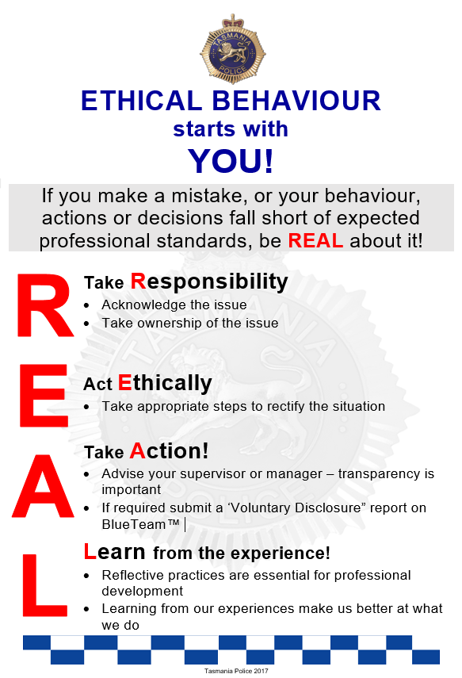
The method of reporting voluntary disclosures is through a Voluntary Disclosure Report on BlueTeam™. A manager receiving a voluntary disclosure is to recategorise the matter as appropriate. In deciding managerial resolution (level 1 matters) or determination under section 43(3) of the Police Service Act 2003 (level 2 and 3 matters), due credit must be given to the member for making the disclosure voluntarily. Depending on the seriousness of a matter, decisions on whether or not to issue a Determination Notice may be influenced by the fact that a member has voluntarily disclosed it.

Family & Sexual Violence Involving Police
The procedures and orders under the Tasmania Police Manual Part 2.5.3, the Family Violence Manual and the Family & Sexual Violence Involving Police Policy apply whenever members attend a family & sexual violence incident involving another member; or receive a family & sexual violence complaint against another member.

Family & sexual violence involving members of Tasmania Police, either as an alleged perpetrator or victim, should be managed in accordance with the legislation and relevant policy, as it would be if the matter involved any member of the public.

The Family & Sexual Violence Involving Police Policy contains additional responsibilities and mandatory requirements specific to family and sexual violence matters involving police. Where a member of Tasmania Police is one of the parties in a reported matter where family and sexual violence is involved, the response, investigation and management of the matter is to be in accordance with that policy.

Family and Sexual Violence incidents and the Code of Conduct
Allegations of family and sexual violence need to be assessed on a case-by-case basis in relation to potential breaches of the Code of Conduct.

Issue and Service of orders to members of Tasmania Police
A PFVO against a member of Tasmania Police can be issued and served by another member of the rank of Sergeant or above, or an authorised officer. Where a member of Tasmania Police is subject to any order:
- any authority given to them to access, use or carry any service weapon is immediately revoked
- they must immediately surrender any firearms in their possession
- they must immediately surrender any police-issue firearm or any firearm purchased for police purposes in their possession
- any access to police firearms storage must be prohibited (key surrendered / code changed / swipe card disengaged).

Handling of evidence
Where there is an allegation of an offence, serious offence or crime against a member of Tasmania Police, attending members are to secure evidence in the first instance in accordance with standard crime scene attendance procedures. Witness statements and associated enquiries may be required to be taken by attending members. If Professional Standards is likely to have carriage of a matter, they should be consulted about task allocation in securing and collecting evidence.
Where photographs or electronic evidence is required by Forensic Services, there is no change to standard procedure, except that photographs of intimate body parts will not be uploaded to the Forensic Register. In such case, advice must be sought from Professional Standards.

Family Violence incidents and the Code of Conduct
Allegations of family violence need to be assessed on a case-by-case basis in relation to potential breaches of the Code of Conduct.

Reports required for Family and Sexual Violence incidents involving a member
In addition to submission of a FVMS report, the following Blue Team™ reports are required when a family and sexual violence matter is reported, and that matter involves a police officer as one of the parties:

TYPE | BlueTeam™ CATEGORY LEVEL
Family Argument | Registered Information
Family Violence Incident + order where no offence is alleged to have been committed | Registered Information
Family Violence Incident + order + offence, serious offence or crime | Complaint 2 or 3  IRM 2 or 3
Breach of existing order | Complaint 2 or 3  IRM 2 or 3
Any argument or incident where the alleged perpetrator is not a police officer but the victim is a police officer | Registered Information

Breach of the TPM and other Policies
Breaches of the TPM and other Tasmania Police or DPFEM policies are reported on BlueTeam™ as internally raised matters (IRMs). Examples include breaches of the Commissioner’s Directions for Alcohol and Drug Testing, informant management procedures and information security policies.

Breach of Road Safety (Alcohol and Drugs) Act 1970
This section applies to incidents involving on-duty and off-duty members who return a positive roadside breath test or positive oral fluid test. It is essential that in this situation the intercepting members understand their primary duty is to the law and their secondary duty is to other members’ wellbeing. The intercepting members must ensure that all legal obligations (e.g. breath analysis) are complied with in the first instance. As with any other offence, members are not to be treated differently to any other person.
Below are the steps to be followed in different situations.

Drink Driving
Where a member, on-duty or off-duty, returns a positive roadside test with a result greater than the prescribed concentration of alcohol (in any circumstance e.g. random, manner of driving or crash):
- the intercepting member immediately notifies their supervisor (and the duty inspector to monitor the process); then
- the parties return to a police station for the standard breath analysis process (a duty inspector should, where possible, be present to observe the breath analysis process. If the duty inspector is not available a supervisor should be present); then
- if breath analysis is above the prescribed limit the member is charged then the reporting member registers the incident on BlueTeam™ as:
  - IRM2 (above prescribed limit but below 0.10)
  - IRM3 (0.10 and above; DUI; fail / refuse test)
and routes the entry to their supervisor and standard Abacus processes follow. Professional Standards and the District Commander are to be notified.
If the breath analysis is below the prescribed concentration of alcohol and the member is off-duty there is no BlueTeam™ entry.
If the breath analysis is below the prescribed concentration of alcohol and the member is on-duty then a BlueTeam™ entry is to be made (for any reading). Consideration is then to be given to further testing under the Commissioner’s Directions for Alcohol and Drug Testing.

Positive Oral Fluid Test
Where a member, on-duty or off-duty, returns a positive roadside test (in any circumstance e.g. random, manner of driving or crash):
- the intercepting member immediately notifies their supervisor and the duty inspector; then
- the parties attend a medical facility for the standard blood sample process. A duty inspector should, where possible, be present to observe the process. If the duty inspector is not available a supervisor is to be present; then
- the reporting member registers the incident on BlueTeam™ as an IRM3 and routes the entry to their supervisor and the standard Abacus processes follow. Professional Standards and the District Commander are to be notified; and
If the member is on-duty then a BlueTeam™ entry is to be made. Consideration is then to be given to further testing under the Commissioner’s Directions for Alcohol and Drug Testing.

Indicative Actions Framework for Drink and Drug Driving
The actions outlined in this framework are indicative only. The framework is intended as a guide to indicate the likely actions in the event that a member is detected drink driving or drug driving. Actions are not limited to those listed in this section. Consideration may be given to a broad range of options which include section 43(3) Actions or removal or limitation from higher duties or internal / external courses. Regardless of the indicated actions the Commissioner has the authority to determine what action will be taken including, in serious cases, termination of appointment. Members’ rights of appeal to the Police Review Board do not change.
Where demotion is an indicated action, a reduction in remuneration may be considered in the alternative depending on all relevant circumstances and considerations. Where the member is on or near the base level of remuneration, an alternative action may be considered.

On-Duty
ON-DUTY - POLICE VEHICLE / PRIVATE VEHICLE
0.050  –  0.099 | 0.100  –  0.149 | 0.150+ | DUI alcohol / drugs | Drug Driving | 2nd offence | Fail / refuse test* | Indicative action
● |  |  |  |  |  |  | demotion, reprimand & transfer
 | ● | ● | ● | ● |  |  | termination of appointment
 |  |  |  |  | ● |  | termination of appointment
 |  |  |  |  |  | ● | termination of appointment
*In circumstances that amount to an offence

Off-Duty
OFF-DUTY - PRIVATE VEHICLE
0.050  –  0.099 | 0.100  –  0.149 | 0.150+ | DUI alcohol / drugs | Drug Driving | 2nd offence | Fail / refuse test* | Indicative action
● |  |  |  |  |  |  | reprimand & transfer
 | ● |  |  |  |  |  | demotion, reprimand & transfer
 |  | ● | ● | ● |  |  | termination of appointment
 |  |  |  |  | ● |  | termination of appointment
 |  |  |  |  |  | ● | termination of appointment
*In circumstances that amount to an offence

OFF-DUTY - POLICE VEHICLE
0.050  –  0.099 | 0.100  –  0.149 | 0.150+ | DUI alcohol / drugs | Drug Driving | 2nd offence | Fail / refuse test* | Indicative action
● |  |  |  |  |  |  | demotion, reprimand & transfer
 | ● |  |  |  |  |  | termination of appointment
 |  | ● | ● | ● |  |  | termination of appointment
 |  |  |  |  | ● |  | termination of appointment
 |  |  |  |  |  | ● | termination of appointment
*In circumstances that amount to an offence
Other considerations:
- crash involving significant injury or significant damage
- evading or attempting to evade apprehension
- poor behaviour at intercept or subsequent processing
- conduct history and service history
- any other relevant circumstances.

Academic Misconduct

Defining Academic Misconduct
In a training and educational setting learning involves a genuine change in knowledge, skills and attitudes and requires ethical behaviour and hard work. Training includes vocational knowledge, skills and attitudes; and education and personal development includes tertiary qualifications, conceptual and analytical skills.
Integrity is one of the values of Tasmania Police and the community expects honesty from its members. Academic misconduct can take a number of forms. It includes:
Plagiarism | Plagiarism is associated with any formal written work which is accompanied by a set of instructions and is assessed (e.g., essays, syndicate and individual assignments, research projects, in-tray reports).  Plagiarism can be unintentional or intentional. Intentional plagiarism occurs when a person deliberately or knowingly uses others’ words, ideas, phrases, without acknowledgement (citing or indicating the source). Unintentional plagiarism can arise from:  - an incomplete understanding of the conventions of academic writing within a formal training and education setting;  - a lack of experience and the necessary underpinning knowledge, skills and attitudes to undertake written work within a formal training and education setting; and  - inadequate research skills, such as not keeping correct details of sources of information and/or direct quotes.
Cheating | The practice of deception and acting unfairly or fraudulently. Within the police education and training environment, cheating refers to academic misconduct which occurs during written examinations and practical assessments.
Collusion | Acting with another person with the intention to deceive. This form of deception relates to when a person uses work that someone else has done previously as their own, either in full or in part, and with the original author’s permission. It can also include another person writing any part of a student’s work / assignment.  Collusion should not be confused with the sharing of ideas and information with others in a learning environment. The crucial aspect is that those ideas are not copied verbatim.
Academic misconduct does not allow learning to occur. Plagiarism, cheating and collusion are all forms of intellectual theft and breach a number of provisions of the Code of Conduct: including the requirements to act with honesty and integrity, and care and diligence.
The Advice to Students on Academic Misconduct provides guidance on avoiding academic misconduct; information and procedures about TURNITIN® software for detecting plagiarism and collusion.

Management of Academic Misconduct Allegations
Members should be aware that if an educational institution detects Academic Misconduct (e.g. the University of Tasmania), they will inform Tasmania Police of the circumstance. If the Academic Misconduct is identified by Tasmania Police, Tasmania Police will notify the educational institution. Tasmania Police acknowledges that the educational institution will take action in accordance with their Ordinances.
Academic penalties may include but are not limited to:
- resubmission of assignment, with or without specific assessment requirements;
- requirement to complete alternative or additional assessment task(s) commensurate with the purpose and level of the original assessment task;
- resit alternative examinations;
- deemed fail (Not Yet Competent) in the assignment
- deemed fail (Not Yet Competent) in the qualifying process, course, or module / unit;
- reduction or cancellation of academic marks allocated to the member;
- formal counselling;
- determination that the member is ineligible to sit examinations, undertake or continue a course or qualification process for a nominated period.
- the exclusion of the student from UTAS, and suspension of their enrolment, permanently or for any period that the University thinks appropriate
Members should also be mindful that any suggestion of academic misconduct will be investigated internally and that there may be additional consequences for breaches of the code of conduct over and above academic penalties.

Breaches of the Code of Conduct
Allegations of academic misconduct must be registered on BlueTeam™ as IRMs. Procedural fairness principles and members’ rights and obligations apply to allegations of academic misconduct, as with any other Abacus matter. The standard procedure for categorisation also applies and the appropriate level must be selected (IRM2 or IRM3). After reaching the IAPro™ ‘holding bin’ they will be allocated to a manager within the Education and Training Command or to Professional Standards.
These sections of the Police Service Act 2003 are relevant:
s42(1) A police officer must behave honestly and with integrity in the course of his or her duties in the Police Service.
s42(2) A police officer must act with care and diligence in the course of his or her duties in the Police Service.
s42(7) A police officer, in connection with his or her duties in the Police Service, must not –
(a) knowingly provide false or misleading information; or
(b) omit to provide any matter knowing that without that matter the information is misleading.
Where it is determined that a member has breached the Code of Conduct action may be taken under section 43(3) of the Police Service Act 2003.

Overview of Compliance Review
By its nature policing involves high risk activities. Tasmania Police has long-established procedures for investigation and review of these matters. Under Abacus the following types of incident must be recorded on BlueTeam™:
COMPLIANCE REVIEW MATTERS
CR | Compliance Review | - Death in custody  - Life threatening injury in custody  - Police shooting
COI | Conflict of Interest | - Conflict Of Interest
DA | Declarable Association | - Declarable Association
ADT | Drug Test | - Alcohol Test (Targeted)  - Alcohol and Drug Test (Random, Targeted, Serious Incident)
FD | Firearm Discharge | - Firearm Discharge - intentional (including animal destruction)  - Firearm Discharge - unintentional
RI | Registered Information | - Refer 3.3.3 Registered Information for details.
UOF | Use of Force | - Any use of force - if UOF provisions not complied with an IRM must be raised
PVC | Vehicle Accident | - Police vehicle crash
PP | Vehicle Pursuit | - Authorised Follows  - Pursuits  - Vehicle interceptions - death, serious injury, significant property damage
VD | Voluntary Disclosure | - Voluntary Disclosure
Recording these incidents centrally on BlueTeam™ offers a streamlined, clearer reporting process for members; and case management capability. It assists in identifying organisational learning and individual professional development needs through data analysis. Compliance review is essential for community confidence and is consistent with the Tasmania Police values.
The remainder of this chapter describes the various types of Abacus compliance review matters (unless they have been described elsewhere).

Use of Force
Police are endowed with many powers of coercion and control under various legislation and members are highly accountable for the exercising of those powers. If members do not abide by legislation and policies relating to these powers they may be prosecuted.

Use of Force Reports and Flowchart
Part 10.1 of the TPM contains an order stating that an electronic Use of Force Report (UOFR) is required to be submitted when:
- use of force results in the death or injury to any person;
- where a firearm is drawn outside a firing range for the possible use against a person;
- a firearm is discharged, outside of a firing range, including unintentional discharges; or
- a less-lethal weapon/impact/takedown technique is used on a person.
Where a UOFR is required to be submitted in accordance with Part 10 of the TPM, members must register the matter on BlueTeam™. The Guide to Entering and Forwarding Electronic Use of Force Reports is available on the intranet and provides an easy to follow template for reporting. Part 10 of the TPM further states that all UOFR are checked by divisional inspectors. This process ensures accountability and organisational learning - divisional inspectors must determine or comment on adherence to policy and orders; effectiveness and clarity of policy; and training deficiencies.
The Operational Skills Unit monitors all UOFRs to ensure that the application of force and the tactical force options used by members are appropriate and consistent with policy. Some UOFRs may be identified as requiring further scrutiny. Where compliance with policy has not occurred, it must be registered on BlueTeam™ as an internally raised matter (IRM) by the divisional inspector or the inspector with responsibility for the Operational Skills Unit.

Flowchart Summary
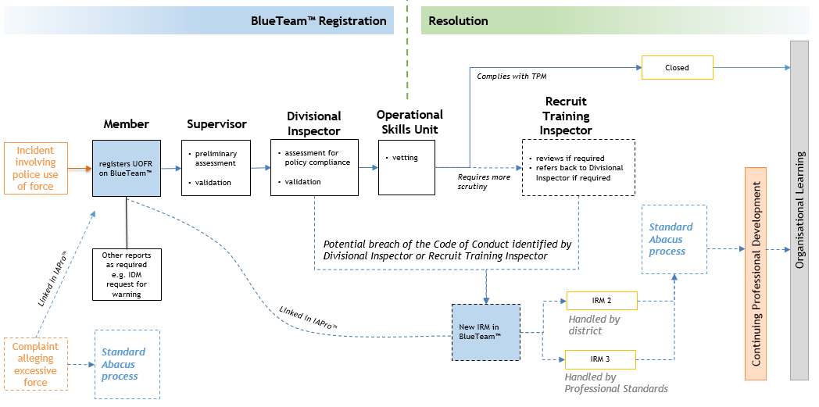

Reasonable Force and Member Claiming Self-Defence
The Operational Skills Unit has produced comprehensive guidelines which include the following relating to use of force (paraphrased):
- reasonable force is minimal and necessary
- reasonable force depends on:
  - the situation
  - how the member views the situation (subjective test)
  - how others (or the average person) would view the situation (objective test)
  - case law decisions as to what is reasonable in comparable circumstances
- other factors for consideration include:
  - age, gender and build of all parties
  - physical ability of all parties
  - prior knowledge
  - motivation
  - known diseases
  - known injuries
  - involvement of weapons
  - number of police involved
  - number of other people involved
  - location and geographical or environmental situation

Excessive Force
Section 46 of the Criminal Code provides for self-defence and defence of another person:
46. Self-defence and defence of another person
A person is justified in using, in the defence of himself or another person, such force as, in the circumstances as he believes them to be, it is reasonable to use.
Part 1.44 of the TPM (Use of Force) states that members are justified in using reasonable force in defence of themselves or any other person. Members must only use force that is reasonable, necessary, proportionate and appropriate to the circumstances.
In determining whether or not force used is reasonable or otherwise, the inquirer / investigator and authoriser will be required to consider the circumstances both objectively and subjectively.

Consequences of Excessive Force including Prosecution
Members who are the subject of a complaint or UOFR resulting in a level 2 or 3 inquiry or investigation may be found to have breached one or more provisions of the Code of Conduct. Consequently, they may receive a Determination Notice and section 43(3) Action in accordance with Abacus. They may also be charged with an offence such as common assault.

Firearm Discharge
All incidents involving the use of police firearms must be recorded on BlueTeam™. Different incidents have different reporting requirements, as shown below:
INCIDENT | BLUETEAM™ REPORTS | REPORTING MEMBER
intentional discharge at person (‘police shooting’) | Firearm Discharge | involved member / supervisor
intentional discharge at person (‘police shooting’) | Use of Force | involved member
intentional discharge at person (‘police shooting’) | Compliance Review | Professional Standards
unintentional discharge | Firearm Discharge | involved member
firearm drawn but not discharged | Use of Force | involved member
intentional discharge at animal | Firearm Discharge | involved member

Police Shooting
Professional Standards will manage the investigation process and register a Compliance Review report on IAPro™ which will be linked to the UOFR and Firearm Discharge report in IAPro™. Members are directed to Part 10.9 of the TPM for further reporting obligations.

Deaths or Life-Threatening Injury in Custody
Specific directions for these incidents are contained in Section 13.3 of the TPM. All incidents of life-threatening injury or deaths in custody must be registered on BlueTeam™ as a Compliance Review report. Other reports should be submitted as applicable (e.g. where force is used). ‘In custody’ is defined within section 13.3 of the TPM.
Professional Standards will notify the Integrity Commission in writing as soon as possible following any incident that results in a death or life-threatening injury for accountability reasons, however the Integrity Commission has no role in any compliance review process.

Police Vehicle Pursuits
The Management of Police Pursuits and Authorised Follows are described fully in Part 14.14 of the TPM. Pursuits are categorised at three levels, Pursuit 1, Pursuit 2 and Pursuit 3.

Pursuit 1
A level 1 pursuit requires no investigation and is deemed to have occurred when the initial assessment of the circumstances indicates there has been an authorised pursuit or authorised follow and there has been:
  - no injury to any person; or
  - no crash; or
  - no damage to any vehicle or property caused during the pursuit or authorised follow (excluding damage to tyres caused by deployment of Vehicle Immobilisation Device (VID); or
  - no breach of TPM order(s)

Pursuit 2
A level 2 pursuit is investigated in the relevant district and is deemed to have occurred when the initial assessment of the circumstances indicates there has been a pursuit (authorised or unauthorised); or a follow (authorised or unauthorised) and there has been:
- a minor-moderate injury to any person (first aid only) caused during the pursuit or authorised follow; or
- a minor crash; or
- minor damage to any vehicle or property caused during the pursuit or authorised follow (excluding damage to tyres caused by deployment of VID); or
- breach of TPM order(s)

Pursuit 3
A level 3 pursuit is investigated by Professional Standards Command (or as directed by the Deputy Commissioner) and is deemed to have occurred when the initial assessment of the circumstances indicates there has been a pursuit (authorised or unauthorised); or a follow (authorised or unauthorised) and there has been:
- an injury to any person requiring hospitalisation or treatment by a doctor (other than first aid) caused during the pursuit or an authorised follow; or
- a serious crash; or
- more than minor damage to any vehicle or property caused during the pursuit or an authorised follow (excluding damage to tyres caused by deployment of VID); or
- breach of TPM order(s)

Police Vehicle Crashes
The obligations of members, supervisors and managers in relation to police vehicle crashes are contained within Part 3.8.5 of the TPM.
All police vehicle crashes are to be recorded on the Traffic Crash Reporting System. They are also to be entered into BlueTeam™. All related documents and reports are to be attached and the matter referred to the responsible manager for review and routing to Professional Standards. Professional Standards will release it from the IAPro™ ‘holding bin’ and then refer the Police Vehicle Crash report back to the District for finalisation. In some circumstances Professional Standards may be required to undertake the investigation (e.g. pursuit 3 related crash).

Commissioner’s Directions for Alcohol and Drug Testing
The Commissioner’s Directions for Alcohol and Drug Testing fully describe the obligations of members, supervisors and managers in relation to alcohol and drug testing conducted under the provisions of Division 4 (Alcohol and Drugs) of the Police Service Act 2003.
Alcohol and drug testing can be random, targeted or serious incident related. It is conducted by an independent service provider. All alcohol and drug tests are recorded on IAPro™.

RECEIVING, REGISTERING & CATEGORISING ABACUS MATTERS
This chapter relates to all levels of matters.

Registration Flowchart Overview
Below is a chart showing the registration process. If any member is in doubt of their Abacus responsibilities or the processes, they should seek advice from a supervisor, manager or Professional Standards.
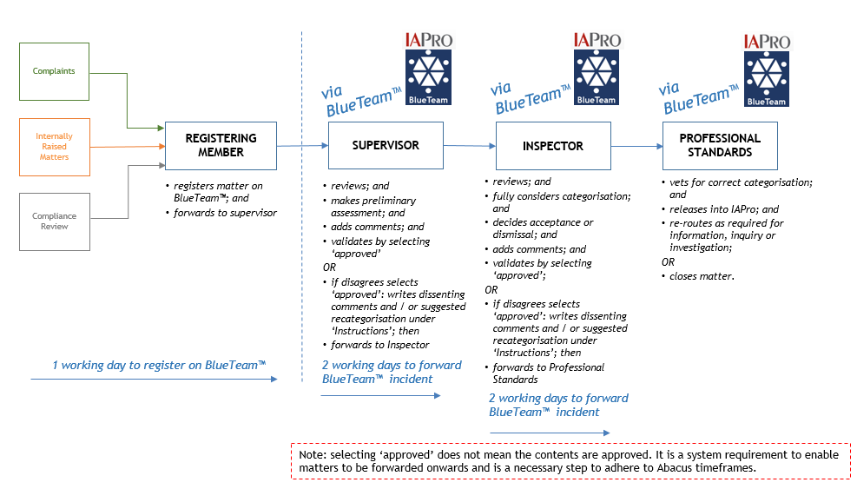
When matters are routed through BlueTeam™ the recipient receives a notification e-mail in their normal Outlook inbox. The BlueTeam™ User Guide has detailed directions on the data entry process.
Members and/or supervisors should consider whether managers require immediate verbal notification of some matters and take appropriate action. They should record on BlueTeam™ that notification was made.
The timeframes noted in the above diagram are measurable time points and are included in six-monthly reports to the Deputy Commissioner. There is a clear requirement on all involved to ensure they meet their measurable time point obligations.

Rights of Complainants
All complainants are entitled to be treated with dignity and respect. Members receiving complaints must demonstrate:
- respect and courtesy
- patience and tolerance
- discretion and confidentiality
- a willingness to assist
- good judgement and common sense
Members are similarly entitled to be treated with dignity and respect. Further information is at Complaint from a person demonstrating unreasonable behaviour.

Reference Number
If a complainant asks for a reference number they should be advised that it is not immediately available (as the number is not given until the matter leaves the IAPro™ ‘holding bin’), but the IAPro™ number can be provided to them in approximately 5 working days. If the complaint is accepted as a level 2 or 3 matter the reference number will be contained in their acknowledgement letter.

Receiving Complaints
Part 13 of the Tasmania Police Manual (TPM) contains the following orders:
ORDER
A member who is advised by any person that they wish to make a complaint against a police officer, or Tasmania Police, is required to obtain details (person reporting, circumstances, etc.) and must register the matter on IAPro™ or BlueTeam™ as a Complaint 1, Complaint 2 or Complaint 3 (whichever is appropriate to the circumstances).
A statement of complaint must be obtained for all Complaint 2 and Complaint 3 matters. A statement of complaint is not required for Complaint 1 matters.
Certain members are exempted from this Order in particular circumstances. Those circumstances are detailed in Abacus 5.3 Receiving Complaints.
If the member receiving an Abacus complaint or IRM believes they have a conflict of interest, they must continue to take the complaint and register it on BlueTeam™, making a note of the conflict in the entry.

Radio Dispatch Services (RDS) Members
An exemption exists for Radio Dispatch Services (RDS) members who are not obliged to receive and register complaints, unless the complaint relates to an RDS member (in which case the matter should be referred to an RDS supervisor). In all other circumstances they will transfer the call to the supervisor of the member complained about, or another supervisor on-duty in that member’s area.
If a supervisor on-duty is unavailable the RDS member will create an ESCAD job and allocate it to that supervisor. The responsibility for contacting the complainant and registering the complaint on BlueTeam™ lies with that supervisor.

Prosecutors
In accordance with Part 8.8 of the Tasmania Police Manual (TPM), if magistrates or justices make adverse remarks about police action in open court then prosecutors will inform them of the avenues to formally make a complaint should they wish to. The prosecutor is not obliged to register the matter on BlueTeam™.
Where a prosecutor becomes aware of any criticism or comment relating to the conduct of a member (including a failure to comply with correct procedure) made by a magistrate in a written decision, the prosecutor is obliged to register the matter on BlueTeam™ as an IRM and attach, if available, the written decision. The matter is to be referred to the prosecutor’s supervisor or manager.

State Service Employees
State service employees (SSEs) are not required to take or register complaints against police but they must refer complainants to a police officer. Complainants are not to be told to come back at a later time or to attend another police station or to call again. SSEs working in police stations must refer complainants to a police officer who is present and if none are available the SSE is to immediately obtain the reporting person’s details and create a BlueTeam™ Registered Information entry. They are to forward the matter to a supervisor or manager for prompt action.
The SSE is to advise the person reporting with the name and contact details of the supervisor or manager to whom the Registered Information report will be forwarded.

Constables
If a constable is on-duty and a person indicates that they are considering making a complaint, or that they wish to make a complaint, the constable should, in the first instance, refer the matter to a supervisor or manager.
If a supervisor or manager is not immediately available to deal with the matter, the constable is obliged to take the complaint and register the matter on BlueTeam™.

Complaints Received by Mail

Records Information Services / Office of the Commissioner
Written complaints by mail, e-mail, or fax received at Records Information Services and addressed to the Commissioner are scanned into HP Records Manager and delivered electronically to the Commissioner’s Office. The staff officer to the Deputy Commissioner is responsible for entering these matters on to IAPro™, categorising them, and preparing initial correspondence. The staff officer is also responsible for entering on to IAPro™ written complaints received by mail, e-mail, or fax directly to the Office of the Commissioner.

District / Division
Written complaints received by mail, e-mail, fax directly to a District or Division are to be recorded on HP Records Manager and a note is to be added that the matter is on BlueTeam™ (the IAPro™ number is to be added to the HP Records Manager document by Professional Standards). They are then to be uploaded on BlueTeam™ by the relevant commander or inspector. From that point, all correspondence in relation to that matter is stored and managed on IAPro™/BlueTeam™ and not HP Records Manager.

Notification to the external bodies by Tasmania Police
Tasmania Police must notify the Integrity Commission whenever it is reasonably suspected that a member has engaged in serious misconduct or whenever a Commissioned Officer (that is, a person of or above the rank of inspector or a person undertaking authorised higher duties at the rank) is the subject of any complaint. The Integrity Commission may either investigate the allegation or refer the matter back to the Commissioner of Police.
Notification is to be made by Professional Standards, or the Deputy Commissioner. More information in relation to the Integrity Commission is available here.
Tasmania Police must notify the Office of the Independent Regulator (OIR) of any matter relating to child safety in accordance with the Reportable Conduct Scheme. Information on the OIR can be found here.
Tasmania Police will also notify the Registrar, Working with Vulnerable People where alleged behaviours may present a risk to vulnerable persons.

Offences Committed by Members of other Police Services
Offences committed by members of other police services must also be reported in accordance with Part 2.19 of the TPM.
ORDER
Members must notify their divisional inspector or the duty inspector promptly if they detect a member of any other police force or police service committing:
- a criminal offence; or
- a drug offence; or
- a serious traffic offence which is likely to result in a driver's licence cancellation or suspension.
An incident sheet must be submitted prior to the conclusion of duties and forwarded for the information of the commander and the Office of the Commissioner.
The Deputy Commissioner is to notify their counterpart within the police force or police service of the offending member promptly.

Is Immediate Action Required?
Members are expected to use good judgement and assess whether any immediate action is required. If a complaint is received that requires immediate attention, for example an excessive force complaint involving minor-moderate injury, members are to arrange the collection of photographs and the complainant’s statement and secure any other evidence as necessary. Relevant CCTV footage should be downloaded to ensure that it is secured for possible future use before it is recorded over. If it is not possible to obtain a complainant statement (e.g. because they are intoxicated, obtaining medical treatment), all evidence is to be secured and a BlueTeam™ entry submitted.
If a level 3 matter is reported then immediate telephone notification to the divisional inspector or duty inspector is required. The divisional inspector or duty inspector is to determine if the matter requires the Professional Standards Commander to be notified immediately.

Registration on BlueTeam™
The process for registering complaints, internally raised matters (IRMs) and compliance review matters is to create a new entry on BlueTeam™ and route it to a supervisor. A matter is ‘registered’ (for the purposes of section 45 of the Police Service Act 2003) once it is routed to a supervisor/manager. Members of any rank can register matters on BlueTeam™. All complaints are to be registered, including those that are dismissed, conciliated (informally resolved or formally resolved), or withdrawn; and matters that are dealt with on the spot.
The log-in for BlueTeam™ is the registering member’s employee number (not badge number). This number will also be the password at the initial log-in and members will then be prompted to change the password. Comprehensive directions on using BlueTeam™ are available on the intranet. A flowchart summary is at the start of this chapter.
Matters must be registered on BlueTeam™ within 1 working day (i.e. before the end of shift). As some matters are received via e-mail over a weekend, the timeframe for registration has been set at within 1 working day of receipt. Adherence to timeframes is important for timely resolution of the matter.

Initial Categorisation by Registering Member

Member Receiving Complaint / Internally Raised Matter
Members will, when registering a matter on BlueTeam™, be required to choose an Abacus category based on their assessment of the incident or allegation(s). Categories are further explained under IAPro and BlueTeam™ Report Names and Levels.

Multiple Allegations or Conduct Matters Identified within One Complaint
If one complaint or internally raised conduct matter contains several allegations which fit into more than one Abacus category, then the highest category is to be selected on BlueTeam™.

How does Abacus Relate to other Reporting Requirements?
Depending on the nature of an Abacus allegation, there may be a requirement for member’s details to be recorded on standard information systems such as FVMS, TCRS, DORS, OLC, BAS and PINS. If that is the case, member’s details will be recorded as required, and in the same manner that any member of the public would be recorded.
There are two Tasmania Police systems where member’s details will be treated differently. The two exceptions to this are:
- Offence Reporting System (ORS2)
- Forensic Register
This is explained below.
Note: all Tasmania Police systems are auditable and any inappropriate access will be dealt with as a potential breach of the Code of Conduct.

Offence Reporting System (ORS2)
Any entries into the Offence Reporting System (ORS2) will be made at the appropriate time by Professional Standards (or an inquirer/investigator on the advice of Professional Standards). The reason for this is because BlueTeam™ is the single case management system for Abacus matters. An Offence Report will only be raised if a member is to be charged with an offence, serious offence or crime that requires an Offence Report, or when it is required for forensic purposes, such as fingerprint results.

Forensic Register
Where forensic samples are required the Forensic Register is to be used in accordance with standard forensic procedures. The only exceptions to this are highly personal photographs e.g. of members’ intimate body parts. Those photographs should instead be uploaded to BlueTeam™.
Where a complainant provides an exhibit in connection with their complaint the receiving member must ensure it is securely packaged in accordance with Tasmania Police forensic procedures.

HP Records Manager
With the exception of Final Determination Notices, documents relating to Abacus complaints, IRMs and other matters are not uploaded to HP Records Manager. The only exception to this is if the matter is first brought to the attention of Tasmania Police by correspondence to Records Information Services who are required to upload it to HP Records Manager when it is first received.

Atlas Intelligence Submissions
Intelligence or information relating to criminal activity or threats against police is recorded as an intelligence submission on Atlas. If information is provided that amounts to a complaint against police or an IRM, that part of the information should also be submitted separately on BlueTeam™. Conversely, if a complaint against police or IRM also includes general information or intelligence an Atlas intelligence submission should be submitted as well as the BlueTeam™ entry.
Important: members should use good judgement in submitting Atlas reports arising from complaints. Care must be taken to limit the report to information relating to the wider criminal activity – information about the complaint against police is not to be included.
Example
A complainant alleges that a police officer has an improper association and corrupt dealings with a civilian who is a member of an Outlaw Motor Cycle Gang (OMCG). During the BlueTeam™ registering process the member receiving the complaint checks Atlas and sees that the civilian does not have any intelligence linking them to the OMCG. The receiving member completes the BlueTeam™ registration and separately submits a brief intelligence submission about the civilian’s alleged OMCG association.

Acceptable Formats for Complaints
The Police Service Act 2003 at section 44 requires that a complaint:
(a) must be made in writing or in a manner approved by the Commissioner; and
(b) must be made within 6 months after the conduct became known to the complainant (unless amounting to ‘special circumstances’ – see s44(4)); and
(c) must contain details of the conduct; and
(d) does not need to identify the complainant.
Generally speaking, ‘in writing’ includes a completed Statement of Complaint, letter, e-mail, fax, statutory declaration or formal audio or video interview. The complaint must be addressed to Tasmania Police, Department of Police, Fire, and Emergency Management (DPFEM) or one of its sections or employees. ‘In writing’ does not include comments or posts made on social media or news media (such as comments on an online news article or letters to the editor), although these may be registered as Registered Information. These requirements are set out on the Tasmania Police website and in publicly available information about making a complaint.

Level 1 matters by Telephone
Complaints in relation to level 1 matters do not need to be made in writing and may be made via telephone or in person, however like all other Abacus matters they must be registered on BlueTeam™.

Basic Information Required from Complainants
In receiving a complaint members must obtain certain details which are contained in the Statement of Complaint template. If the template is unavailable members should obtain the following details if possible:
  - complainant’s name and contact details, including email address if possible, unless the complainant wishes to remain anonymous
  - identity of member(s) the complaint relates to
  - date and time of complaint
  - details of the conduct complained about
  - whether the complaint has been previously made and responded to (either by Tasmania Police or another agency)
  - details of witness/es
  - special assistance required by the complainant to properly interact with Tasmania Police (refer Special Assistance Required by Complainants and Witnesses)
  - outcome sought by complainant (if applicable), including whether the complainant seeks follow up contact by Tasmania Police (note that there is a requirement to notify a complainant of a determination to take any action under section 43(3) of the Police Service Act 2003
  - whether or not the complaint is being made within 6 months of the conduct becoming known to the complainant and, if not, what special circumstances exist to warrant the complaint being accepted. Refer to Complaints Made More Than 6 Months after Conduct became known to Complainant.
  - signature

Complaints by Proxy (Third Party)
Under the Police Service Act 2003 complaints may be made by ‘any person’. This includes a person complaining against police in relation to the experience of a person other than themselves. These complaints should be registered on BlueTeam™ and managed in the same manner as any other complaint.
Examples
- a parent complaining about police interactions with their child
- a bystander in a public place complaining about their perception of police interactions with a person unknown to them
If the member is not identifiable it should be registered as complaint against an ‘unknown officer’.

Complaints Made More Than 6 Months after Conduct became known to Complainant
The Police Service Act 2003, Section 44 states that a complaint must be made within six (6) months of the conduct becoming known to the complainant. Subsection (4) states that a complaint may be accepted outside of that time period, if special circumstances exist.
Complaints constituting a level 1 matter that are made more than 6 months after the conduct became known to the complainant are to be recorded on BlueTeam™ (with appropriate notes) and closed with no further action. This accords with section 44 of the Police Service Act 2003.
If the matter constitutes a level 2 or 3 matter the manager validating the BlueTeam™ entry must decide whether the complaint is to be accepted on the basis that there are ‘special circumstances’. The advice of Professional Standards must be obtained. In broad terms, special circumstances are circumstances that are markedly different from the usual and that have sufficient weight to persuade the decision-maker to exercise a discretion to accept a complaint. Consideration should be given to whether or not the report could reasonably have been made within six months. Matters to be considered include (but are not limited to):
- is or was there ill health (including mental health or addiction) or disability of the person reporting;
- was the person reporting fearful or did they feel threatened
- does the statute of limitations for the offence still apply – if so a complaint must be taken;
- was the person unaware of the situation or full circumstances of the matter;
- was the person unable to access direct forms of communication, for example by reason of incarceration or being overseas.
- did the person receive incorrect legal advice;
- was the person seeking to make the report genuinely overborn by the nature of reporting the matter to police; and
- was there an attempt to report the matter previously to Tasmania Police or an oversight body.
- how serious is the allegation(s)
Generally, the more serious the alleged breach of the Code of Conduct, the more likely it is to meet ‘special circumstances’ criteria; the less serious it is, the less likely that it should trigger the discretion to accept it.
- is the reputation of Tasmania Police likely to be damaged if the complaint is not taken
- what is the time period since the behaviour is alleged to have occurred
- what is the time period since the person reporting became aware of the matter
- is the matter relevant to any current or closed investigation or court matter
- has the subject officer repeated the behaviour that is alleged
- has the matter been dealt with by another agency
- has the matter previously been reported to Tasmania Police by any person; and
- is the person seeking to report the matter anonymous.
If a decision is made to accept the complaint it is to be registered and progressed in accordance with Abacus.
If a decision is made not to accept the complaint it must still be registered and categorised in accordance with Abacus. A record of the reasons for the decision not to accept the complaint must be included in the registration. The matter should then be routed to Professional Standards where it will be closed. A letter is to be sent to the complainant, by the decision-maker, advising them of this decision.

Complaint from a Charged Person
Some complaints relate to matters in which the complainant is subject to prosecution, for example a charge of assault police. The complaint should be taken in the standard manner. See also Impact of Court Proceedings.

Complaint from an Intoxicated Person
Complaints made by people who appear intoxicated or affected by drugs must be registered as Registered Information on BlueTeam™. Notes relating to the person’s apparent intoxication should be included. Although it is inappropriate to obtain a written complaint from a person in such a state, members must ensure that other inquiries are addressed, e.g. securing photographic evidence of alleged injuries. The complainant will need to be contacted again when they are sober. As members must adhere to the Abacus timeframes, the registering member must submit the Registered Information report within 1 working day. The member should route the BlueTeam™ report to their supervisor, noting that the complainant needs to be contacted when sober. It will then fall to the member’s supervisor to arrange follow-up contact with the complainant (either themselves or through another member) as the supervisor has two working days to route the report onwards.

Complaint from a Person Behaving Unreasonably
Some complainants exhibit behaviour that may be considered unreasonable, such as:
- being aggressive or verbally abusive
- threatening harm or violence to others or themselves
- lying or being intentionally misleading
- displaying unreasonable persistence or demands
- making inappropriate demands on time and/or resources including the prioritisation or escalation of their matter
- bombarding the organisation with excessive phone calls or e-mails
- displaying irrationality, e.g. expressing peculiar conspiracy theories
- unreasonable arguments
- refusing to accept decisions and/or recommendations already made by the organisation about their complaint (based solely on the fact that the finding was not in their favour)
- unreasonable lack of cooperation, e.g. denying responsibility for actions or providing disorganised information (where they are clearly capable of organising the information)
- the complaint contains unreasonable persistence, unreasonable demands, unreasonable lack of cooperation, unreasonable arguments or unreasonable behaviour
This behaviour may be fleeting and members should relate the unreasonableness to the behaviour and not the person. Complainants have a reasonable right to express dissatisfaction, providing they comply with the law. Strategies for dealing with this behaviour are set out below.

Strategies for Managing Unreasonable Behaviour from a Complainant
It is important to remember that, even where a person’s conduct may be unreasonable, they may have a valid complaint and their complaint should be handled appropriately. Fair consideration must be given to the complaint while ensuring that there is not undue use of resources to investigate and resolve the complaint, understanding that such complaints can be a disproportionate drain on resources.
Strategies for managing complainants demonstrating unreasonable behaviour include:
- immediately reporting to a supervisor any workplace health and safety issues arising from dealing with the complainant;
- documenting in detail all contact with the complainant including words used by the complainant, dates and time of interactions with them and any advice given to them by police. This information should be recorded on running sheet entries on BlueTeam™;
- where required, requesting all future communication from the complainant regarding their complaint be made in writing and not in person (reiterating that they may still contact police if they require emergency assistance or wish to report a crime);
- where required, advising the complainant that all future communication with them regarding their complaint will be restricted, for example they may only liaise with a designated officer or designated position;
- where required, politely terminating a phone call if the complainant’s conduct warrants it; or
- referring dissatisfied complainants to external agencies such as Ombudsman Tasmania, the Integrity Commission or Equal Opportunity Tasmania (where applicable). This should only occur when the complaint has already been registered on BlueTeam™ and the advice to take their matter elsewhere should be documented on a BlueTeam™ running sheet entry on the original complaint.
Complaints falling into this category will be registered on BlueTeam™ and managed appropriately. Managers can give consideration to dismissing such complaints without an investigation under section 46(2) of the Police Service Act 2003 namely:
(a) what action has been or is to be taken to remedy the subject matter of the complaint;
(b) whether the complaint is frivolous, vexatious or not made in good faith;
(c) whether the subject matter of the complaint is trivial;
(d) whether the subject matter of the complaint is able to be resolved by conciliation;
(e) whether there was or is an alternative and satisfactory means of redress available to the complainant;
(f) whether the subject matter of the complaint is being, is to be, or has been, dealt with in other proceedings;
(g) any other matter the Commissioner considers appropriate.
Further information is available through Ombudsman Tasmania publication Guidelines for Managing Unreasonable Conduct by Complainants.

Persistent Complainants
There are a minority of complainants whose unreasonable persistence escalates to an excessive degree. They may be dissatisfied with the outcome of their complaint and seek to re-lodge it or have it investigated repeatedly. Whilst they are entitled to be heard, where their repeated persistence relates to the same complaint then they may be deemed a persistent complainant.
A manager may seek the advice of Professional Standards with a view to having a person declared a persistent complainant. Professional Standards will then conduct an assessment and make a determination. If assessed as a persistent complainant, Professional Standards is responsible for sending the person a template letter and arranging an INTREPID Central Enquiry (ICE) warning. Repeat complaints from persistent complainants (that is, the same person complaining about the same matter) will be recorded as Registered Information. Matters will not be re-investigated unless there is fresh evidence.
Members must be mindful that, despite being declared a persistent complainant, the person may have a fresh and legitimate complaint to make. Members are to establish whether the person is seeking to make a fresh complaint or to resurrect an old one. Members are obliged to take a fresh complaint from a person previously assessed as a persistent complainant.

Forensic Exhibits from Complainants
Where a complainant provides an exhibit in connection with their complaint the receiving member must ensure it is securely packaged and continuity correctly recorded in accordance with standard procedures. The Forensic Register is to be used in all cases except for highly personal photographs of members, e.g. intimate body parts, which are to be uploaded to BlueTeam™ instead.

Supplementary Information from Complainants
If a member without carriage of a particular Abacus matter receives supplementary information relating to a complaint, they should deliver it to the member handling the matter (if known). If it is unknown who has carriage of the matter, advice should be sought from Professional Standards. If the supplementary information is a forensic exhibit the above forensic procedures apply.

Complaints from Informants (Human Sources)
This section refers to terminology contained in the Informant Management Guidelines available on the intranet. In some circumstances informants (human sources) may make complaints or disclose allegations to their Controller of a potential breach of the Code of Conduct by a member. The Controller must inform the Registrar of the information received. Depending on the extent of detail in the information received, the Registrar may either register the matter on to BlueTeam™ or notify Professional Standards directly. These matters are to be recorded as a complaint if appropriate, or as an IRM. In all documentation the informant should be referred to only by their Informant Code.

Complaints Received through Other Avenues

Magistrate and Judge Decisions
Tasmania Police may, from time to time, be advised of decisions of magistrates or justices that contain adverse comments about the conduct of a member. Any such decision will be assessed to determine whether or not the matter should be dealt with as a complaint against police. If so, it will be registered on BlueTeam™ by the prosecutor, in accordance with Registering a Complaint - Prosecutors.
If Tasmania Police is advised of an adverse comment by the Office of the Director of Public Prosecutions, or directly by the court, through correspondence directed to Office of the Commissioner, the Staff Officer to the Deputy Commissioner is responsible for entering the matter on IAPro™. If the advice is to Professional Standards, then Professional Standards must enter the matter on IAPro™.

Letters regarding Police Infringement Notices
When Tasmania Police receives letters from people who have been issued a Police Infringement Notice (PIN) that contain comments or allegations about the conduct of the issuing member, the letter will be dealt with by the member’s district commander. The district commander will assess whether or not it amounts to a complaint against police. If so, it will be registered on BlueTeam™. If the letter challenges the facts upon which the PIN was issued, the person will be reminded that they may elect to have the matter dealt with in court.

Letters to a Minister
When Tasmania Police receives correspondence from a minister and that correspondence includes comments or allegations about the conduct of a member, consideration will be given to whether or not the matter amounts to a complaint against police. The Staff Officer to the Deputy Commissioner is responsible for ensuring the matter is registered on IAPro™.
The Minister’s correspondence will be dealt with on HP Records Manager, and the complaint aspect managed on BlueTeam™.

Alternative Complaint Agencies
Complaints about Tasmania Police or its members may be made to various other agencies. Where a matter is received by an external agency and referred to Tasmania Police it will be assessed and categorised by Tasmania Police in accordance with Abacus procedures.

Registration of Complaints to External Agencies
Tasmania Police will not deal with a complaint that is being dealt with by another agency unless approved by the Deputy Commissioner, but it must be registered on IAPro™/BlueTeam™ upon Tasmania Police being advised of the complaint. Responsibility for registration of matters from external agencies rests with the staff officer to the Deputy Commissioner.
If the external agency is maintaining carriage of the matter but is notifying Tasmania Police for information then the matter will be registered on IAPro™/BlueTeam™ as Registered Information. IAPro™/BlueTeam™ checks must be made of both the subject officer(s)’ conduct history and the complainant’s complaint history to determine if Tasmania Police has already received the complaint directly and if an inquiry / investigation is in progress. If an inquiry / investigation is already in progress by Tasmania Police, the external agency is to be advised of this. If the external agency wishes to continue to investigate the matter, Tasmania Police will suspend or close its own inquiry / investigation unless the Deputy Commissioner advises otherwise.
If the external agency is referring a matter to be dealt with by Tasmania Police the matter will be registered on IAPro™/BlueTeam™, assessed and the appropriate category assigned unless the matter has previously been received, is under investigation or has been investigated.

Integrity Commission
The Integrity Commission works to improve the standard of conduct, propriety and ethics in Tasmania's public sector and is independent of the Government. It undertakes educative and preventative work and investigates misconduct.
Complaints may be made to the Integrity Commission about misconduct and serious misconduct by public officers. ‘Public officers’ includes members and SSEs. The Integrity Commission may assess, investigate, inquire into or otherwise deal with complaints relating to serious misconduct by a member, or refer matters to Tasmania Police. The Integrity Commission may also assume responsibility for an investigation commenced by the Commissioner of Police into misconduct by a member. It may audit the way the Commissioner of Police has dealt with police misconduct, in relation to either a particular complaint or a class of complaint.
A person may also complain to the Integrity Commission if they are not satisfied that ‘misconduct’ or ‘serious misconduct’ under the Integrity Commission Act 2009 has been adequately dealt with by Tasmania Police.
More information is at www.integrity.tas.gov.au.

Ombudsman Tasmania
Complaints may be made by any person (including members) to Ombudsman Tasmania about the administrative processes of Tasmania Police. These complaints generally concern process and may involve allegations that there has, for example, been a failure to provide procedural fairness or that correct procedure was not followed in some way. Ombudsman Tasmania has no jurisdiction over police conduct and cannot change any outcomes determined by Tasmania Police.
Wider issues addressed by Ombudsman Tasmania include the actions of Tasmanian Government departments and agencies, the provision of local government services, the treatment and wellbeing of people in prison and the administrative actions of State-owned businesses and Government Business Enterprises.
More information is at www.ombudsman.tas.gov.au.

Equal Opportunity Tasmania
Complaints relating to discrimination may be made to Equal Opportunity Tasmania. Discrimination occurs when a person is disadvantaged or treated less favourably than other people because they have a particular attribute such as their age, race, sex, sexual orientation or disability. More information is at www.equalopportunity.tas.gov.au.

Complaints or IRM against State Service Employees (SSEs)
Any complaint or IRM relating to a state service employee (SSE) employed within Tasmania Police business units are directed to the Deputy Commissioner for referral to Business and Executive Services (BES) – unless the matter is criminal in which case it may be investigated by Professional Standards or allocated to another District by the Deputy Commissioner.
Any complaint or IRM relating to a state service employee (SSE) employed within a Tasmania Police business unit is to be registered on IAPro™/BlueTeam™ as a Registered Information.

Withdrawal of Complaints
Any pressure placed on a complainant to withdraw a complaint will constitute a breach of the Code of Conduct. Allegations of this nature cannot be dealt with as a level 1.
External and internal complainants may voluntarily withdraw their complaint at any time. This must be done in writing and a specific template is available for this purpose. It is not necessary for the subject officer to be consulted as part of the process. If a decision is made to close the matter due to the withdrawal of the complaint the subject officer should be advised in writing.
Sound judgement is always required in determining which matters are suitable for withdrawal. In the interests of maintaining proper standards of conduct and public confidence some matters ought to be inquired into or investigated regardless of the desire of the complainant to withdraw their complaint. Where any doubt exists, advice can be sought from Professional Standards. Complainants and members must be aware that Tasmania Police reserves the right to continue an inquiry or investigation after a complaint is withdrawn.
The member receiving the withdrawal must either update BlueTeam™ (if it is allocated to them) or send an e-mail with relevant details to Professional.Standards@police.tas.gov.au.

Special Assistance Required by Complainants or Witnesses
It is important that police have the skills and knowledge to identify complainants and witnesses who require additional assistance; and the resources available to provide it. The particular needs of such complainants and witnesses must be taken into account. Where applicable, contact should be made with relevant support people, agencies or liaison officers.
People who may potentially require special assistance are those who:
- have difficulty understanding
- have an intellectual disability
- have a mental health problem
- have an acquired brain injury
- have a disability
- have drug / alcohol addiction(s)
- are children or youths
- are Aboriginal or Torres Strait Islander
- are culturally or linguistically diverse (e.g. from a non-English speaking background)
- are lesbian, gay, bisexual, transgender or intersex (LGBTI)
- are making a complaint that relates to a family violence matter
- are making a complaint that relates to a sex crime
Furthermore, a person may otherwise require special assistance due to the particular circumstances of the complaint and how it relates to their own personal circumstances. This may include police complainants.
Part 2.26 of the TPM (People with disability and impairment) contain specific provisions regarding different types of special assistance. Also, a comprehensive list of advocacy, legal, health and other services is available at www.findhelptas.com.au.
Members are reminded of the importance of confidentiality in all Abacus matters.

Deciding if a Complaint will be Investigated
The determination of whether to investigate a complaint or dismiss it without an investigation as per section 46(1) of the Police Service Act 2003 rests with the line manager of the registering member. For comprehensive guidance on decisions about complaints refer to Managers’ Responsibilities.

False Complaints against Police
If at any time during the preliminary assessment or the course of an inquiry / investigation, evidence is identified that suggests that the complaint against police is false, consideration will be given to whether or not a prima facie case exists to commence prosecution of the complainant or witnesses. The types of prosecution include, but are not limited to:
- false reports to police – section 44A Police Offences Act 1935
- fabricate evidence – section 97 Criminal Code
- pervert the course of justice (or attempt) – section 105 Criminal Code
- false statutory declaration – section 113 Criminal Code
Prior to final determination to prosecute a person for making a false complaint, consideration will be given to whether or not there is a reasonable prospect of conviction, noting that the standard of proof is beyond reasonable doubt.
If a person is convicted of making a false report to police under section 44A Police Offences Act 1935 then the prosecution may seek an order from the court under section 44A(2) of that Act for payment of expenses from the person relating to the investigation.

Diversity and Inclusion Principles

Diversity and Inclusion Principles
DPFEM have the DPFEM Diversity and Inclusion Policy (the Policy) and DPFEM Diversity and Inclusion Guidelines (the Guidelines) which provide information regarding the roles and responsibilities of members, and what behaviours constitutes a discrimination, prohibited conduct (which includes harassment, sexual harassment and victimisation) or bullying matter, as well as victimisation of people making such complaints.
The Guidelines detail the role of the Diversity and Inclusion Coordinator and the Diversity and Inclusion Contact Officers who have specific functions regarding these matters.
The processes described in this section relate to behaviours reported by members, or DPFEM employees, about members, whether on-duty or off-duty. It does not relate to the behaviours of State Service employees of Tasmania Police or DPFEM unless stated.

Complaints against police
A complaint of discrimination, prohibited conduct or bullying from a member of the public about a member does not apply to this Chapter. It is to be registered on BlueTeam™ as a level 1, 2 or 3 complaint.

Complaints about Tasmania Police State Service Employees
Any discrimination, prohibited conduct or bullying complaint about a State Service Employee working for Tasmania Police are not dealt with under Abacus and should follow the complaint process for State Service Employees. Further details can be found in the DPFEM Diversity and Inclusion Policy and Guidelines and advice can be sought from People and Culture. For the purpose of record keeping these matters are allocated to a Supervisor on BlueTeam™ and may be recorded as a ‘Diversity and Inclusion SSE’ report.
All persons managing discrimination, prohibited conduct and bullying matters must ensure, as far as practicable, that any improper conduct found to exist does not continue. Refer to the DPFEM Diversity and Inclusion Guidelines for advice on managing these matters and the related processes.
Professional Standards may take carriage of any Discrimination, Prohibited Conduct or Bullying matter in consultation with the Diversity and Inclusion Coordinator or at the request of the Deputy Commissioner.
Any disputes between the Diversity and Inclusion Coordinator and Districts regarding the classification or management of matters may be referred to the Commander, Professional Standards by either party.

Process Overview
Matters of Discrimination, Prohibited Conduct or Bullying should be viewed as serious and may be a breach of the Code of Conduct and/or an offence or crime. Members who experience, become aware of, or witness these behaviours are to bring it to the attention of a supervisor, manager, Diversity and Inclusion Contact Officer, or the Diversity and Inclusion Coordinator.
For police members in lieu of the Diversity and Inclusion Contact Form specified in the DPFEM Diversity and Inclusion Policy (the Policy) and DPFEM Diversity and Inclusion Guidelines (the Guidelines),all BlueTeam™ reports regarding Discrimination, Prohibited Conduct and Bullying are to be initially submitted as a ‘Diversity and Inclusion’ (DAI) entry on BlueTeam™, unless it is Diversity and Inclusion Registered Information, see Abacus 6.7. This will allow for assessment and recommended categorisation of matters by the Diversity and Inclusion Coordinator. Any person may submit a DAI BlueTeam™ entry if they become aware of an issue, including complainants, witnesses, Diversity and Inclusion Contact Officers and managers / supervisors.
The Incident Type, District Assigned and Allegation Classification fields should be entered as ‘Diversity and Inclusion’. The allegation/s should fall into one or more of the following categories:
- Discrimination
- Bullying
- Harassment – Sexual
- Harassment – Other
- Victimisation
- Inappropriate Workplace Behaviour

Examples of matters which would be Discrimination, Prohibited Conduct or Bullying are:

- A member making an offensive remark about the racial identity of another employee.
- A member making an offensive joke or comment about the sexual identity of another member.
- A member displaying a sexually explicit calendar in their locker which is observed by other employees in the workplace.
- An employee being criticized by their supervisor about their childcare responsibilities.
- An unwelcome sexualised comment from one member to another employee.
- A supervisor unfairly refusing an employee an opportunity based on their gender, pregnancy or family responsibilities.
- Indecently touching, assaulting or sexually assaulting an employee.
- Proposing or offering intimate relations with an employee on the promise of professional benefit to that employee.
- Bullying or harassment of an employee by a member/s.
- Harassment, abuse or threats towards an employee on the basis of them making a complaint, or to prevent them from making a complaint, of discrimination, prohibited conduct or bullying.

Once a DAI report is received it is assessed by the Diversity and Inclusion Coordinator. The Coordinator, in consultation with Professional Standards, and the District if needed, will determine the appropriate response for the report.
Where Discrimination, Prohibited Conduct and Bullying matters are of a minor nature and are not assessed as being a potential breach of the code of conduct or offence, Districts may resolve these matters immediately and, where possible, following consultation with the Diversity and Inclusion Coordinator. A DAI report must still be submitted via BlueTeam™ following resolution, clearly identifying that the matter is resolved, and details of action taken and outcomes. These matters will be filed as DAI matters.
Where the minor DAI is not resolved at the time of submission, it will be returned to the District via BlueTeam™ for allocation to a Resolver for Managerial, Informal or Formal Resolution as per Abacus section 9 Alternative Resolution Options. Resolvers are encouraged to discuss the appropriateness of their intended approach with the Diversity and Inclusion Coordinator.
Resolution processes must provide opportunity for individuals to respond to any allegations made against them prior to resolution options being progressed.
Where Resolvers, during the course of resolving the matter, find additional behaviours or conduct which would ordinarily require submission of a level 2 or 3 IRM, they shall immediately discuss the matter with the Diversity and Inclusion Coordinator. The identified behaviours or conduct may require the submission of an additional report or re-categorisation of the report for inquiry or investigation.
Managerial, Informal and Formal Resolutions for DAI matters may include:
- Mediation / Facilitated conversation between parties;
- Directives or role/expectation clarification for any party, parties or DPFEM;
- Training / Coaching to any party or work unit;
- Improved supervision of a party or parties;
- Changes or adaptations to systems and processes;
- Identification and rectification of workplace barriers which discriminate or prohibit equal access to opportunities or resources; and
- Any other suitable resolution identified.

Categorisation of DAI matters
Where matters of Discrimination, Prohibited Conducted and Bullying are serious due to their nature, involves repetitive behaviour, or because they may constitute a breach of the Code of Conduct or offence, the Diversity and Inclusion Coordinator will forward the DAI to Professional Standards for consideration of re-categorisation to IRM2 or IRM3. If approved, Professional Standards will create an IRM 2 or IRM 3. IRM 2 matters will be forwarded to the District via BlueTeam™ for inquiry, whilst IRM3 matters will remain at Professional Standards for investigation. The initial DAI report will be filed with appropriate notes and linked to the relevant IRM. If not assessed by Professional Standards as constituting an IRM 2 or 3, the DAI will be returned to the Diversity and Inclusion Coordinator to manage as a DAI report.

The parameters for Abacus level 2 and 3 matters apply to IRM2 and IRM3 matters that arise from DAI reports, including resolution timeframes. Like other Abacus matters, where a member has breached the Code of Conduct in an IRM2 or IRM3 matter, various outcomes are possible including section 43(3) Actions. If it is determined that a breach of the Code of Conduct has occurred and the matter results in a determination notice, it will form part of the member’s conduct history.

Inquirers and Investigators are encouraged to discuss the appropriateness of their recommended provisional determination with the Diversity and Inclusion Coordinator. This will assist in achieving equitable outcomes across Tasmania Police and DPFEM.

Inquirers and Investigators must ensure, as far as practicable, that any discrimination, bullying or prohibited conduct found to exist does not continue.

Professional Standards will promptly advise the Deputy Commissioner of all matters that are categorised as Level 3.
All resolutions, inquiries and investigations should reflect and apply the principles at Section 6.1 and considerations for diversity and inclusion matters at 6.4.

Finalisation of all Discrimination, Prohibited Conduct and Bullying matters
At the conclusion of a DAI resolution, IRM2 inquiry or IRM3 investigation all relevant documentation and outcomes should be uploaded to BlueTeam™. On completion of the matter, it should be forwarded to the District Commander who will consider any broader District action(s) required, comment accordingly, and forward to the Diversity and Inclusion Coordinator.

DAI matters (not assessed as an IRM2 or IRM3) that cannot be resolved should be discussed with the Diversity and Inclusion Coordinator who may refer the matter to the Deputy Commissioner for determination as to future action.

The Diversity and Inclusion Coordinator will review the report and either file or request further action.

Any sensitive hard copy documentation should be forwarded to the Diversity and Inclusion Coordinator for confidential filing.

Diversity and Inclusion Registered Information reports
In rare instances members may submit a Diversity and Inclusion Registered Information report which is recorded on BlueTeam™ and provided to the Diversity and Inclusion Coordinator but is not actioned. The purpose of these reports is to make a record of an incident, acknowledging that action cannot be taken, or action should not be taken. The submission of a report informs the Diversity and Inclusion Coordinator of trends or behaviours that can be addressed by broader interventions such as training, general reminders about behavioural expectations, or procedure / policy change.

Diversity and Inclusion Registered Information reports may be submitted by any party, including a witness, a Diversity and Inclusion Contact Officer, the Diversity and Inclusion Coordinator or a Supervisor or Manager.

Examples of circumstances in which Registered Information reports should be submitted include:
- A critical party in the matter has since left the employment of Tasmania Police and further action is of no benefit or not possible.
- The complainant is unwilling or unable to participate in the process and there is insufficient information to substantiate further action being taken without their participation.
- The matter is so trifling in nature that action is not justified but it is determined notation of the matter may be useful to allow greater understandings of behavioural or cultural issues within Tasmania Police.
- A discrimination, bullying or prohibited conduct matter was reported directly to Equal Opportunity Tasmania (EOT) and has been accepted for investigation by EOT (See Abacus 6.11).

Should a party request anonymity of themselves or any other person involved in the submission of a Diversity and Inclusion Registered Information report, the submitting person should select ‘Unknown Officer’ as the Involved Officer and detail within the ‘Summary of Incident’ that anonymity was requested.

Diversity and Inclusion Registered Information reports cannot be considered as part of a member’s conduct history, or in determining future matters, but may be considered in categorising of future reports.
Diversity and Inclusion Registered Information reports are strictly confidential and only viewable by the Diversity and Inclusion Coordinator. Where a Registered Information report identifies conduct of a named member, that member is not to be informed about the existence of the report in cases where no further action is to be taken unless exceptional circumstances exist, and only after prior consultation with the Diversity and Inclusion Coordinator or Professional Standards.
Tasmania Police may still enquire into a Registered Information report in instances where there is a significant risk of harm to a person or the organisation. These reports may be re-categorised as DAI, IRM2 or IRM3 with approval of the Commander, Professional Standards.

Information to be supplied to Diversity and Inclusion Coordinator
The Diversity and Inclusion Coordinator maintains an oversight and advisory role regarding the matters and resolution options to ensure that the organisation’s responsibilities under the Anti-Discrimination Act 1998, the Police Service Act 2003 and the Work, Health and Safety Act 2012 are being met.

The identification of workplace barriers, discriminatory policy, systemic issues or cultural issues should be reported to the Diversity and Inclusion Coordinator by the Resolver, Inquirer, Investigator, or District. Where appropriate, the Diversity and Inclusion Coordinator may also bring the matter to the attention of the Diversity and Inclusion Steering Committee for consideration of broader organisational responses.

Members Rights and Obligations
The same Members’ Rights and Obligations and options for review of decisions apply in Discrimination, Prohibited Conduct and Bullying matters as all other Abacus matters.

Confidentiality and Record Keeping
Confidentiality principles as elsewhere explained in Abacus apply to all Discrimination, Prohibited Conduct and Bullying matters. All reports under this section are to be handled promptly, impartially, sensitively and with consideration of the Principles. As Tasmania Police has a duty of care to all members and to the organisation, in some cases complaints may be progressed irrespective of the complainant’s wishes.
Access to all DAI reports on BlueTeam™ are restricted to the Diversity and Inclusion Coordinator and, where applicable, the member in the District who is allocated the matter for resolution. All documents should be added electronically to the BlueTeam™ entry, and not recorded elsewhere, other than determination notices, which are also added to the members electronic dossier. Any hard copy documents that need to be retained should be forwarded to the Diversity and Inclusion Coordinator to be held confidentially by the Coordinator.
6.11 Complaints to Equal Opportunity Tasmania
On occasion complaints about conduct which may breach the Anti-Discrimination Act 1998 (Tas) may be referred by Tasmania Police to the Anti-Discrimination Commissioner at Equal Opportunity Tasmania (EOT). Additionally, any member can make a complaint directly to EOT. Complaints are assessed by the Anti-Discrimination Commissioner and are either accepted for investigation, or rejected. Accepted complaints are investigated by the Anti-Discrimination Commissioner and may be subject to a conciliation conference. If conciliation is unsuccessful or unsuitable the matter may be referred to the Tasmanian Civil and Administrative Tribunal (TasCAT) for inquiry. Rejected complaints may, upon application, be reviewed by TasCAT.
Tasmania Police will not deal with a complaint that EOT is already dealing with, unless approved by the Deputy Commissioner. These matters shall be recorded on BlueTeam™ as a Diversity and Inclusion Registered Information report.

RESPONSIBILITIES IN THE REGISTRATION PROCESS
This chapter relates to all levels of matters.

Alternative Resolution Options
Supervisors and managers must consider whether or not a matter is suitable for Alternative Resolution Options which are only available for:
- Complaint 1, DAI or IRM1 (handled in districts); or
- Complaint 2 or IRM2 (mostly handled in districts).
Decisions and actions taken by supervisors and managers must be documented on the BlueTeam™ running sheet.

Receiving Member
Members of any rank must register on BlueTeam™ any complaint made to them; and any other matter as required by Abacus procedures.

Supervisor’s Preliminary Assessment
The Registration Flowchart Overview and the Abacus Flowchart may assist with this section.
Preliminary assessments are undertaken by a supervisor following registration of a matter on BlueTeam™. It may involve fact checks on Tasmania Police information systems to assess the validity of basic claims in the complaint; or contact with the complainant or the subject officer (unless the matter is serious and contact with the subject officer may jeopardise later investigation). The purpose of preliminary assessment is to assist with the prompt categorisation and resolution of the matter. It does not amount to an inquiry or investigation.
If it is a level 2 or 3 matter the supervisor is required to ensure the complainant statement has been obtained, or arrangements have been made for it to be obtained, and any exhibits secured.

Supervisor’s Validation of Registration
All matters registered on BlueTeam™ require validation by a member who is senior to the reporting member - similar to the Offence Reporting System (ORS2) and Family Violence Management System (FVMS). This process allows a check and balance of the categorisation selected by the registering member.
If one complaint or internally raised matter contains several allegations which fit into more than one category, then the highest category is to be selected on the BlueTeam™ entry. If the supervisor believes the categorisation level is incorrect they should note this on the BlueTeam™ transmission ‘instructions’ to the manager and request the matter be recategorised.
If the supervisor assesses the matter as a level 1 matter, if appropriate they can resolve it by taking appropriate action (e.g. informal resolution or formal resolution). This step is intended to prevent the past practice of minor matters being over-investigated.
Validation occurs when a supervisor (and subsequently a manager) selects “approved” against the matter on BlueTeam™ and routes it onwards. Note: “approved” does not necessarily mean that they approve the contents; rather it is a system requirement to allow the matter to be moved onwards. Where a supervisor or manager identifies mistakes, omissions or issues on the BlueTeam™ entry they should continue to route the matter through the chain of command to Professional Standards to meet the required timeframes. The mistakes, omissions or issues should be documented on BlueTeam™ and the member responsible informed to ensure that the mistakes, omissions or issues do not occur in the future.

Managers’ Responsibilities
The Registration Flowchart Overview and the Abacus Flowchart may assist with this section.

Considering Protected Disclosures
Managers must give consideration to whether or not some complaints or internally raised matters should, more properly, be made under the Public Interest Disclosure Act 2002 if it involves improper conduct as defined under that Act. If the matter is assessed as such then it should be managed in accordance with the procedures described here. The reporting member should be informed that their matter can be managed under that legislation. Any investigation that follows may or may not be handled as an Abacus investigation: due to the protections provided, including anonymity provisions, these matters can be reported in many ways and do not have to be registered on BlueTeam™. The manager may determine that such a matter should not be recorded on BlueTeam™. If it has been recorded on BlueTeam™ the manager can contact Professional Standards and request a high-level security access be applied, or alternatively, that the matter be removed.
For public interest disclosure matters that are to be dealt with under Abacus, and for all other matters, the process detailed below applies.

Deciding to Investigate or Dismiss Complaints
Upon receiving a complaint or conduct matter via BlueTeam™ routing, a manager (on Commissioner’s delegation) may determine whether it is to be investigated or dismissed without an investigation. If there are no grounds for dismissing a complaint it must be investigated.
If it is appropriate to dismiss a complaint, then the manager must determine the basis for dismissal in accordance with section 46(2) of the Police Service Act 2003, namely:
- what action has been or is to be taken to remedy the subject matter of the complaint;
- whether the complaint is frivolous, vexatious or not made in good faith;
- whether the subject matter of the complaint is trivial;
- whether the subject matter of the complaint is able to be resolved by conciliation;
- whether there was or is an alternative and satisfactory means of redress available to the complainant;
- whether the subject matter of the complaint is being, is to be, or has been, dealt with in other proceedings;
- any other matter the Commissioner considers appropriate.
Further consideration should be given to whether:
- it has previously been dealt with by Tasmania Police as a complaint
- another agency is already dealing with the matter
- it disputes liability for a traffic or other fine and would be better resolved through legal process (unless it also involves an allegation of a breach of the Code of Conduct)
- it is the subject of current court proceedings (unless it also involves an allegation of a breach of the Code of Conduct)
- there are continual complaints from the same complainant against one person or body about the same issue
- a complainant is seeking to revisit the same issue after a preliminary assessment, inquiry or investigation, when no new evidence or material is provided
- a complainant is making repetitive complaints and then withdraws them
- complaints about another person are being used as an attempt to divert attention from the complainant’s own situation (noting that such matters may still have substance)
- the complaint is based on false statements of fact
- the complainant is making ongoing complaints on an issue which has previously been determined to be trivial, frivolous or made in bad faith
- the complaint has been instituted or pursued without reasonable grounds
- the complaint has been instituted or pursued to harass or annoy, cause delay or detriment, or achieve another wrongful purpose; and
- the complainant’s behaviour is unreasonable (see also Complaint from a Person Behaving Unreasonably.)
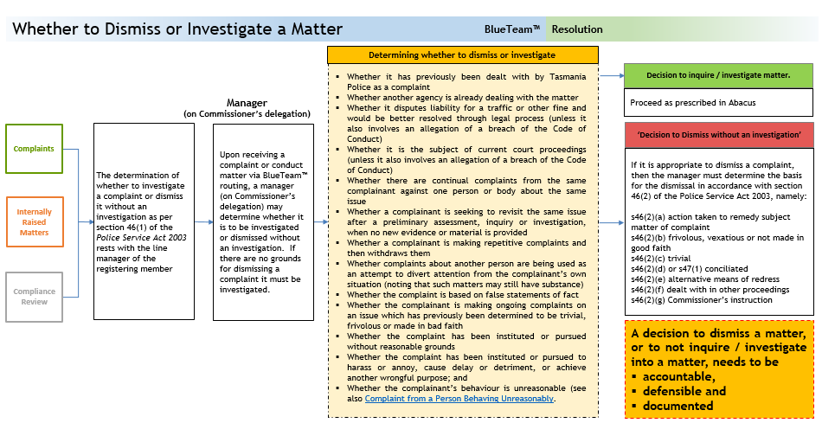
If a member dismisses a complaint, they must ensure that they maintain appropriate records in relation to their decision-making. A member delegated this responsibility is representing the Commissioner and their decision is seen to be the decision of the Commissioner – and cannot be overturned.
A decision not to investigate a matter, or to dismiss it, needs to be accountable, defensible and documented.
The section 46 decision and resolution decisions made by managers are summarised in the diagram below:
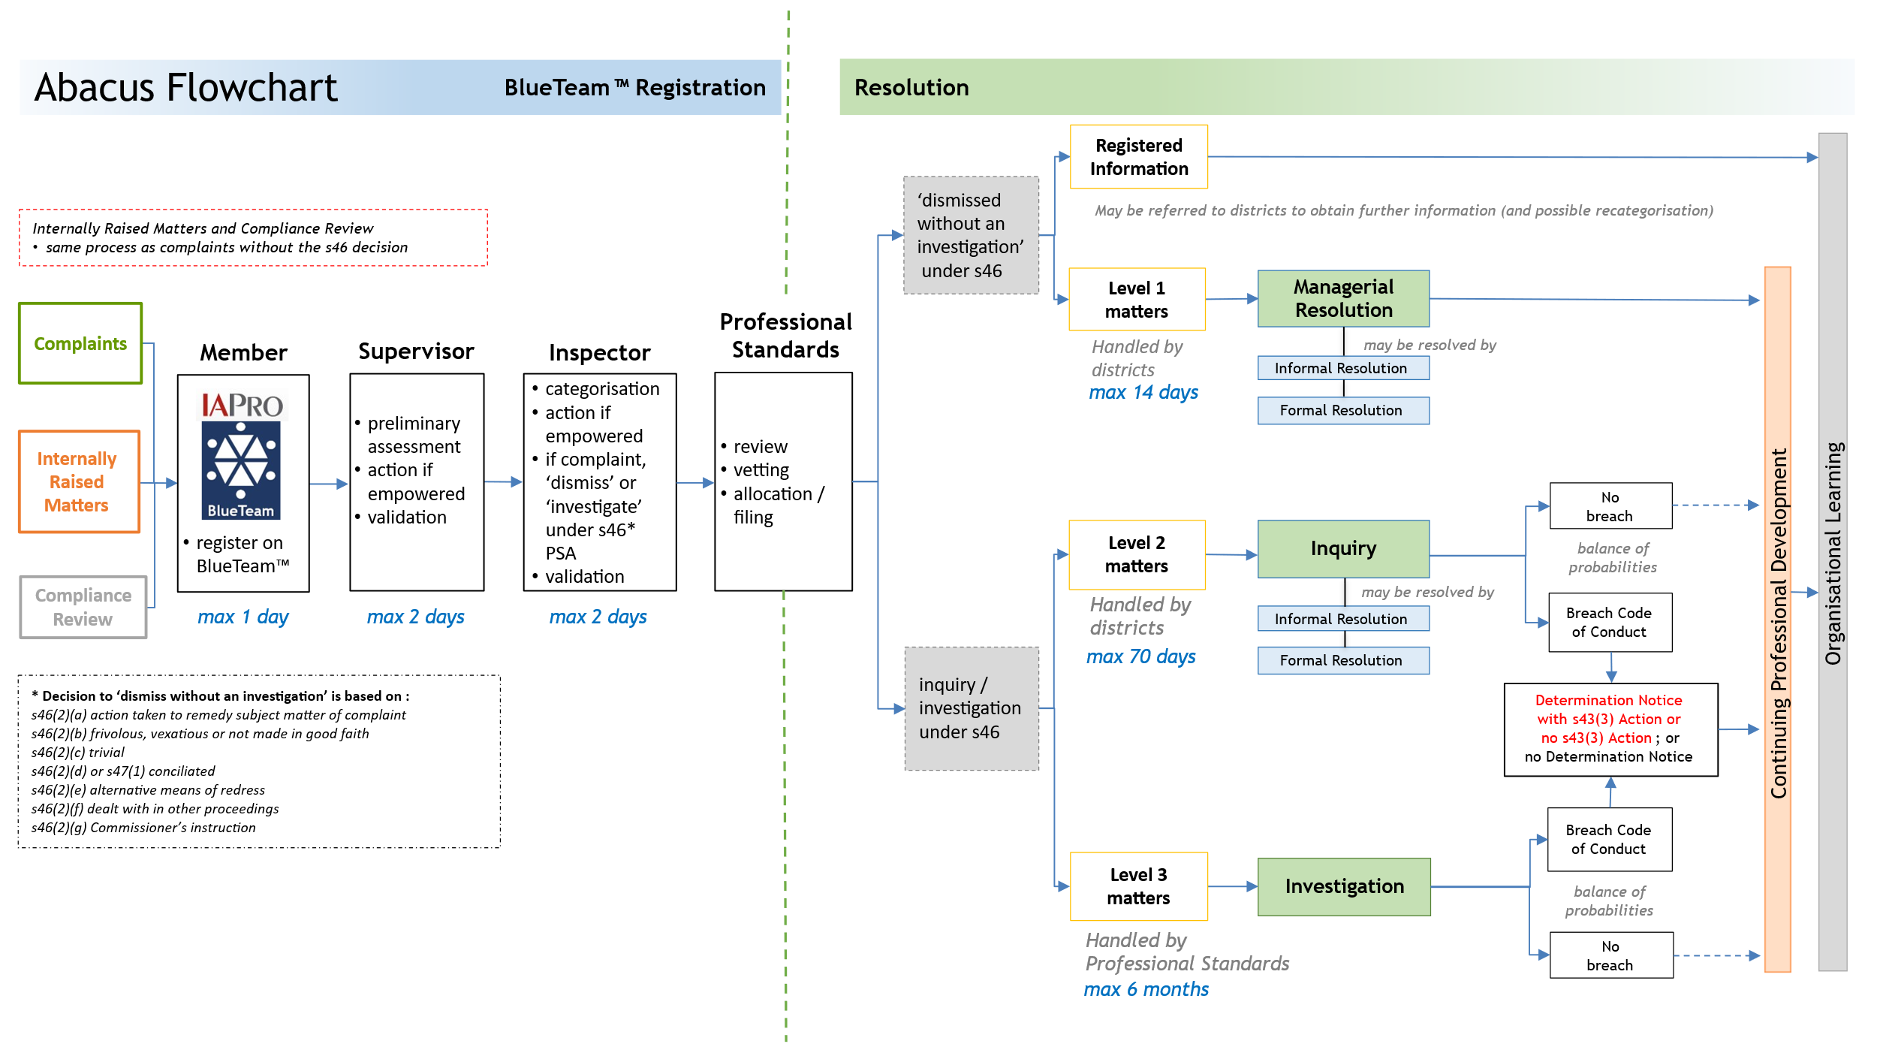

Categorising
Decisions and actions taken by managers must be documented on BlueTeam™.
If one complaint or internally raised matter contains several allegations which fit into more than one category, then the highest category is to be selected on the BlueTeam™ entry. If this was not done by the registering member, the supervisor might have identified it in the transmission note. If the manager believes the categorisation level is incorrect they should note this on the BlueTeam™ transmission ‘instructions’ to Professional Standards and request the matter be recategorised.
In deciding the seriousness of alleged conduct it is necessary to consider all of the relevant circumstances and minds might reasonably differ in that decision. An isolated incident of alleged conduct might not merit a description of serious, but repeated incidents when considered collectively might be considered as serious. Similarly, the seriousness of alleged conduct may depend on the nature of the role of the subject officer. If the manager is in any doubt as to the appropriate categorisation they should contact Professional Standards for advice. Factors which may bear upon the judgement as to whether particular alleged conduct is serious include:
  - whether the complaint is about a service, procedure or system and if so, it may be dealt with as Registered Information or managerially and no investigation is required;
  - the level of seniority or degree of responsibility of the member;
  - any apparent repetitive conduct and the extent and seriousness of that behaviour;
  - any apparent forethought leading to the alleged conduct, depending on the seriousness;
  - any apparent consciousness of wrongdoing on the part of the member;
  - whether the member reasonably should have appreciated that the conduct was wrong and/or what the member ought properly to have done;
  - the level of risk presented to others or to the State and/or the harm or potential harm associated with the alleged conduct;
  - the degree to which the member was acting in concert with others, and the nature of their complicity or involvement;
  - the benefit/advantage or potential benefit/advantage derived from the alleged conduct by the member or by another person;
  - how the conduct of the member might reasonably be viewed by the community and/or the organisation;
  - the content and demonstrable seriousness of any breach of applicable policies including the Code of Conduct;
  - whether the alleged conduct involves a minor breach or complaint and is not seen to be part of a pattern of conduct that would lead to significant disciplinary action - if so, it may prima facie be classified as a level 1 matter;
  - whether the matter involves discrimination, particularly of a racial or ethnic nature (racial and ethnic aspects are often broader than the formal allegations) and, if so, the matter may prima facie be classified as a level 2.
The following may prima facie be classified as level 3 matters:
  - where the alleged conduct involves a serious offence or crime which carries a significant penalty, i.e. would the matter warrant termination of appointment and/or amount to a serious offence or crime;
  - where the alleged conduct is likely to merit serious disciplinary or other serious internal consequences;
  - where the complainant has suffered a significant injury*; or
  - where the matter alleges corruption or the commission of a serious offence or crime.
*Where significant injury is sustained and there is no complaint, e.g. person falls by themselves; or a police shooting in accordance with guidelines, then it is to be categorised as Compliance Review.
This list is not exhaustive - it is provided as a guide to the types of consideration that may bear upon the categorisation. The Professional Standards vetting process will resolve any categorisation issues.
Where a matter has been categorised on the basis of repeated behaviour, managers are to record this on BlueTeam™. If managers are unaware if the member has been the subject of similar allegations previously, they should categorise the matter on face value and record a request on the BlueTeam™ routing for Professional Standards to check the subject officer on IAPro™ for matters involving similar alleged behaviour (Professional Standards may then recategorise it if appropriate).

Deciding Nature of Inquiry / Investigation: Code of Conduct or Criminal?
Managers are to decide whether the matter is to be dealt with solely as a Code of Conduct matter, or as an offence, serious offence or crime, or both. This is to be determined on a case-by-case basis and may necessitate the seeking of advice from Professional Standards. If legal advice is required it is to be facilitated by Professional Standards unless otherwise approved by the Deputy Commissioner.
The manager is to record their decision, including the rationale, on BlueTeam™ for the information of the inquirer / investigator:
SECTION 46(1) DECISION | METHOD OF RESOLUTION
‘dismissed without an investigation’ | managerial resolution (level 1); or
inquiry | only as a potential breach of the Code of Conduct (level 2); or
inquiry | as a potential offence (level 2); or
inquiry | both as a potential offence and a potential breach of the Code of Conduct (level 2).
investigation | as a potential serious offence or crime (level 3); or
investigation | both as a potential serious offence or crime and a potential breach of the Code of Conduct (level 3).
Members who make a voluntary disclosure must be given due credit for doing so.

Routing to Professional Standards for Vetting and Release
Once a BlueTeam™ matter is validated, the manager is to route it to Professional Standards. Professional Standards then vet it for appropriate categorisation. It is anticipated that managers will properly categorise a matter and that recategorisation by Professional Standards will rarely need to happen.

Acknowledging Complaints
Once a decision is made to investigate a complaint, or dismiss it without investigation, the manager is responsible for sending an acknowledgement letter to the complainant.
If a complaint is accepted for investigation the complainant will receive an acknowledgement letter (refer template letter) that restates the behaviour they have complained about. This ensures Tasmania Police and the complainant are agreed on the specific behaviours that are subject to complaint.
For complaints that are dismissed without investigation, the legislative basis for the dismissal must be provided in the acknowledgement letter.

Professional Standards’ Responsibilities

Vetting
Vetting is a simple administrative process that is essential for maintaining consistency across the organisation. Professional Standards will check subject officers on IAPro™ for matters involving similar alleged behaviour and may recategorise a matter if appropriate. For example, if a member is alleged to have used abusive language to members of the public on several separate occasions then a matter that on its own would have been a level 1, will instead be a level 2.
If Professional Standards is of a view that a matter has been incorrectly categorised, it will be discussed with the relevant District Commander and a categorisation decision will be made through consultation between the two commanders.
Once categorisation is confirmed the matter is released into the IAPro™ system, at which point a reference number is automatically applied.
Professional Standards will conduct audits of matters that have not been released from BlueTeam™ on a random basis. This will be focussed on ensuring the timeframes for registration are met.

Allocating
Following the registration, categorisation, validation and vetting processes matters will be allocated as follows:
  - Pursuit 1 matters will be closed.
  - Registered Information matters may be filed during the vetting process or may be sent to the member’s district to seek clarity or further information.
  - Complaint 1, Diversity and Inclusion and IRM1 are allocated to the member’s district for managerial resolution. DAI matters may be handled by the Diversity and Inclusion Coordinator.
  - Level 2 matters are typically allocated to the member’s district for proportionate inquiries (but in some circumstances may be allocated to Professional Standards).
  - Level 3 matters are allocated to Professional Standards for investigation (unless otherwise directed by the Deputy Commissioner).

Interim Administrative Measures
In some matters there may be a requirement to implement an administrative measure while the inquiry or investigation is underway for safety, risk management, legislative and other reasons. These measures do not constitute section 43(3) Actions and are not considered to be an outcome of the matter and do not form part of a member’s conduct history. They are practical measures taken in the interests of all parties prior to resolution of the matter.

‘Non-Operational’ Status and Secondments
Interim administrative measures include a member being seconded to another position or area; or their duties altered to a ‘non-operational’ role. ‘Non-operational’ refers to members who are working in roles that are office-based or station-based and have no requirement to wear accoutrements as their role does not involve physical interactions with members of the public in a typical frontline policing sense. Unlike standing down and suspension, the term ‘non-operational’ does not have any application to the Police Service Act 2003. Decisions of this nature will require the approval of a commander or the Deputy Commissioner.
Examples
  - A member who receives a Police Family Violence Order is required to change to non-operational duties due to the firearm-related condition on the order.
  - A member subject to a Diversity and Inclusion complaint is seconded to another area to facilitate resolution of the matter.

Standing Down
Under Section 38 of the Police Service Act 2003 the Commissioner may stand a member down:
(1) The Commissioner may stand down a police officer from duty for any reason and for any period not exceeding 7 days the Commissioner considers appropriate.
(2) The Commissioner, by notice served on the police officer, must notify the police officer of the stand-down.
(3) A stand-down takes effect on service of the notice.
(4) The Commissioner may revoke a stand-down.
Section 39 states that a member who is stood down from duty is to be paid their usual remuneration and allowances; and are not entitled to exercise any power, or perform any of their duties during the period of being stood down; and are subject to any direction of the Commissioner.
If a subject officer is stood down, the period cannot exceed seven days. The subject officer would return to duty, unless suspended. If a member is served with a stand-down notice at 4pm on 1 July, the seven days expires 6 days later at midnight on 7 July.
The service of a suspension notice might lead to an overlap with a stand-down notice. Whilst the Commissioner may determine to suspend someone on, for example, day 3 or day 4 of a stand-down, it does not take effect until served.

Suspension
Under Section 40 of the Police Service Act 2003 the Commissioner may suspend a member:
(1) After a police officer has been stood down under section 38, the Commissioner may suspend the police officer from duty for any reason and for any period the Commissioner considers appropriate.
(2) The Commissioner, by notice served on the police officer, must notify the police officer of the suspension.
(3) A suspension takes effect on service of the notice.
(4) The Commissioner may revoke a suspension.
Section 41 states that a member may be suspended with or without their usual remuneration, allowances (or both) and are not entitled to exercise any power, or perform any of their duties during the period of suspension; and are subject to any direction of the Commissioner.

MEMBERS’ OBLIGATIONS, RIGHTS AND WELLBEING
8.1 Confidentiality
  - Member’s obligations
8.3 Obligations for members subject to other legal proceedings
8.4 Police as Complainants or Informants
8.5 Finalisation of Code of Conduct or Criminal/Summary matters where members are under medical treatment
8.6 Subject officers’ Rights and Obligations
8.7 Witness officers’ Rights and Obligations
8.8 Members’ rights and obligations in complaints investigated by other agencies
8.9 Members accessing own IAPROTM Holdings
8.10 Wellbeing Protocol
8.11 Family Violence Leave
8.12 Workers’ Compensation matters
8.13 Wellbeing Support – Client Confidentiality and Services
This chapter relates to all levels of matters.

Confidentiality
All members involved in the management and resolution of Abacus matters must maintain appropriate confidentiality. The Need to Know Principle applies; that is, information must only be available to those members or state service employees (SSEs) who need to access that information to ensure that appropriate support services are in place. The disclosure of information must be no wider than that. It is the responsibility of all members and SSEs to adhere to this principle. Any breach of confidentiality will be treated seriously.

Members’ Obligations
Under Part 13 of the TPM members must comply with the following Orders.
ORDER
A member who becomes aware of another member
- committing a serious offence or crime; or
- committing a breach of the Code of Conduct
must report the matter immediately to a senior officer. The senior officer is to direct the informing member to register the matter on BlueTeam™; or register it themselves. Registration is to occur prior to the conclusion of duty that shift, unless the matter is able to be dealt with as provided for in Abacus 4.1.1 Discretionary Action for minor internally raised matters or victimisation/discrimination of police complainants.

ORDER
A member who is advised by any person that they wish to make a complaint against a police officer, or Tasmania Police, is required to obtain details (person reporting, circumstances, etc.) and must register the matter on IAPro™ or BlueTeam™ as a Complaint 1, Complaint 2 or Complaint 3 (whichever is appropriate to the circumstances).
A statement of complaint must be obtained for all Complaint 2 and Complaint 3 matters. A statement of complaint is not required for Complaint 1 matters.
Certain members are exempted from this Order in particular circumstances. Those circumstances are detailed in Abacus 5.3 Receiving Complaints.

ORDER
Any member who is
- proceeded against for any offence (other than a parking offence) or a serious offence or crime (including whilst interstate or overseas); or
- proceeded against civilly; or
- subject to bankruptcy proceedings
must immediately inform a senior officer and register the matter on BlueTeam™ as a Registered Information report. The Registered Information report may be re-categorised as appropriate.
A member appearing in any court as a defendant or accused person is not to wear any item of police uniform.

Obligations for Members Subject to Other Legal Proceedings
An inter-department committee advises the government on legal actions against public officers, including members, for acts or omissions arising in the course of the performance of their duties.
If a writ or summons is served on a member alleging an act or omission arising in the course of the performance of the member's duties, that member is to, immediately submit a full report, in writing, of the circumstances through official channels to the Assistant Commissioner, Specialist Support. The report is to include advice on what action, if any the member is considering taking to defend the action. The member should seek early advice in relation to representation and the legal expenses attached to that representation. Members should also be aware of the Legal Assistance provisions.

Police as Complainants or Informants

Internal Complaints or Internally Raised Matters
When members feel confident to report conduct within the organisation it indicates a robust and accountable system. Members should feel empowered to report any member in accordance with our values and obligations, including those in Part 13 of the TPM. Members are reminded of the importance of confidentiality in all Abacus matters.
Any victimisation of police complainants will not be tolerated. Such behaviour constitutes a breach of section 42(12) of the Police Service Act 2003. Any member becoming aware of such conduct must either register it on BlueTeam™ as a new matter, or report it to a senior officer. Failure to comply with this will undermine the entire system. In this instance, the reporting member can choose to make the report anonymously. This can be done in a variety of ways – irrespective, the member will need to keep a record of when, where and how the matter was reported. This is essential should the member be required to demonstrate that they have complied with the TPM obligation to report a member breaching the Code of Conduct.
Alternatively members may make a public interest disclosure or make a report to another agency - see Alternative Complaint Agencies. If members make a complaint directly to an external agency they should enquire as to how it will be handled, as it may be referred back to Tasmania Police for investigation and resolution.

Finalisation of Code of Conduct or Criminal/Summary matters where members are under medical treatment
Tasmania Police is mindful that the timely finalisation of a Code of Conduct or, criminal or summary allegations, is normally in the best interests of the member, other officers involved and the community. The intent of Abacus remains to finalise such matters promptly and in a manner that balances the rights and needs of the complainant with those of the alleged perpetrator. This includes relevant wellbeing considerations.

Criminal and Summary matters
Tasmania Police’s policy position is that alleged breaches of the law by police officers should be treated in the same manner as breaches by members of the public. Tasmania Police has an obligation to finalise criminal or summary matters due to the statute of limitations and other prescribed duties. In addition, case law decisions and advice received from the Office of the Director of Public Prosecutions requires Tasmania Police to give priority to the finalisation of criminal or summary matters over Police Service Act 2003 Code of Conduct matters, though concurrent investigations may still occur.
Fundamentally, police officers should not be treated differently or afforded any special considerations, by virtue of their position, that would not normally be extended to members of the public in similar circumstances. This is particularly important in terms of protecting the safety and rights of victims. If a member, against whom a breach of the law is alleged, is known to be under medical treatment for a mental health related matter, regardless of whether they are at work or absent from the workplace for any reason including on mental health related sick leave or in a mental health related medical facility, advice from the Director, Wellbeing Support will be sought prior to approaching the member for interview or service of documentation. This is for the purpose of planning the approach, not unnecessarily delaying it.

Disciplinary matters
If a member, suspected to have committed a breach of the Code of Conduct, is known to be under medical treatment, regardless of whether they are at work or absent from the workplace for any reason including on sick leave or in a medical facility, advice from the Director, Wellbeing Support can be sought prior to approaching the member for interview or service of documentation. Any prompt and reasonable advice received will be considered in determining the most appropriate way in which to progress the inquiry or investigation. All medical advice correspondence, specific to Code of Conduct matters, must occur via the Director, Wellbeing Support.
Where a member is absent from the workplace due to worker’s compensation, sick leave, stand-down or suspension and / or has been diagnosed with a medical condition and the member is seeking to rely on that medical diagnosis that they are not fit to respond to a direction to submit a report, or participate in an interview, they are to provide a medical certificate to that effect from their clinician/s. Members will be afforded a reasonable opportunity to obtain medical advice, within the required time period for a response to be submitted, to support their position. Consideration is to be given to progressing the matter in an alternative way so that it may be finalised, either in full or in part, having regard the requirement for procedural fairness.
If a member is seeking to rely on a medical diagnosis that they are not fit to submit a report or participate in an interview, the Commissioner may then determine, on a case-by-case basis, if the member is to undergo medical examination by a medical practitioner nominated by the Commissioner pursuant to section 29(3) of the Police Service Act 2003.
If it is determined that a member is not fit to submit a report or participate in an interview, the matter can still be finalised, subject to the procedural fairness provisions being satisfied. For example, alternatives are explored for a member to have a right of reply, that is received in a timely and alternative format which is reasonably able to be considered, before a decision is made that may adversely affect them.
If it is provisionally assessed that the balance of probabilities is satisfied, a Provisional Report can be provided to the member, notwithstanding that they have not provided a report or been interviewed. The Provisional Report is to invite (not direct) the member to put their case forward. If no response is received within 15 days (or other period if an extension is approved), the matter can be finalised in the terms of the Provisional Report. If a member is seeking to rely on a medical diagnosis that they are not fit to respond to the Provisional Report, they are to provide a medical report to that effect from their clinician/s. That report must include lawfully allowable details of the diagnosis and the expected time period that they will be unable to respond. If the member has previously provided a medical report to the effect that they could not be interviewed / contacted, the Provisional Report should only be provided at the expiration of the period specified in that medical report. The Commissioner will then determine, on a case-by-case basis, if the member is to undergo medical examination by a medical practitioner nominated by the Commissioner pursuant to section 29(3) of the Police Service Act 2003, or if the matter is to be finalised in the terms of the Provisional Report on the basis that:
- the member has had an opportunity to put their case forward, including any opinion provided by their clinician/s
- there is no bias in the decision-maker
- there has been inquiry into credible and relevant matters
- there is evidence to support a decision based on the balance of probabilities
- there should be no unnecessary delay, including the need to finalise the matter in the interests of any complainants and other officers.

Subject Officers’ Rights and Obligations
Members who are subject officers are entitled to rights that are available regardless of whether the matter involves allegations of an offence, serious offence or crime, or a breach of the Code of Conduct. Subject officers will be treated in accordance with the Values of Tasmania Police.
If a subject officer believes that an inquirer / investigator or authoriser has a conflict of interest that should preclude them from involvement in the matter, they must provide written advice to their manager detailing the conflict. The inquirer / investigator or authoriser will then consider the matter and, if it is believed that an insurmountable conflict exists, refer the matter to the relevant Commander or the Deputy Commissioner for determination.
Recent High Court of Australia cases have questioned the legal authority to remove the privilege of self-incrimination, the right to silence and the use of evidence of compulsion. Against this background a set of interview protocols has been established and is set out below.

Inquiries / Investigations of matters solely as potential breaches of the Code of Conduct
Inquiries / Investigations of matters solely as potential breaches of the Code of Conduct may involve:
- interview of subject officers, both voluntary and – if required - directed
- a direction to submit a written report
- other inquiries as required.

Inquiries / Investigations of matters as potential offence, serious offence or crime
Inquiries / Investigations of a matter as a potential offence, serious offence or crime may involve:
- interview of witness officers, both voluntary and – if required – directed
- assessment of evidence
- interview of subject officers under caution and not directed
- where the subject officer elects not to answer questions under caution there are two options
  - cessation of the caution interview and an assessment of the available evidence to determine whether or not there are grounds to initiate a prosecution. This is likely to involve the seeking of legal advice, primarily from the Office of the Director of Public Prosecutions (DPP)
  - cessation of the caution interview and the commencement of a directed interview if previously approved by the Deputy Commissioner or the Professional Standards Commander
- where legal advice has been obtained and / or if approved by the Deputy Commissioner or the Professional Standards Commander a directed interview may occur. If the matter is to be prosecuted a determination will be made by the Deputy Commissioner on whether or not to progress a directed interview for any Code of Conduct matter (noting that a directed interview is not able to be provided to a prosecuting authority)
- other inquiries as required.
If at any point in an investigation it is decided that the matter is to be investigated purely as a Code of Conduct matter, the member is to be informed of this in writing or verbally in the audio interview (meaning, although a prima facie case for prosecution might exist, a decision has been made to deal with it solely as a Code of Conduct matter).

Due Credit
Due credit is recognition of a subject officer’s own actions towards resolving a matter (such as making an apology or a voluntary disclosure). Such recognition may be shown through leniency in the final outcome.

Subject Officers’ Rights when asked for a Written Report
Subject officers who are asked to submit a written report are instructed to do so in writing by a senior officer, a member of Professional Standards or a member delegated by the Commissioner. They are given 15 calendar days (or a period as agreed) to respond in writing. The response is to be provided directly to the inquirer / investigator (without following the usual chain of command) although the subject officer is entitled to provide a copy to their supervisor or manager if they choose. The written report is not to be placed on HP Content Manager. The written report can be sent via e-mail. Direction to provide a written report will only apply when there is no criminal or offence allegation.
When providing a written report members should submit a subject report.
Subject officers are entitled to:
- obtain advice from an independent person
- obtain advice from a representative of the Police Association of Tasmania
- obtain advice from a legal practitioner (normally at a member’s own expense)
- maintain a copy of all correspondence provided to them
- be informed of the nature of the complaint or conduct matter
- be informed if the matter involves a conduct allegation only, or if it is associated with, or as a result of the outcome of, a criminal or offence investigation.
- be permitted sufficient time within work hours to complete the report (unless stood down or suspended)
- object (in writing) to an inquirer/investigator or authoriser being involved in the matter if they believe the inquirer/investigator or authoriser has a conflict of interest that should preclude their involvement in the matter. Reasons should be outlined in the written objection. Such objection must be received by the inquirer within the original 15 day period and an extension as outlined below must be sought at the same time.
The above rights are available to subject officers at all times during the process and are to be stated in the written direction to provide the report. If subject officers wish to seek an extension of time beyond 15 calendar days they are to submit a written request (email will suffice) to the inquirer / investigator.
Subject officers should be aware that additional information may be required of them. This might result in a request for an additional written report or participation in an interview.
The Police Association of Tasmania operates a legal assistance hotline: 1800 777 920 (after business hours) and 03 6278 1900 (business hours).

Subject Officers’ Rights at Interview
Subject officers participating in an interview are entitled to:
- have an independent person, such as a representative of the Police Association of Tasmania, present during any interview
- Where a representative of the Police Association of Tasmania is not present at the interview, obtain advice from such a representative at any stage of the interview.
- obtain advice from a legal practitioner, including at any stage of an interview (normally at a member’s own expense)
- record the interview themselves, upon notifying the interviewing officers
- have breaks as needed for personal necessities
- be informed of the nature of the allegation
- be informed whether the matter involves criminal allegations (which by extension include conduct allegations) or conduct allegations only
- be cautioned for criminal matters
- be interviewed at a reasonable hour (unless unique circumstances apply and preclude this).
The above rights are available to subject officers at all times. Items 1 to 8 must be read out to subject officers at the commencement of the interview. If subject officers wish to exercise any of these rights they should advise the interviewing officers. The interviewing officers will suspend the interview to enable the subject officer to have an opportunity to seek or be provided with those rights.
The independent person mentioned in item 1 may be present in the room throughout the interview but is not allowed to respond to any questions put to the interviewee. If an independent person wishes to speak they should ask for the interview to be suspended so that they may speak to the subject officer.
An independent person is to be aware that their presence is by invitation and the invitation can be withdrawn at any time. If an independent person’s invitation to be present is withdrawn, the subject officer is to be advised that they can have another independent person present. An independent person should be aware that they may be called as a witness to any proceedings.
The Police Association of Tasmania operates a legal assistance hotline: 1800 777 920 (after business hours) and 03 6278 1900 (business hours).

Members’ Rights – Personal Devices
For a matter relating to a crime, offence, or Code of Conduct matter, a personal device is only to be seized pursuant to a search warrant, unless it is provided by consent or otherwise enabled by legislation. In some cases, a screen shot, or other download, may be requested by the inquirer/investigator to alleviate the need to seize a communication device. A warrant should also specify providing PIN numbers and passwords where necessary.
At the time of taking possession of the device reasonable opportunity is to be provided for the member, or an investigating officer, to extract key contact telephone number(s) from the device – cognisant that a risk of evidence being deleted or altered may render this unacceptable. In cases where a law specifically provides for communications or contact details to be withheld, members are to be advised they will not be able to retrieve the contact numbers.
Where possession is taken of a member’s device, the member will be provided with a mobile phone by Tasmania Police to make and/or receive calls. In most instances this will be until the member’s phone is returned to them. The device will have the ‘hotline’ phone numbers for DPFEM Wellbeing Support Services and the ‘Police Association of Tasmania assistance line’ pre-installed in the contact directory. The telephone number is to be communicated to Wellbeing Support and the Police Association of Tasmania. Professional Standards will arrange mobile phones, including SIM cards, to be available state-wide for this purpose. Where possession is taken of a member’s device, the member will be provided Mobile Telephone Seizure from Sworn Members Policy (A23/224114)

Legal Assistance

Members of the Police Association of Tasmania
Members of the Police Association of Tasmania may be entitled to apply to the Legal Assistance Scheme for financial assistance for legal advice and / or legal representation in cases where the matter giving rise to the advice or representation arose out of the member’s duties as a police officer or where action is taken or proposed under the Police Service Act 2003.
Factors taken into consideration by the Police Association of Tasmania when considering applications to the Legal Assistance Scheme include whether or not the member’s behaviour is consistent with ethical policing practices and / or done in good faith; and / or the assistance is in the interests of the general membership. A Legal Committee made up of Executive Members considers all applications. If an application is unsuccessful, an appeal can be made to the full Executive.
Members must contact the Police Association of Tasmania prior to incurring legal expenses if it is intended to submit a claim for those legal expenses.
The Police Association of Tasmania legal assistance hotline is 1800 777 920 (after business hours) and 03 6278 1900 (business hours).

Legal Assistance for Integrity Commission Matters
Legal assistance can be provided to members who receive certain types of ‘coercive’ notices from the Integrity Commission. The legal assistance may be provided by the Principal Legal Officer. If the Principal Legal Officer is unable to assist, financial assistance up to a value of $3,000 is available on request to the Commissioner. Members are advised to inform the Commissioner of their intention to seek financial assistance prior to incurring legal expenses if they intended to submit a claim for those legal expenses.
While ‘coercive’ notices specify that members cannot divulge their existence to anyone, legal advice is that members who intend to seek legal assistance have a ‘reasonable excuse’ to inform the Commissioner.

Legal Assistance for Equal Opportunity Tasmania Matters
If a member is named as a respondent in an Equal Opportunity Tasmania matter, Tasmania Police is also named as a respondent. The Principal Legal Officer represents Tasmania Police and, except where there is a conflict of interest, the member.
If the Principal Legal Officer is not able to represent the member, the member should consider requesting legal assistance from the Commissioner. Legal assistance, up to a value of $3,000, may be available. Members are advised to inform the Commissioner of their intention to seek financial assistance prior to incurring legal expenses if they intended to submit a claim for those legal expenses.

Section 46(3) Direction including ‘Directed Interviews’
Section 46(3) of the Police Service Act 2003 states:
The Commissioner may -
- direct any police officer to -
- assist in the investigation of a complaint; and
- provide any information or document or answer any question for the purpose of the investigation; and
- conduct the investigation in any manner the Commissioner considers appropriate.
This section applies to what is commonly referred to as directed interviews.
Subject officers should be aware that if they elect not to answer questions in the directed interview a determination will be made based on the evidence that is available. That determination will be made on the balance of probabilities.
Inquirers / investigators conducting interviews must give an undertaking to subject officers that they will not provide any directed interview, or any material obtained as a consequence of a directed interview of a subject officer, to the DPP or any other prosecuting authority, in matters that relate to the prosecution of the subject officer. The only exception would be if the subject officer provides written consent for that interview to be tendered in evidence. This requirement is to form part of the interview preamble and is contained within the template.
If a member of the public is being prosecuted and the circumstances of the charge involve a complaint against police, any statements obtained during the inquiry / investigation of the complaint are disclosable to the defence. The Principal Legal Officer has advised that this includes interviews / statements in which subject officers have been directed to answer questions. Those interviews continue to not be available to any prosecution of the subject officer.
Subject officers are entitled to access material in relation to any inquiry / investigation. The process is described under Right to Information.

Submission relating to Provisional Report
In accordance with the principles of procedural fairness subject officers are entitled to make a written submission in response to a ‘notice’ they receive from the Commissioner (or their delegate) in relation to intended action under section 43(3) of the Police Service Act 2003. Under Abacus the timeframe is 15 days or other time period as agreed. Refer to Provisional Report for more details.
Under Abacus the ‘notice’ to the subject officer is in the format of the Provisional Report, however from time to time the notice may be in another format e.g. notice to ‘show cause’ relating to termination of appointment. The subject officer’s submission must be made within the period specified in the ‘notice’ and it is to be provided directly to the authoriser (e-mail would suffice).
Under Abacus subject officers are invited to make a submission in reference to action under section 43(3) (a),(b),(e),(f) and (g) relating to counselling, reprimand, reassignment, transfer and probation.
There is a legislated entitlement under s31A for subject officers to make a submission relating to intended actions under s30 or s31 and the remainder of section 43(3) actions, namely section 43(3)(c),(d),(h),(i) and (j) relating to fines, reduced remuneration, demotion and termination of appointment. The Commissioner must notify the subject officer of the intention to take such action and the reasons for that intention under section 31A(1)(m) of the Act. The Commissioner must also, section 31A(1)(n) of the Act, provide the member with an opportunity to make a submission within the period specified in the notice (not less than 14 days) as to the reasons why the member believes the Commissioner should not so act. The written submission can include:
- agreement or disagreement with a provisional finding
- agreement or disagreement with a provisional determination
- identification of an area of inquiry / investigation that the subject officer believes should have been examined but was not
- mitigating factors that the subject officer requests the authoriser to take in to account
- any other matter the subject officer considers is relevant and pertinent to the making of a final decision.
If a subject officer seeks access to any documentation they should proceed as outlined in Right to Information.

Broader Consequences of Determination Notice

Application for a Course
Any Determination Notices issued will be kept in members’ HP Content Manager dossiers. Staff within People and Culture have access to HP Content Manager dossiers and are entitled to consider any Determination Notice as part of the member’s conduct history when assessing their application for a course and their suitability for the course.

Application for Transfer
Any Determination Notices issued will be contained in members’ HP Content Manager dossiers. Staff within People and Culture have access to HP Content Manager dossiers and are entitled to consider any Determination Notice as part of the member’s conduct history when assessing their application for transfer and their suitability for the position.
People and Culture are able to seek advice from Professional Standards on current Abacus matters only where the transfer relates to a position in which there is considered to be organisational risk.

Application for Promotion
Section 18(5) of the Police Service Act 2003 states:
In determining whether to promote or recommend the promotion of a police officer, the Commissioner may take into account the conduct of the police officer.
Any Determination Notices issued will be contained in members’ HP Content Manager HR dossier. Staff within People and Culture have access to HP Content Manager dossiers and are entitled to consider any Determination Notice as part of the member’s conduct history when assessing their application for promotion and their suitability for the rank.
People and Culture are able to seek advice from Professional Standards on current Abacus matters in relation to all applicants for promotion. Whilst People and Culture can be advised of current Abacus matters, weight given should be commensurate with the seriousness of allegations and weight of apparent evidence.

Medals
The Commissioner’s Medal may be awarded to members who have completed a period of 10 years continuous, diligent and ethical service and is earned through honest hard work, dedication to duty and professionalism. The National Police Service Medal may be awarded to members who have served a minimum 15 years with demonstrated commitment to ethical and diligent service.
If a subject officer receives a Determination Notice with resulting section 43(3) Action of reprimand or higher, the Determination Notice must include a limitation on wearing or being awarded the Commissioner’s Medal, clasp or National Police Service Medal for a finite period of time (such as 12 months). The period of time will be stated on the Determination Notice. The subject officer must have been advised of the proposed period of ineligibility in the Provisional Report. At the conclusion of that period the subject officer’s eligibility will be reinstated.
A Commander is able to impose a limitation on the subject officer wearing or being awarded the Commissioner’s Medal or National Police Service Medal for a period up to and including 12 months. An Assistant Commissioner or the Deputy Commissioner can impose a limitation on the subject officer wearing or being awarded the Commissioner’s Medal or National Police Service Medal for a period up to and including 5 years.
If a subject officer has not yet been awarded a medal, or is yet to be eligible, the authoriser is to give consideration to whether the eligibility is to be deferred when the subject officer becomes eligible to receive the medal. If a limitation of time is to be applied, the subject officer must be advised of this in the Provisional Report and in the Determination notice.
If a member has been found to have committed a serious offence or crime they may be deemed permanently ineligible to receive or wear the Commissioner’s Medal, clasp or National Police Service Medal. Any decision of this nature is to be made by the Commissioner or Deputy Commissioner.
Examples
- Officer X has served for 15 years and is the recipient of the Commissioner’s Medal for Diligent and Ethical Service, and has been reprimanded by the Deputy Commissioner and fined for an honesty and integrity breach of the Code of Conduct. The Deputy Commissioner, given the seriousness of the section 43(3) action taken (reprimand and fine), must impose a period of ineligibility to wear the Commissioner’s Medal. The Deputy Commissioner imposes a period of 12 months.
- Officer Y has served for five years and is due to be considered for the Commissioner’s Medal in five years. The circumstances of the matter are exactly the same as Officer X. The Deputy Commissioner must consider whether to defer Officer Y’s eligibility to be awarded the Commissioner’s Medal. The Deputy Commissioner defers Officer Y’s eligibility to be awarded the Commissioner’s Medal for a period of 12 months from the date they would have been eligible (e.g. their 10th anniversary).

Witness Officers’ Rights and Obligations
As a witness officer is not being investigated for an offence, serious offence or crime, they do not have the protection against self-incrimination (right to silence) that applies to subject officers.
Witness officers can be directed to answer questions under section 46(3) of the Police Service Act 2003 which states:
(3) The Commissioner may
(a) direct any police officer to
(i) assist in the investigation of a complaint; and
(ii) provide any information or document or answer any question for the purpose of the investigation
(b) conduct the investigation in any manner the Commissioner considers appropriate.
Witness officers should be aware that evidence they provide – whether under direction or otherwise – will be used as part of the inquiry/investigation process. It may also be provided to another party who is lawfully entitled to access it (e.g. the DPP or defence counsel).
During a directed interview, if a witness officer makes any admission in relation to their role as a principal offender in an offence, serious offence or crime, that interview is to cease and a caution interview commence.
Any material relevant to them obtained as a consequence of that directed interview, will not be provided to the DPP or any other prosecuting authority, in matters involving the prosecution of the witness officer. The only exception would be if the witness officer (who would now be considered to be a subject officer) provides written consent for that interview to be tendered in evidence.
A witness officer who makes any admissions, etc. (e.g. to a breach of the Code of Conduct, or the commission of an offence, serious offence or crime) is entitled, from the time of the disclosure to the same rights as a subject officer.
If a member of the public is being prosecuted and the circumstances of the charge involve a complaint against police, any statements obtained during the inquiry / investigation of the complaint are disclosable to the defence. The Principal Legal Officer has advised that this includes interviews / statements in which witness officers have been directed to answer questions. Those interviews continue to be unavailable in any prosecution of the witness officer.

Witness Officers’ Rights when asked for a Written Report
Witness officers who are asked to submit a written report are required to do so within 15 calendar days (or a period as agreed). The response is to be provided directly to the inquirer / investigator (without following the usual chain of command) although the witness officer is entitled to provide a copy to their supervisor or manager should they wish to do so. The written report is not to be placed on HP Content Manager. The written report can be sent via e-mail.
Witness officers are entitled to:
- obtain advice from an independent person
- obtain advice from a representative of the Police Association of Tasmania
- obtain advice from a legal practitioner (normally at a member’s own expense)
- maintain a copy of all correspondence provided to them
- be permitted sufficient time within work hours to complete the report (unless stood down or suspended)
The above rights are available to witness officers at all times during the process. If a witness officer wishes to seek an extension of time beyond 15 calendar days they are to submit a written request to the inquirer / investigator.
Witness officers should be aware that additional information may be required of them. This might result in a request for an additional written report or participation in an interview.
The Police Association of Tasmania operates a legal assistance hotline: 1800 777 920 (after business hours) and 03 6278 1900 (business hours).

Witness Officers’ Rights at Interview
Witness officers participating in an interview are entitled to:
- have an independent person present during any interview
- obtain advice from a representative of the Police Association of Tasmania, including at any stage of an interview
- obtain advice from a legal practitioner, including at any stage of an interview (normally at a member’s own expense)
- record the interview themselves, upon notifying the interviewing officers
- have breaks as needed for personal necessities
- be interviewed at a reasonable hour (unless unique circumstances apply and preclude this)
The above rights are available to witness officers at all times. Items 1 to 5 must be read out to witness officers at the commencement of the interview. The interviewing officers will suspend the interview to enable the witness officer to have an opportunity to seek or be provided with those rights.
The independent person mentioned in item 1 may be present in the room throughout the interview but is not allowed to respond to any questions put to the interviewee. If an independent person wishes to speak they should ask for the interview to be suspended so that they may speak to the witness officer.
An independent person is to be aware that their presence is by invitation and the invitation can be withdrawn at any time. If an independent person’s invitation to be present is withdrawn, the witness officer is to be advised that they can have another independent person present. An independent person should be aware that they may be called as a witness to any proceedings. A form containing this information is available from Professional Standards if required.
The Police Association of Tasmania operates a legal assistance hotline: 1800 777 920 (after business hours) and 03 6278 1900 (business hours).

Members’ Rights and Obligations in Complaints Investigated by Other Agencies
Tasmania Police will not inquire into or investigate a complaint that is being dealt with by another agency unless approved by the Deputy Commissioner. If Tasmania Police has already inquired into or investigated the matter, any subject officer directed interview will not be provided to an external agency that has a prosecutorial role if the prosecution is of that subject officer. Subject officer directed interviews will only be provided to an external agency in accordance with legislation.

Equal Opportunity Tasmania / Anti-Discrimination Tribunal
Equal Opportunity Tasmania is responsible for investigation of complaints about conduct prohibited by the Tasmanian Anti-Discrimination Act 1998. The complaint is assessed against the Act and the Anti-Discrimination Commissioner determines whether the complaint can be dealt with under the Act or is outside the scope of the Act. If outside the scope of the Act, the complaint will be rejected. If within the scope of the Act, the complaint is investigated and pending the outcome of the investigation, the complaint will either be dismissed, resolved through conciliation or referred to the Anti-Discrimination Tribunal (ADT) for an inquiry. A party may be permitted by the ADT to be represented by a lawyer or other authorised person or accompanied by another person: a written or verbal application for such permission must be made to the ADT at the earliest opportunity.
Members may be eligible for legal assistance in relation to Equal Opportunity Tasmania matters. (Refer 6.6.7.3)

Anti-Discrimination Tribunal
If the matter is referred to the Tribunal, a Directions Conference will be held (in private). A Tribunal Member will make directions to the parties in relation to the preparation of information for the Hearing including lists of documents they want to present and witnesses they intend to call. The Tribunal may, by notice, require any person (not just a party) to attend a directions conference and require that person to provide and produce specific information and documents to the conference. Many parties are not legally represented at Directions Conferences. Proceedings are relatively informal and have been designed to be straightforward.
A Referral Report will be prepared by the Anti-Discrimination Commissioner, which will identify documents gathered during the investigation and witnesses the Commissioner considers should be called at the inquiry. However, the parties are not bound by this Report, and are free to decide which witnesses to call and which documents to present, including any not listed in the Report. Any documents listed in the Report are available for the parties to inspect and copy, unless an objection has been made by a party on the grounds of confidentiality, in which case the Tribunal will determine if the document should be made available.
The Tribunal may refer a complaint to conciliation, facilitated by an experienced conciliator appointed by the Tribunal, at any stage. The parties and their legal advisor or advocate are required to attend. Conciliation is held in private. If conciliation is not successful then the matter is resolved by inquiry. Nothing said during conciliation will be disclosed if the matter proceeds to inquiry.
The inquiry is held in public unless the Tribunal otherwise directs. The ADT may order any oral or documentary evidence not be published or that the identity of any person not be disclosed. Any person seeking such an order may request this at any stage verbally or in writing. At the inquiry Hearing, each party is responsible for the presentation of their case. The party who brings the complaint has the burden of proving the complaint. However, the conduct of an inquiry is inquisitorial, and the ADT is not restricted to the evidence or material relied upon by the parties. Although obliged to comply with rules of natural justice, the ADT is not bound by the laws of evidence and will ensure that all material that may assist its consideration of a matter is provided to it.
If the Tribunal finds that the complaint is substantiated, it may order the respondent: not to repeat or continue the prohibited conduct; to redress any loss or injury suffered by the complainant as a result of the prohibited conduct; to re-employ the complainant; to pay, within a specified period, an amount the Tribunal thinks is appropriate compensation; to pay a fine not exceeding 20 penalty units; to vary or declare void any contract or agreement. It may also order that it is inappropriate for further action to be taken, or make any other order it thinks is appropriate. Determinations of the ADT may be appealed to the Supreme Court.

Integrity Commission
Integrity Commission investigations can be very wide-ranging and gathering evidence in a complex investigation can take a significant period of time. The decision to start an investigation does not mean that there has been any wrongdoing. The Integrity Commission's role is to investigate and establish the facts. The Integrity Commission does not make findings of misconduct.
The Integrity Commission's powers include entry, search and seizure, use of surveillance devices; and directions to attend, answer questions and produce information.
Often witnesses who are not suspected of any wrongdoing are required to give evidence for no other reason than to assist an inquiry. In that instance, members will not necessarily be told the detail of the matter prior to giving evidence. Evidence is generally given in private, although the Integrity Commission does have the ability to convene public Integrity Tribunals. A person required or directed to give evidence or answer questions as part of an investigation may choose to be represented by a legal practitioner or other independent person. A brochure to assist witnesses understand the process involved in giving evidence is available from the Integrity Commission website.

Integrity Commission Notices
The Integrity Commission may serve notices upon members to compulsorily give evidence or produce documents. If this happens a member will usually first be contacted by the investigator by phone. The investigator will arrange to meet with the member privately to serve the notice and to explain the process to be followed. A notice is usually subject to confidentiality provisions (which will be explained in the notice) and members will not be able to discuss the notice or its contents with anyone unless they have a ‘reasonable excuse’ to do so (refer section 98 of the Integrity Commission Act 2009).
Members should take care to ensure they do not do or say anything that might disclose the existence of the notice to any person. However, members may disclose the existence of the notice if it is necessary for obtaining legal advice or in order to ensure compliance with the notice. For example, members may need to brief a colleague in order to retrieve or gain access to a relevant document; or request permission from a supervisor to leave the workplace to give evidence. If it is necessary to inform another person, section 98(2)(b) of the Integrity Commission Act 2009 stipulates that members should also inform that person that the notice is a confidential document and that it is an offence for them to disclose the existence of the notice to another person unless there is a reasonable excuse.
An Integrity Commission investigator may contact a member and explain the level of contact the member is likely to have with the Integrity Commission before and after the completion of the investigation. If a member has been part of an investigation and received a notice containing confidentiality provisions, the member will be notified when the matter has been finalised and that the confidentiality provisions attached to the notice have been removed. If you have any doubt about whether or not it is reasonable in a particular case to disclose the existence of the Notice, you should seek to clarify the matter with the nominated contact officer.
A Commission investigator must comply with the rules of procedural fairness. In practice this includes providing an opportunity to a person, about whom an adverse finding or comment might be made, to provide comments or submissions. The investigator takes these into account before finalising the investigation report for the Commission CEO.
Evidence collected by the Integrity Commission as part of an investigation is not subject to the Right to Information Act 2009. Generally, the Integrity Commission does not report publicly on its investigations; however, it can and does from time to time including when it is deemed to be in the public interest. Each investigation is different and the content of such a report is decided on a case-by-case basis.
Members may be eligible for legal assistance in relation to Integrity Commission matters. (Refer 8.6.7.2)

Ombudsman Tasmania
The Ombudsman Tasmania is an independent statutory officer pursuant to the Ombudsman Act 1978. The role of the Ombudsman Tasmania is to investigate the administrative actions of public authorities to ensure that their actions are lawful, reasonable and fair. The Ombudsman Tasmania works in an independent, impartial and objective way to resolve complaints and to address systemic problems in order to improve the quality and standard of Tasmanian public administration.
Members may complain to Ombudsman Tasmania about administrative processes, e.g. how Tasmania Police has dealt with administrative actions or complaints where the member is a complainant or a subject officer. Ombudsman Tasmania cannot overturn a determination of Tasmania Police. Ombudsman Tasmania reviews issues concerning process, e.g. whether any action:
- was taken in accordance with law and policy;
- was conducted in a fair and equitable manner; or
- demonstrated that procedural fairness requirements were met.
Ombudsman Tasmania will not accept complaints where a member has an avenue of review through a court or the Police Review Board and generally requires that members attempt to resolve a complaint with the entity complained about in the first instance. Online complaint forms are available at www.ombudsman.tas.gov.au.
After a complaint is received it is assigned to an investigation officer who will assess the matter to determine whether or not it is within jurisdiction and if it meets the required thresholds imposed by the Ombudsman Act 1978, and in most cases preliminary inquiries are made with the relevant public authority (e.g. Tasmania Police). Over 90% of complaints are resolved through the preliminary inquiry process but occasionally a formal investigation is conducted if a complaint appears to disclose serious maladministration or a systemic problem.

Members Accessing Own IAPro™ Holdings
Members who are subject to an Abacus matter are entitled to apply for the IAPro™ holdings in relation to that matter. Refer to ‘right to information’ for further explanation.

Wellbeing Protocol
This Wellbeing Protocol provides instruction for the management of the wellbeing needs and support of members.

Notification of Wellbeing Support
Inquirers / investigators, supervisors, and managers must always be mindful of wellbeing needs and must take action to ensure that appropriate support services are in place. Mandatory notification to the Director, Wellbeing Support is required when a member or SSE:
- has been advised that their probation may not be confirmed or their engagement as a trainee may not continue;
- is a victim or alleged perpetrator of family violence;
- is subject to an Abacus Level 3 investigation or, where any person has been killed or seriously injured, a Compliance Review (e.g. police shooting) or Pursuit 3;
- is searched - including a search of their person or property (this does not include a search of a member’s locker in accordance with section 13.3 of the Tasmania Police Manual);
- has addiction issues (alcohol and/or drugs – licit or illicit); or
- is subject to an Abacus or Alcohol and Drug Testing provision that requires notification of Wellbeing Support.
Inquirers, investigators, supervisors, and managers are also required to advise the Director, Wellbeing Support, when a member or SSE subject to an Abacus matter:
- has personal issues that are considered to place them, or others known to them, at risk (e.g. recent separation, custody issues, financial issues, etc.).
- has health issues (including mental health issues) that are considered to place them, or others known to them, at risk (this might, for example, only relate to a defined period of heightened risk or crisis).
Notification to Wellbeing Support can be verbal but should then be committed to writing. This can occur on BlueTeam™ by selecting ‘Wellbeing Support Referral’ from the drop-down list. People Support Referral notifications are not viewable in EIPro™ or accessible on IAPro™ by anyone other than Wellbeing Support staff.
Once notification has occurred, consideration by the Director, Wellbeing Support, as to whether or not a support person is immediately required is to occur. An inquirer / investigator / authoriser cannot be a support person or Wellbeing Support Officer for the member.
Communication with Wellbeing Support is normally to be one-way and managers, supervisors, inquirers / investigators will not be informed if the member involved is in receipt of support services, or if they receive support services following the notification, unless the member so requests. Wellbeing Support will however acknowledge communications received in writing. The only exception to this is if there is a risk to the safety of the member or any other person. To this end an inquirer / investigator may advise the Director, Wellbeing Support of the identity of a member subject to inquiry or investigation who is not known to be receiving support and seek feedback in accordance with this section. In that case, risk mitigation strategies will mandate notification within the parameters of the ‘Need to Know’ principle. Wellbeing Support are to minimise repeated contact with investigators / inquirers once initial notification has taken place.

Members affected by significant decisions under the Police Service Act 2003
Where a member is subject to administrative action under the Police Service Act 2003, such as being stood down, suspended, asked to ‘show cause’ why their appointment should not be terminated, demoted, or dismissed, the action is accompanied or followed by the service of particular documentation. The document is known as a ‘Notice’. The following notices apply:
- Notice of Stand Down;
- Notice of Suspension;
- Notice to 'Show Cause' (consideration of termination of appointment or demotion);
- Notice of Demotion;
- Notice of Termination of Appointment (Dismissal); or
- Service of a Summons
The provisions of this section also apply if it is intended to serve a member with an Interim Family Violence Order, or Family Violence Order, regardless of whether the Order was issued by police or the court. The Commander, Professional Standards must be advised of the intention to serve or service of a family violence related order.
If a member is to be served with any of the above Notices or Orders, the following must occur:
- The Commander, Professional Standards must ensure notification of Wellbeing Support of the intention to serve a Notice or Order on a member.
- Communication with Wellbeing Support is to be one-way and managers, supervisors, inquirers / investigators will not be informed if the member involved is in receipt of support services, or if they receive support services following the notification, unless the member so requests. The only exception to this is if there is a significant risk to the safety of the member or any other person. In that case, risk mitigation strategies will mandate notification within the parameters of the ‘Need to Know’ principle.
- The Director, Wellbeing Support, will determine whether a support person or Wellbeing Support Officer should be present when service of a Notice or Order is to occur and make the necessary arrangements. Consultation with the police psychologist may occur where required. An inquirer / investigator / authoriser cannot be a support person or Wellbeing Support Officer for the member. To do so would create an untenable conflict of interest and be procedurally unfair. Clarity of role is essential.
- The Deputy Commissioner, Commander of Professional Standards, or a nominated manager must notify the Police Association of Tasmania of the intention to serve a Notice on a member. The Police Association should be requested to acknowledge such notification in writing. In any event, a record of the notification is to be made.
- The Police Association of Tasmania will determine whether they will have a representative present when service of a Notice or Order is to occur and make the necessary arrangements.
- The service of any Notice will be deferred, if requested by Wellbeing Support and/or the Police Association of Tasmania, to facilitate the presence of a nominated support person, Wellbeing Support Officer, or Police Association of Tasmania representative. Any such deferral request is to be provided in writing.
- The Commander, Professional Standards or a Professional Standards inspector is to notify the commander of the member of the intention to serve of a Notice.
- Wherever possible, the commander of the member is to make arrangements for a commissioned officer of the member to be available for support and facilitation of any necessary actions or arrangements.
- If a family member or support person is not able to be present when the service of a Notice takes place, the member must be given an opportunity to contact a family member or support person. This opportunity must be provided promptly.
If the member makes such a request, the member/s serving the Notice are to remain with the member until the nominated person arrives. Once they are present, the member/s serving the Notice can leave.
If the member does not request the attendance of a family member or support person, the member’s rights and entitlements take primacy and their decision is to be respected. The member/s serving the Notice can leave.
Should the member make a request for a family member or support person to be notified of the situation but does not want them to attend, that notification is to be facilitated.
- Upon the service of a Notice the member is to be advised whether or not Wellbeing Support have been notified (if a wellbeing support officer is not present). The member will also be provided the opportunity to contact the PAT if not present. Any objection is to be noted.
- If, when a Notice is served, it is intended to take possession of a member’s private phone pursuant to a search warrant, or by consent, action is to be taken as described in 8.6.6. Members’ Rights – Personal Devices.
- Where the member is required to leave police premises, they must be provided reasonable opportunity to collect personal belongings prior to leaving and are to be discretely escorted while this is facilitated.
- Consideration is to be given, on a case by case basis, regarding retention of any issued mobile telephone or tablet device and/or access to police systems and/or premises. Advice from the Deputy Commissioner is to be sought in circumstances where this may be unclear. The member must be informed prior to access to systems or premises being suspended or cancelled.
- In addition to any offer of support or other service, the member must be offered transport to their home address or other nominated location that is reasonable in the circumstances. If accepted, transport arrangements are to be facilitated.
- Running sheet notes are to be maintained and records made of any decisions, and rationale for decisions made, including the rationale for any departure from this process.
- If there is a significant concern for the wellbeing of the member, the Deputy Commissioner will determine whether a media release or any public comment will be made in relation to significant decisions.
Where appropriate this process, in full or in part, in conjunction with and following advice from the Deputy Secretary, Business and Executive Service (BES), can be applied during inquiries and investigations involving Tasmania Police State Service Employees.
Managers, including the Director, Wellbeing Support, are to consider both during or after the aforementioned investigative or administrative processes, whether Wellbeing Support is made available and provided to inquirers / investigators.

Supported return to duty following suspension or similar absence
The Director, Wellbeing Support, in conjunction with the Commander of the work area of the member will develop a work plan to accommodate the reintegration of a member who has been absent from the workplace due to a period of stand-down or suspension. This plan should also incorporate necessary validations and refresher training.

Family Violence Leave
A member who is a victim of family violence is able to access family violence leave, pursuant to the provisions of the Police Award. The provisions are fully described in Chapter 4.4, Family Violence.

Workers Compensation Matters

Impact of process on Workers Compensation matters
At times there may be members who are subject to an inquiry / investigation who also have active workers compensation matters being managed by Injury Management Advisory Service (IMAS). It is important that members are aware that the inquiry / investigation process does not impact on any worker’s compensation matter or vice versa.
The management of a workers compensation claim is co-ordinated through IMAS and that remains the case until the claim is closed.
If a member is stood down, suspended or even dismissed as a result of an inquiry / investigation process, their workers compensation matter will remain unaffected and the member will continue to receive any entitlements associated with the claim until it is closed.
This arrangement is reflected in the fact that workers compensation matters are managed in accordance with the Workers Rehabilitation and Compensation Act 1988 and conduct matters under the Police Service Act 2003.

Wellbeing Support Client Confidentiality and Services

Wellbeing Support Officers
The confidentiality provisions that apply to Wellbeing Support Officers are similar to, and consistent with, the law and / or professional obligations that apply to mental health providers.
Wellbeing Support Officers must advise clients (members) that if any of the following are disclosed, the Wellbeing Support Officer has a duty to report the disclosure to the Director, Wellbeing Support of:
- abuse of a child
- family violence
- a serious offence or crime
- a Code of Conduct breach that amounts to a Level 3 Abacus matter
- use of illicit substances.
Where lawful and appropriate, the Wellbeing Support Officer can negotiate with the member as to how the matter is to be disclosed – and this may include a Voluntary Disclosure by the member. This does not alleviate any mandatory reporting requirements by a police officer or health professional. Whilst not an Abacus matter, the Wellbeing Support Officer is also required to report a serious threat of self-harm or harm to another (active planning) to the Director, Wellbeing Support;

Police Psychologist
The Police Psychologist is a registered psychologist with the Psychology Board of Australia and is also a member of the Australian Psychological Society and as such is subject to the professional obligations of a psychologist, including those that arise by virtue of the law. The Charter for clients of Australian Psychological Society psychologists provides for client rights, which include the right:
- to be treated with respect at all times
- for cultural background and language tradition to be respected
- to a clear explanation of the services to be received
- to give their consent for any service provided by the psychologist, prior to the service commencing and as it progresses
- to know about the estimated number of sessions required to achieve the goals set
- to receive skilled and professional services from the psychologist
- to know the goals that are being worked toward
- to ask any questions about the service
- to receive an explanation about the confidentiality of the service and the exceptional situations where their confidentiality may not be protected.
In relation to confidentiality, the Police Psychologist advises clients “What you say here stays here. I don’t report that you have attended, or what you have attended for, unless you request me to do so and I have written consent allowing me to provide information to a third party. The only exception is if you tell me that you are going to harm yourself or someone else, or if you are involved in a serious crime. I can’t keep that a secret but I have never had to breach someone’s confidentiality without negotiating how that would happen”.

External Psychologists
External psychologists are contracted when required. External psychologists are subject to the same confidentiality provisions as the Police Psychologist.
Accounts from external psychologists do not include reference to a client’s name – instead a reference code is used to protect the client’s privacy and to ensure that no record which identifies an individual is available through the invoice payment process.

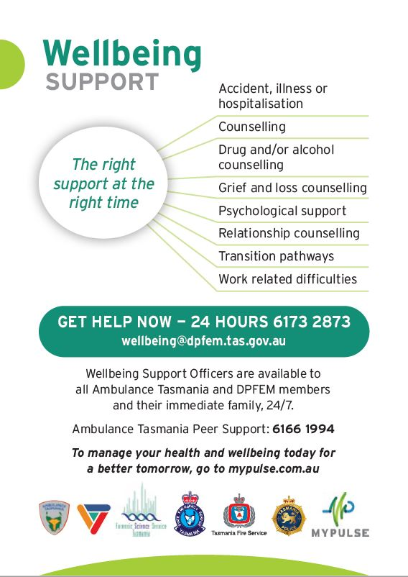

ALTERNATIVE RESOLUTION OPTIONS & APOLOGIES
This chapter only relates to matters classified as:
- Complaint 1 DAI or IRM1 (handled in Districts); or
- Complaint 2 or IRM2 (mostly handled in Districts).

Managerial Resolution (Level 1 only)
Level 1 matters are intended to be resolved promptly and are considered best handled by members’ line supervisors or managers. Both are empowered to resolve these matters. Managerial resolution may include informal resolution, formal resolution and / or Continuing Professional Development (CPD).
Supervisors and managers must maintain a running sheet and record the details of the managerial resolution on BlueTeam™.

Informal Resolution (Level 1 and Level 2 only)
In some circumstances, where formal resolution is not available or not considered necessary, a level 1 or level 2 matter can be resolved through informal resolution. Informal resolution is a type of conciliation. The complainant would need to agree to this course of action – and it might involve an apology. These matters must still be registered on BlueTeam™ and appropriate notes made against the entry or on the running sheet.
Informal resolution is suitable for minor matters where no section 43(3) action is envisaged. It circumvents the requirement for formal inquiries into a complaint and therefore also avoids the need for any official determination about whether the Code of Conduct has been breached. It is only suitable for Complaint 1 and 2, IRM1 and 2, and DAI matters.
The informal resolution process involves the:
- complaint being received by a member
- matter being registered on BlueTeam™ and routed to a supervisor / manager
- supervisor / manager assessing the matter and considering the conduct and service history of the subject officer
- supervisor / manager determining if the matter is appropriate for informal resolution
If in any doubt a supervisor must consult a manager prior to any action being taken; and a manager must consult their commander or Professional Standards prior to any action being taken.
- supervisor / manager speaking with the complainant and negotiating an agreed resolution. The resolution must, in all instances, involve the subject officer being spoken with. The complainant must be satisfied that their complaint / concerns will be addressed appropriately – without this, informal resolution cannot occur.
- complaint / concerns being discussed with the subject officer and their account of the circumstances noted
- complainant being advised that the subject officer has been spoken with
- supervisor / manager updating BlueTeam™ and ensuring sufficient notes are made in relation to the informal resolution
- matter being routed from the manager to Professional Standards
- Professional Standards closing the matter as ‘informally resolved’.
If the subject officer disagrees with the facts stated by the complainant then consideration must be given to whether or not the matter can continue to be informally resolved on the basis of ‘agreeing to disagree’. If not, where it is:
    - a level 1 matter, the points of disagreement are to be noted; or
    - a level 2 matter, the points of disagreement are to be noted and consideration is to be given by the supervisor / manager to redirecting it for a formal inquiry. The subject officer is to be advised if the matter is redirected.
Example Level 1
- Mr R attends Launceston Police Station and makes a complaint to Constable D at the front counter.
- The complaint is against a male officer, Senior Constable M who attended his home at 3am that morning for a curfew check on Mr R’s daughter. The complaint is that Senior Constable M deliberately and unnecessarily shone his torch into Mr R’s face for a prolonged period of time. Mr R says that he does not necessarily want Senior Constable M to be disciplined but wants him to heed the complaint and to not to do it again.
- Constable D registers the matter as a level 1 complaint on BlueTeam™ and routes it to his supervisor, Sergeant S.
- Sergeant S makes a preliminary assessment and determines that the matter is suitable for informal resolution. Sergeant S contacts Mr R and it is agreed that Senior Constable M will be spoken with.
- Sergeant S speaks with Senior Constable M as he is commencing his shift that night. Senior Constable M accepts that he shone his torch at Mr R while they were speaking on the doorstep and stated that while it was necessary to use his torch for visibility, he will take care not to direct it at a person’s face for a prolonged period.
- Sergeant S contacts Mr R and informs him of the conversation with Senior Constable M.
- Sergeant S updates the BlueTeam™ entry with notes about the informal resolution and routes it to her manager, Inspector W.
- Inspector W approves the course of action, notes his decision on BlueTeam™ and routes it to Professional Standards to be closed.
- Professional Standards close the matter as ‘negotiated’.
Tasmania Police reserves the right to formally inquire into a level 1 or level 2 matter despite the desire of a complainant or the person reporting the matter to resolve it through informal resolution.

Formal Resolution (Level 1 and Level 2 only)
Under sections 46(2)(d) and 47(1) of the Police Service Act 2003 a matter that was initially received as a complaint may be resolved by conciliation. This includes Diversity and Inclusion matters. A member of the rank of inspector or above may decide that a complaint is to be formally resolved.
Formal resolution is a type of conciliation. It does not involve a judgement about the correctness of any particular point of view or set of circumstances that may be in issue; nor reaching a finding in respect to a subject officer’s conduct. Rather, it is a process of bringing two sides together to reach a compromise, thereby resolving the matter and enabling the parties to move on. The parties agree to settle a matter on mutually acceptable terms, while recognising that they each may still hold divergent views.
Formal resolution is suitable for minor matters where no disciplinary action is envisaged. It circumvents the requirement for formal inquiries/investigations into a complaint and therefore also avoids the need for any official determination about whether the Code of Conduct has been breached. It is only suitable for Complaint 1 and 2, IRM1 and 2, and DAI matters.
Care should be exercised when considering the suitability of formal resolution for matters of discrimination or excessive force.

How to Formally Resolve a Complaint
It is essential that the complainant and the subject officer both agree to the process. The manager performing the role of Resolver (see below) must also agree to the process on behalf of Tasmania Police. Reasons why a manager may not agree to the process include when a subject officer is alleged to have repeated behaviour (e.g. continues to use inappropriate and unprofessional language in the workplace or in public) and the matter warrants inquiry / investigation instead of a formal resolution outcome. If agreed to and deemed appropriate, formal resolution can be undertaken at any time, even if an inquiry / investigation has commenced.
All decisions should be recorded on BlueTeam™, including agreements to formally resolve a matter or where a party changes their mind about their willingness to participate.

Role of Resolver
The formal resolution process should be coordinated by the subject officer’s line manager (‘Resolver’) following the registration and vetting process, unless a conflict of interest prevents this. The Resolver must act as an impartial third party whose role is to coordinate the process and assist the parties in considering different options and provide information about the possible terms of a formal resolution. The Resolver must ensure that a third party (ideally themselves) is present in any communication between the complainant and subject officer about that specific complaint. Both the complainant and the subject officer may have a support person present during discussions. The Resolver must ensure that any special assistance requirements are addressed.
After consulting with both parties the Resolver will decide how formal resolution will take place and who will participate. The Resolver is not an advocate for either side. The Resolver helps both sides talk about the issues and makes sure that the process is as fair as possible for everyone involved. While the Resolver does not decide who is right or wrong, they can provide information, for example about legislation or Tasmania Police procedures. The Resolver helps the complainant and subject officer think about ways to resolve the complaint and assists them to negotiate an agreed outcome. All parties must agree to keep negotiations and outcomes confidential. The Formal Resolution template is to be used for this process and must be loaded to BlueTeam™ when complete.

Agreed Terms
A matter must not be formally resolved unless the subject officer is consulted and the terms of formal resolution are acceptable to them and the complainant. Terms of formal resolution will vary depending on the nature of the complaint.
Examples
- making an apology
- explaining to the complainant why certain actions were / were not taken
- agreeing to undertake CPD such as retraining
The terms by themselves do not constitute formal resolution – rather, formal resolution is the process of the parties negotiating and agreeing to the terms. It is to involve a face-to-face engagement or telephone engagement that involves all parties, including the manager. If a matter is formally resolved, Tasmania Police may still require the subject officer to undertake CPD.

Record Keeping
The Resolver must document on BlueTeam™ the terms upon which the matter is formally resolved. Note: a complaint may involve more than one allegation so members updating BlueTeam™ must accurately record which specific allegation(s) are formally resolved. The outcome of the matter will be recorded as ‘formally resolved’ by Professional Standards.

Failure of Formal Resolution
If at any stage in the formal resolution process one or both parties is no longer agreeable to formal resolution then the normal procedures for level 1 or level 2 (whichever applies) are to be followed.

When Formal Resolution May Not be Used
Formal resolution may not be used for level 3 matters due to the perceived level of seriousness and / or complexity.
Sound judgement is always required in determining which matters are suitable for formal resolution. In the interests of maintaining proper standards of conduct and public confidence some matters ought to be inquired into or investigated regardless of the preparedness of the parties to conciliate. Tasmania Police reserves the right to inquire into or investigate matters even when all parties agree instead to formal resolution. Where any doubt exists, advice can be sought from Professional Standards.

Apologies
An apology may be given for level 1, 2 or 3 matters or part of a matter. An apology is not an outcome in itself but can be given during the informal resolution of a matter, during formal resolution or during an inquiry / investigation. Tasmania Police reserves the right to continue to inquire into / investigate such matters as a breach of the Code of Conduct or offence, serious offence or crime. The giving of a personal apology from a member would, however, be taken into account when assessing appropriate action and given due credit.
Apologising should not be seen as a sign of organisational weakness. To the contrary, it is a sign of organisational strength and maturity. Many complainants are merely seeking to be listened to and provided with an explanation and apology. For low level matters, a prompt and sincere apology to the complainant may avoid the escalation of a matter and lead to a more timely and appropriate resolution and in some cases may lead to the matter being closed.
An apology does not amount to an admission of liability as per s7 of the Civil Liability Act 2002 which states:
Effect of apology on liability
(1) An apology made by or on behalf of a person in connection with any matter alleged to have been caused by the fault of the person –
(a) does not constitute an express or implied admission of fault or liability by the person in connection with that matter; and
(b) is not relevant to the determination of fault or liability in connection with that matter.
(2) Evidence of an apology made by or on behalf of a person in connection with any matter alleged to have been caused by the fault of the person is not admissible in any civil proceedings as evidence of the fault or liability of the person in connection with that matter.
(3) In this section, apology means an expression of sympathy or regret, or of a general sense of benevolence or compassion, in connection with any matter, which does not contain an admission of fault in connection with the matter.

Circumstances Appropriate for an Apology
Regardless of whether an apology is made, all matters must be registered on BlueTeam™. The circumstances in which it might be appropriate for an apology will need to be assessed on a case-by-case basis. Consideration should be given to:
- whether a member has caused any adverse impact or harm to the complainant
- whether an apology is appropriate
- whether the complainant is willing to accept an apology.

Personal Apology from Member
A member who is the subject of a complaint may choose to apologise to the complainant. Due credit must be given to that member for the apology. If an apology is made by a member on behalf of the subject officer (for example, a sergeant on behalf of a constable under their supervision), then the subject officer(s) should be consulted and consent to an apology being made on their behalf, before it is made.

Apology from Tasmania Police
Apologies by a member of the rank of inspector or above may be made on behalf of Tasmania Police. Apologies may not be made on behalf of an individual member unless they have given their consent.

How to Make an Apology
Apologies can be made verbally or in writing. All apologies should include the following elements:
- acknowledgement that the action or inaction was incorrect, inappropriate, impolite, unreasonable, etc.
- acknowledgement that the action or inaction had an impact on the complainant, for example it embarrassed or offended them
- explanation of the cause of the incident, or contributing factors
- an expression of remorse (“I am sorry” or “I apologise on behalf of Tasmania Police”)
- assurance that the subject officer(s) have been spoken to
- an undertaking that steps will be taken to ensure the incident is not repeated.
If an apology is made by the subject officer then they may consider having another officer present as a witness to the apology. A running sheet entry summarising the conversation should be added to the matter on BlueTeam™ (or notified to the member with carriage of the BlueTeam™ matter).
Examples
Police Officer
“I apologise. That was unprofessional”
“I apologise that I did not act in a timely manner. I realise this matter is significant to you and that it would have been beneficial to you for me to have kept you informed.”
Inspector or above
“I regret that the actions of Tasmania Police were not appropriate”.
“I apologise on behalf of Tasmania Police.”

THE INQUIRY / INVESTIGATION PROCESS
This chapter only relates to matters classified as:
- Complaint 2, IRM2, or Pursuit 2 (mostly handled in districts); or
- Complaint 3, IRM3, or Pursuit 3 (mostly handled by Professional Standards).
Members must not perform the role of inquirer / investigator in a matter where they are a subject officer or witness officer as this is an insurmountable conflict of interest.

Process Summary
- The inquirer / investigator is given written direction contained on BlueTeam™ on the overall approach to the matter (i.e. to be dealt with as a potential breach of the Code of Conduct or as a potential offence, serious offence or crime; or both) when they receive the matter. The direction is to include a clear statement on the avenues/behaviours that are to be examined and those that are not, if any.
- The inquiry / investigation phase commences.
- The inquirer / investigator contacts the complainant and subject officer (if it would not jeopardise the matter).
- The inquirer / investigator handles the matter in the same manner and completeness as any matter reported to police involving a civilian subject. The extent of inquiry / investigation must be proportionate to the allegation or conduct. Over-investigation is discouraged. Inquirers / Investigators will be required to explain (in writing) any over-investigation of matters in terms of length of reports and time taken for completion.
- Inquirers / Investigators must identify all avenues of inquiry / investigation (such as witness accounts, CCTV footage, receipts, forensic evidence) and document these on the IAPro™/BlueTeam™ running sheets. However, not all avenues need to be followed up if there is sufficient reason not to. The reasons not to follow up must also be documented on the IAPro™/BlueTeam™ running sheet in the interest of accountability. For instance, if a decision is made not to obtain a witness account this must be recorded on the running sheet with an explanation.
- If an inquirer / investigator believes that a matter that is being dealt with as a Code of Conduct matter should, given the evidence, be dealt with as a potential offence, serious offence or crime, they must advise their manager. Advice from Professional Standards (including legal advice) can be obtained.
- The inquirer / investigator writes a Provisional Report. The Provisional Report must take into account any matters raised by the subject officer in mitigation, their service history, conduct history, and must include a values statement.
- The inquirer / investigator submits the Provisional Report to their line manager (a member of or above the rank of inspector) as the ‘authoriser’ of the matter. An inquirer / investigator, irrespective of rank, cannot be an ‘authoriser’ for that matter.

Timeframes
Tasmania Police is held accountable to the public and to members for the length of time taken in the inquiry / investigation process. It is in the interests of all parties involved that matters are resolved in a timely manner. It is expected that all matters will be resolved promptly and within the maximum timeframes stipulated which are:
Registration to issuing of Provisional Report to subject officer in a level 2 matter | 70 calendar days
Registration to issuing of Provisional Report to subject officer in a level 3 matter | 6 calendar months
In extraordinary circumstances a timeframe extension may be available.

Nature of Inquiry / Investigation: Code of Conduct or Criminal?
SECTION 46(1) DECISION | METHOD OF RESOLUTION
‘dismissed without an investigation’ | managerial resolution (level 1); or
inquiry | only as a potential breach of the Code of Conduct (level 2); or
inquiry | as a potential offence (level 2 ); or
inquiry | both as a potential offence and a potential breach of the Code of Conduct (level 2).
investigation | as a potential serious offence or crime (level 3); or
investigation | both as a potential serious offence or crime and a potential breach of the Code of Conduct (level 3).
If, during the course of an inquiry / investigation evidence is identified that indicates the matter should no longer be examined purely as a Code of Conduct breach, an inspector or above is to decide whether it is to also be dealt with as an offence, serious offence or crime. Consideration will also need to be given to re-categorising the matter.
This is to be determined on a case-by-case basis and may necessitate the seeking of advice from Professional Standards. If legal advice is required it is to be facilitated by Professional Standards unless otherwise approved by the Deputy Commissioner.
Members who make a voluntary disclosure must be given due credit for doing so.

Expected Extent of Inquiry or Investigation
Inquirers / Investigators need to apply the principles of procedural fairness at all times.

Proportionality
The extent of inquiry / investigation must be proportionate to the allegation or conduct. The more serious the outcome is likely to be, the more extensive the inquiry / investigation and robust the evidence needs to be. An audio interview is appropriate in conduct matters where the matter is complex and/or questioning will enable the breadth of issues to be covered efficiently. Audio interviews should also be conducted if a more serious outcome is likely. If a caution is to be given to a subject officer, the interview is to be audio-visually recorded as required by legislation and the Tasmania Police Manual (TPM).
Over-investigation is discouraged. Inquirers / Investigators will be required to explain (in writing) any over-investigation of matters in terms of length of reports and time taken for completion. The inquirer / investigator is to make a reasoned decision as to the extent of the inquiry / investigation taking into account the direction they have received and:
  - the nature and degree of seriousness of the alleged behaviour;
- the public interest and community confidence in Tasmania Police;
- the requirement to ensure procedural fairness;
- the resources required to conduct an inquiry / investigation measured against the potential outcome;
- the liability of Tasmania Police or any other person or body to compensation or litigation; and
- whether the member is willing to accept responsibility for their actions.
Examples
Level 2 Complaint – excessive force
- speak to complainant
- speak with subject officer – depending on the circumstances a conversation may suffice, a subject report may be required or an interview may be warranted
- review Use of Force report
- prepare concise inquiries report with determination and/or recommendations for section 43(3) Action, Continuing Professional Development, or no further action

Level 3 Complaint – unauthorised access to, and release of, confidential information resulting in a perversion of the course of justice
- speak to complainant
- collect and examine evidence including audit of systems access
- assess suitability or requirement for covert inquiries
- interview witnesses
- interview subject officer
- prepare investigation report with determination and/or recommendations for section 43(3) Action, CPD, or no further action
Inquirers / investigators must identify all avenues of inquiry / investigation (such as witness accounts, CCTV footage, receipts, forensic evidence) and document these on the IAPro™/BlueTeam™ running sheets. However, not all avenues need to be followed up if there is sufficient reason not to. The reasons not to follow up must also be documented on the IAPro™/BlueTeam™ running sheet in the interest of accountability. For instance, if a decision is made not to obtain a witness account this must be recorded on the running sheet with an explanation. The inquirer / investigator is entitled to exercise discretion, but if in doubt, should seek advice from their manager.

Example
Charge-room incident – circumstances in which it would not be necessary to interview all members present
- Constable X was one of six police officers in the charge-room.
- A complaint was made and the CCTV footage viewed. Constable X was in frame but clearly not involved.
- There is sufficient evidence available to deal with the complaint without the need for a statement from Constable X.
- The running sheet should note that Constable X was present but that there is no need to interview her as the CCTV footage indicates she was off to the left and unable to see the incident.

Consideration of Investigation Plan in Some Matters
Inquirers into level 2 matters may include an investigation plan, however only if they consider it necessary or helpful for them in resolving the matter.
Investigators of level 3 matters should consider the inclusion of an investigation plan on the basis of the complexity, extent and nature of the intended investigation. An investigation plan is not mandatory.

Running Sheets
Running sheets must be maintained for all matters involving inquiries or investigation. Running sheets can be created on IAPro™/BlueTeam™ or created separately and uploaded to IAPro™/BlueTeam™.

Contact with Subject Officer and Complainant
When speaking with, or obtaining evidence from any person, it is essential that any questions asked do not display partiality, prejudgement, predisposition or bias – ignoring or dismissing evidence without good reason can be evidence of bias.

Initial Contact with Subject Officer
The subject officer may be contacted by the inquirer / investigator (unless it would compromise the investigation) directly or through the subject officer’s manager. If the subject officer is contacted directly, their manager must be notified as a professional courtesy. Depending on the categorisation of the matter the method of contact may be in person, by telephone, e-mail or in writing. Although indicative outcomes are not able to be provided to the subject officer, they may be referred to the matrix below showing the potential outcomes for level 2 (inquiry) and level 3 (investigation) matters:
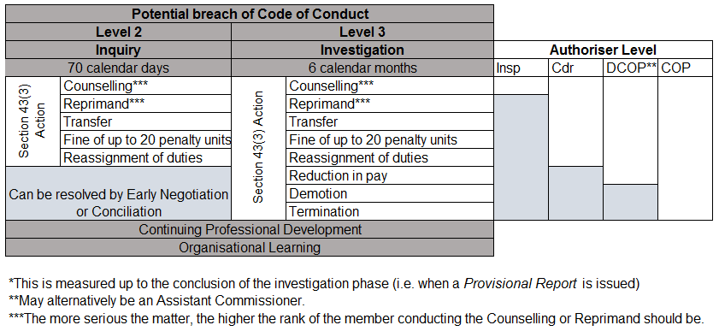
The subject officer will be reminded of Members' Rights & Obligations. An inquiry or investigation will be conducted in accordance with the principles of procedural fairness.
Subject officers will be provided with the allegation prior to interview unless not appropriate (e.g. likely to jeopardise the inquiry / investigation). In a small percentage of level 3 matters subject officers may not be notified that an investigation is occurring as notification would hinder the investigation. Subject officers should be notified in a timely manner and their manager advised so that they can provide appropriate wellbeing support. Care is to be taken to ensure that the subject officer is aware that they are not to speak about the matter to any witnesses or to take any action that might hinder the inquiry/investigation.
If an inquirer / investigator has a conflict of interest that should preclude them from involvement in the matter, they must provide written advice to their manager detailing the conflict. The manager will then consider the situation and, if it is believed that an insurmountable conflict exists, another inquirer / investigator is to be assigned.

Subject Officer and Witness Officer Wellbeing
Tasmania Police is committed to ensuring that members’ wellbeing and support needs are properly catered for and they are treated fairly. Inquirers/investigators and managers should be mindful of the potential impact of an inquiry / investigation on a subject officer or witness officer.
Where concerns are held, the subject officer or witness officer should be referred for support. Inquirers/investigators and supervisors should be mindful of the potential impact of an Abacus inquiry / investigation on a subject officer, witness officer and their family. Where a need is identified the subject officer, witness officer or family member should be referred for support as described in Chapter 8 – Members’ Obligations, Rights and Wellbeing.

Initial Contact with Complainant
Upon being allocated an Abacus matter the inquirer / investigator must contact the complainant or, if an IRM matter, the person reporting and inform them that they have carriage of the matter and provide their contact details. This also provides an opportunity to clarify aspects of the complaint if necessary and to advise the complainant of the Abacus level at which the matter is being inquired into or investigated.

Updating Subject Officers and Complainants
Being kept informed of the progress of a matter is important for both subject officers and complainants or, if an IRM matter, the person reporting. Inquirers / investigators are to update both complainants and subject officers every month.
Inquirers
Level 2 matters

subject officer

complainant
every month ---
Investigators
Level 3 matters

Contact with complainants, the persons reporting and subject officers must be recorded on the IAPro™/BlueTeam™ ‘Task’ (note this is only available once the matter has been routed back to the district from Professional Standards). Members must adhere to the contact requirements unless it is clearly inappropriate because it may hinder an inquiry / investigation.

Methods of Obtaining Subject Officer and Witness Accounts
Accounts of events, including from the complainant and civilian witnesses, can be obtained by whichever method is deemed appropriate, e.g. via telephone, in person, by subject report or signed statutory declaration, audio or audio-visually recorded interview. Reference should be made to the sections directed interviews, Subject Officers' Rights and Obligations and Witness Officers’ Rights and Obligations. Templates are available here.

Interview Format Guides
Interview templates have been written to assist inquirers / investigators conducting interviews of subject officers (including criminal interviews, Code of Conduct interviews and directed interviews); complainants (including complaint interviews); and witnesses. They are available here.

Complaints about Handling of Interviews
As with any investigative interview, at the conclusion the interviewee must be asked “Do you have anything to say about the manner in which you have been treated by any police officer involved in this inquiry/investigation?"
If the person has a complaint about the manner in which the interview was conducted one of the interviewing officers must take the person to a senior officer who is not directly involved in the matter. That senior officer is to complete the Register of Persons Interviewed and to take any other immediate action necessary, including taking a complaint if required in accordance with Abacus procedures. The investigating officer is to update their IAPro™/BlueTeam™ running sheet to reflect that a complaint was made and referred to another officer.

Inquirer / Investigator Absence
If the inquirer / investigator has an impending absence from their usual duties (e.g. to participate in lengthy courses or to take leave) they must consult with their manager regarding the progression of the matter in their absence. Leave or extended absence will not be accepted as an excuse for inaction or a failure to meet the measurable time points. If a matter is to be reassigned (temporarily or otherwise) then the inquiring / investigating member should contact the complainant and inform them of the change in circumstances.
Level 2 matters:
must be reassigned if absence is greater than two weeks.
Level 3 matters:
must be reassigned if absence is greater than four weeks, unless the exigencies of Tasmania Police do not permit it.
Conflict of interest factors must be considered. If the new inquirer / investigator or the subject officer believe a conflict of interest exists they must notify their manager.

Obtaining Specific Advice

Operational Skills Unit
If an inquirer / investigator is seeking advice or is requesting a file review from the Operational Skills Unit (OSU), the following applies:
- They may contact members of the OSU for verbal advice.
- The officer in charge of OSU may require a written request for ad hoc or general queries involving written advice.
- Requests for reviews or formal advice are initially discussed at inspector level to determine the nature of the request and its likely impact on OSU.
- Advice provided by OSU that forms the basis of critical decision-making should be made in writing.
Following an inquiry / investigation referral that are made to the OSU (e.g. for facilitation of CPD) will require agreement from the Education and Training Commander.

Integrity Testing
Section 48 of the Police Service Act 2003 authorises the Commissioner to conduct integrity testing of members:
(1) The Commissioner may conduct, or require an authorised person to conduct, a test of the integrity of a police officer if there are reasonable grounds to suspect that the police officer has engaged in, or is engaging in, or is likely to engage in, conduct that –
(a) may constitute an indictable offence or any other offence punishable by imprisonment; or
(b) is corrupt or seriously unethical.
(2) An integrity test may only involve an act or omission that, but for subsection (3), would be unlawful if –
(a) it is reasonably necessary for the conduct of the integrity test; and
(b) it is authorised by a magistrate.
(3) Despite any other Act or law to the contrary and subject to subsection (2), any act done or omission made in conducting an integrity test is lawful.
(4) The Commissioner may issue a certificate stating that on a specified date or during a specified period a specified person was authorised to conduct or participate in an integrity test involving a specified act or specified omission.
(5) An authorisation under subsection (2) or a certificate issued under subsection (4) –
(a) is admissible in any legal proceedings; and
(b) is evidence of the matters specified in the authorisation or certificate.

Requiring Financial Statements
Section 49 of the Police Service Act 2003 authorises the Commissioner to require members to provide financial statements:
(1) The Commissioner may require a police officer to provide a financial statement if there are reasonable grounds to suspect that the police officer has engaged in, or is engaging in, or is likely to engage in, conduct that –
(a) may constitute an indictable offence or any other offence punishable by imprisonment; or
(b) is corrupt or seriously unethical.
(2) The Commissioner –
(a) for the purpose of allocating duties may require a police officer to provide a financial statement; and
(b) is to cause to be published in the Police Manual a list of duties to which this subsection applies.
(3) A financial statement is to include details of –
(a) assets and liabilities; and
(b) income and expenditure.
(4) The Commissioner is to ensure that a financial statement provided under subsection (1) or(2) –
(a) is only used for the purposes of this Act; and
(b) is kept confidential, secure and in accordance with directions issued by the Commissioner.
Requests for financial information must be specific as to what documents are, or evidence is, required; and must be specific to an allegation.

Impact of Court Proceedings

Court Proceedings Applicable to Member
It is not ‘double jeopardy’ for there to be both court proceedings and administrative (Code of Conduct) proceedings, even if the facts in consideration are the same. In Hardcastle v Commissioner of Australian Federal Police it was found that “the two proceedings are essentially different in character and result”.
Where an Abacus matter involves a member being charged, the Deputy Commissioner will decide on a case-by-case basis whether finalisation of the Code of Conduct matters will occur concurrently or be deferred pending the outcome of the court proceedings.

Court Proceedings Applicable to Complainants
Some complaints relate to matters in which the complainant is subject to prosecution, for example a charge of assault police. The complaint should be taken in the same manner as any other complaint. While they are dealt with on a case-by-case basis, there is nothing to prevent the resolution of the complaint prior to the court proceedings – although in some instances it might be appropriate to suspend an inquiry / investigation pending the court outcome (being mindful that a statute of limitations might apply).
If the complaint has not been resolved prior to court proceedings the prosecution can be monitored by setting a ‘Task’ in IAPro™. The IAPro™ file can remain open for the duration of the court process and after a court decision is made the matter can be reviewed and any required further action may then be taken. Any comments relevant to the complaint, made during the hearing, or referred to in the decision, must be considered by the inquirer / investigator.
While the IAPro™ matter remains open the duration of time taken in court proceedings is not calculated in any measurable time points that are reported on internally and externally.

PROVISIONAL REPORT BY INQUIRER / INVESTIGATOR
The Provisional Report is the only inquiry / investigation report that is prepared by the inquirer / investigator. Exceptions to this are if legal advice is required, or if the inquirer / investigator prepares a report seeking advice from a senior officer. The Provisional Report is submitted with a simple Provisional Report Cover Sheet which assists Professional Standards administration.
The Provisional Report from the inquirer / investigator contains their recommendations as to provisional findings, provisional determinations and provisional actions. Only the delegated authoriser can authorise them and may amend them.
A sample of the Provisional Report is at Appendix D. Word templates for the Provisional Report and Provisional Report Cover Sheet are available on the intranet. The Provisional Report must be proportionate to the allegations. Brevity is required. The Provisional Report is to include the sections listed below, which are also clearly set out in the template.

Responsibilities of Inquirer / Investigator

Recommending Outcomes and Writing Report – Inquirer / Investigator
It is the role of the inquirer / investigator to provide the authoriser with provisional finding(s), provisional determination(s) and provisional action(s) in the Provisional Report.
The outcome of the inquiry / investigation contained in the Provisional Report must adhere to the principles of procedural fairness and provisional Code of Conduct findings must be made on the balance of probabilities. A template of the Provisional Report is available and it is the only inquiry / investigation report required. A simple Provisional Report Cover Sheet is also required for administrative use in Professional Standards.
If there is sufficient evidence for a member to be charged with an offence or crime, a standard court file is to be completed. A Provisional Report might be required at this stage – or may be deferred pending the outcome of the court process. This is to be determined by the Deputy Commissioner.
In general terms the inquirer / investigator’s responsibilities cease at this point, unless the file is returned to them.

Determining the Rank of the Authoriser
The tables below show the rank of the authoriser in different outcomes where the inquirer / investigator is a sergeant (first table) or inspector (second table):
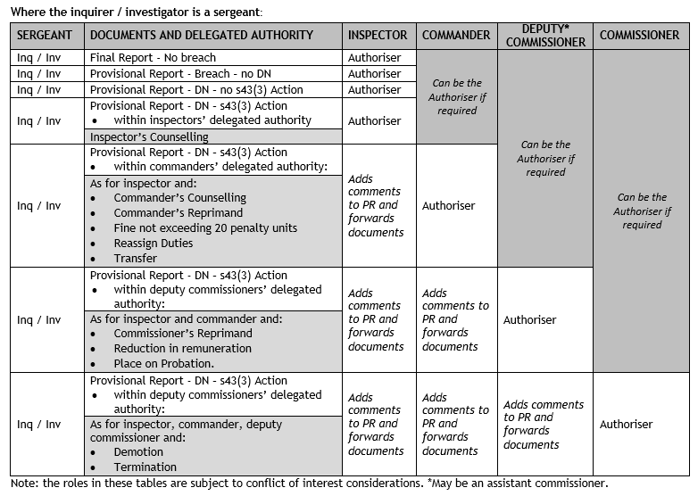
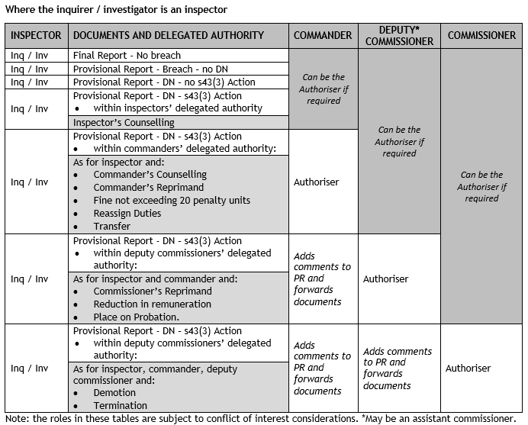

Inquiry / Investigation Outcomes
No two Abacus investigations are the same and no two subject officers have the same service history and conduct history; therefore a one-size-fits-all outcome would be unfair and inappropriate. Section 43(3) Actions should be considered if a member has been provisionally found to have breached the Code of Conduct. CPD opportunities are to be considered in all Abacus matters, whether or not there is a provisional determination that the Code of Conduct has been breached. CPD should occur in the interests of continuous improvement and development of the knowledge and skills of members.
Any action taken under section 43(3) of the Police Service Act 2003 is discretionary. Action is taken to maintain, restore and enhance public confidence, to uphold proper standards of conduct and to ensure members are accountable for their actions.
In considering the final outcome of a matter inquirers / investigators must give due credit where a member has made a voluntary disclosure or an apology to a complainant.
The possible outcomes for Abacus matters are depicted in the list below (and also in the flowchart at Appendix A). There are only two broad outcomes for Code of Conduct matters; that, on the balance of probabilities the Code of Conduct
- was breached
- was not breached.
Within each of those two categories there are a number of options which relate to proposed courses of action:
OUTCOMES | ABACUS LEVEL 2 | ABACUS LEVEL 3
Withdrawn
Withdrawn + CPD
Dismissed
Dismissed + CPD
Informal Resolution
Informal Resolution + CPD
Formal Resolution
Formal Resolution + CPD
No Breach
No Breach + CPD
Breach Justified
Breach + No Determination Notice
Breach + No Determination Notice + CPD
Breach + Determination Notice + no section 43(3) Action
Breach + Determination Notice + no section 43(3) Action + CPD
Breach + Determination Notice + section 43(3) Action
Breach + Determination Notice + section 43(3) Action + CPD
A discretionary decision may be made to not issue a Determination Notice for some breaches of the Code of Conduct – this is only an option when no section 43(3) Action is being taken.
If the final determination is that a Determination Notice is issued the IAPro icon turns red. This means it forms part of the conduct history of that member and may be considered in any future breach of the Code of Conduct. Any section 43(3) Action of a reprimand or higher will affect the member’s eligibility for wearing or receiving medals. A Commander is able to impose a limitation on the subject officer wearing or being awarded the Commissioner’s Medal or National Police Service Medal for a period up to and including 12 months. An Assistant Commissioner or the Deputy Commissioner can impose a limitation on the subject officer wearing or being awarded the Commissioner’s Medal or National Police Service Medal for a period up to and including 5 years.

Factors to Consider
When looking to arrive at an appropriate outcome inquirers / investigators must be mindful that members of Tasmania Police:
- must be accountable for their actions,
- must maintain proper standards of behaviour and conduct; and
- must ensure that public confidence in Tasmania Police is maintained, enhanced and, where necessary, restored.
For further information refer to Provisional Action.

Equity in Outcomes
Inquirers, investigators and authorisers are required to contact Professional Standards to receive advice about the appropriateness of intended actions. This will assist in achieving equitable outcomes across Tasmania Police.
The separate roles of inquirer / investigator and authoriser in the process, combined with audits by Professional Standards, ensures accountable and fair decision-making. Professional Standards provides six-monthly reports to the Deputy Commissioner including a section on the equity of outcomes across the State.

Provisional Report Structure
This section describes the structure of a Provisional Report. An example Provisional Report is at Appendix C.

Introduction
This section describes the purpose of the report, advises who the inquirer / investigator was and that the Provisional Report is based on the inquirer / investigator’s recommendations. It also provides, in broad terms, the provisional outcome.
Note: whilst the Provisional Report is based on the recommendations of the inquirer / investigator, the authoriser exercises their own judgement in relation to the matter and must be satisfied that the provisional findings are able to be substantiated on the balance of probabilities.

Conflict of Interest
Clear statements are required on conflicts of interest. The authoriser is to state whether or not an actual, perceived or potential conflict of interest exists or could be seen to exist that renders them, or might be perceived to render them, unable to impartially assess the matter and complete their responsibilities.
The inquirer / investigator is also to state whether or not an actual, perceived or potential conflict of interest exists or could be seen to exist that renders them, or might be perceived to render them, unable to impartially assess the matter and complete their responsibilities.
Further information on conflicts of interest is available at Part 1.47 of the TPM.

Courses of Action
This section advises the subject officer of the courses of actions that are available to them. The subject officer must:
  - elect to make a written submission in response to the Provisional Report within 15 calendar days (or other period as agreed),
Note:
- If the subject officer elects this course of action, the written submission is to be forwarded directly to the authoriser. The subject officer may provide a copy to her/his manager should they wish to do so. The authoriser will consider any submission the subject officer makes in response to this Provisional Report.
- The authoriser will then, within 15 calendar days of receipt of the submission (or other period of time which will be specified), issue a Final Report and, if applicable, a Final Determination Notice. The Final Report and, if applicable, Final Determination Notice will take into account any matters raised by the subject officer’s submission.
  - Or elect not to make a written submission by signing the end of the Provisional Report in the space provided within 15 calendar days (or other period as agreed)
Note:
- If the subject officer elects this course of action, a signed copy of the Provisional Report is to be forwarded directly to the authoriser. The subject officer may provide a copy to her/his manager should the subject officer wish to do so.
- The authoriser will then, within 15 calendar days of receipt of the signed copy (or other period of time which the authoriser will specify), issue a Final Report and, if applicable, a Final Determination Notice.
  - Or accept the outcome of the Provisional Report within 15 calendar days (or other period as agreed) by signing the end of this document in the space provided and by signing the attached Determination Notice, if any.
Note:
- If the subject officer elects this course of action, a signed copy of the Provisional Report is to be forwarded directly to the authoriser. The subject officer may provide a copy to her/his manager should they wish to do so.

- The Provisional Report then becomes the Final Report and any Provisional Determination Notice will become the Final Determination Notice. Once any actions required on the Final Determination Notice are completed the matter will be considered finalised.
The Provisional Report stipulates that the 15 calendar day’s response provision applies unless the subject officer is granted an extension by the authoriser. It also stipulates that if the subject officer does not respond to the Provisional Report within 15 calendar days (or other period as agreed) the matter may be finalised in the terms of the Provisional Report.
The subject officer is advised in this section of the report that they are being directed to submit a response under the provisions of Section 35 (2) (c) of the Police Service Act 2003. In the interests of fairness, they are further advised that if they do not respond it may be considered to be a failure to comply with a lawful direction, contrary to Section 42(3)(b) of the Police Service Act 2003.
The subject officer is informed that they can contact the authoriser directly, or through their manager, if there is anything that they would like clarified, if they require an extension of time, or if they would like any further advice.

Your Rights
The subject officer’s rights are listed in this section of the Provisional Report, together with contact details for the Police Association of Tasmania and Wellbeing Support.

Incident Overview
A very brief overview of the incident is to be provided here. The overview provided should be proportionate to the level of the matter (2 or 3).

Alleged Behaviours
A concise summary of the alleged behaviours is required. If there are multiple behaviours (or incidents) they should be separately numbered and ordered chronologically where possible.
At this point there is no need to link them to any particular Code of Conduct matter (for example ‘bring discredit’ would be listed by the specific behaviour such as sending an abusive e-mail from a Tasmania Police e-mail account).

Summary of Inquiry / Investigation Undertaken
A concise summary of the inquiry / investigation undertaken is to be required. This should include the names of people interviewed, and any witnesses who were not interviewed. The evidence in relation to each behaviour should be briefly described. Any points in issue or disputed facts should be identified.

Provisional Finding
A provisional finding about the alleged behaviour and whether or not it occurred, on the balance of probabilities is to be recorded for each alleged behaviour.
Sample wording is “…my provisional finding, on the balance of probabilities, is that behaviour #1 occurred/did not occur…”.
It is provisional because it is subject to change by the authoriser, or following a written submission from the subject officer (should they choose to make one).

Provisional Determination
Having arrived at a provisional finding that a certain behaviour did occur, a provisional determination then needs to be made to identify whether or not that behaviour amounts to a breach of the Code of Conduct.
A provisional determination is to be listed for each alleged behaviour. It must specify the section of the Code of Conduct that it relates to, together with the offence or crime name and details of the relevant legislation and section, if applicable. Sample wording is
Having provisionally found that behaviour #1 occurred I considered if the behaviour amounted to a breach of section 42 (Code of Conduct) of the Police Service Act 2003.
My provisional determination is;
42(9) A police officer must not access any information to which the police officer is not entitled to have access.- Breach

Provisional Action
Prior to proposing a Provisional Action the inquirer/investigator, and then the authoriser must take in to account the conduct of the subject officer and a number of other factors. It is essential that the subject officer’s circumstances are taken in to account and that an appropriate balance is struck to ensure that members of Tasmania Police:
- are accountable for their actions
- maintain proper standards of behaviour and conduct; and
- ensure that public confidence in Tasmania Police is maintained, enhanced and, where necessary, restored.
Accordingly, the following must be taken in to account
- any mitigating circumstances
- the subject officer’s service history (including rank, length of service, current position)
- the subject officer’s conduct history (conduct history will be made available to the inquirer / investigator by Professional Standards when requested)
- the appropriateness of a section 43(3) Action/s to ensure standards are maintained
- the subject officer’s eligibility to wear or apply for medals
- the subject officer’s wellbeing needs (if applicable)
- suitable CPD opportunities
- if applicable, the indicative actions framework for drink and drug driving

Mitigation
A clear statement is required that details any mitigating factor(s). If there is no mitigating factor this needs to be stated also. The subject officer’s engagement in the process and openness and honesty is to be commented upon in this section.

Service History
The subject officer’s service history is to be stated. As a minimum it is to include their date of appointment, rank, and current position. It may be appropriate to also add secondary roles or other known significant matters (e.g. previously awarded a Commissioners Commendation for bravery).

Conduct History
The subject officer’s conduct history is to be stated. This section is focussed on whether or not the subject officer has previously received a Determination Notice. If so, the circumstances need to be stated, including
- an incident overview
- the applicable paragraph of the Code of Conduct
- the date the subject officer signed the Determination Notice (if more than five years old the Determination Notice is to be given reduced weight in determining an appropriate provisional action).

Values Statement
A statement is required about how the behaviour does not reflect the Values of Tasmania Police.
Example
It is essential that you understand that accountability, integrity, respect and support must guide our actions and that our behaviour must be appropriate and disciplined. Tasmania Police values are the foundation for the types of ethical behaviour expected from members. This behaviour must be demonstrated in all aspects of work. Your behaviour has fallen short of the standard that we, and the community, expect. You have however, through this process, conducted yourself appropriately. You have demonstrated that you are prepared to be accountable for your actions and have been open and transparent.

Provisional Action
The provisional action recommended should clearly specify which behaviour(s) it is linked to – if it applies to all behaviours then the words “Provisional Action (Global)” should be used. If it is linked to a section 43(3) action, the precise action should be detailed, e.g. “section 43(3)(a) Inspector’s Counselling”.
Example
“I provisionally determined that you breached section 42(9) of the Police Service Act 2003 in that you accessed information you were not entitled to access, namely the entities of your family members. Taking in to account the
- need to ensure members are accountable for their actions
- need to ensure proper standards of conduct are upheld
- need to ensure public confidence is maintained, restored or enhanced
- circumstances of this matter
- your personal circumstances
the provisional action I propose in relation to Behaviour 1 is
- Determination Notice (Breach)
- Section 43(3)(a) Counselling by an Inspector of Police”
The action is provisional because it is subject to change by the authoriser, or following a written submission from the subject officer (should they choose to make one).

Medals
A clear statement must be made in relation to whether or not the matter will have any impact on the subject officer’s eligibility to wear, or be considered for, medals. There is to be no impact unless a provisional action of reprimand or higher is proposed. If a reprimand or higher is proposed the authoriser must clearly state the length of time that the member will not be entitled to wear or be eligible for medals.
A Commander is able to impose a limitation on the subject officer wearing or being awarded the Commissioner’s Medal or National Police Service Medal for a period up to and including 12 months. An Assistant Commissioner or the Deputy Commissioner can impose a limitation on the subject officer wearing or being awarded the Commissioner’s Medal or National Police Service Medal for a period up to and including 5 years.

Organisational Learning
It is important to identify if there are any Organisational Learnings that have been identified. If so, they should be described, and formal correspondence prepared to ensure that the appropriate business area is advised of the issue identified (the HP Records Manager number of that report should be included)

Continuing Professional Development
Any CPD is to be described including detail of who is to administer it (e.g. the subject officer’s supervisor or manager) and whether it involves another area such as the Operational Skills Unit. The time frame in which it is to be completed also needs to be stated.

Determination Notice
Provisional Determination Notices are to be prepared by the inquirer / investigator and will be amended, if required, by the authoriser. A provisional Determination Notice must include any section 43(3) Action or CPD opportunity. Provisional Determination Notices may have either one of those outcomes, or both, or none. A template is provided and is available here, all fields (up to and including the authoriser’s signature) are mandatory. An example Determination Notice is provided at Appendix D.
The wording of provisional Determination Notices must state which section(s) of the Code of Conduct has been breached for each complaint allegation, internally raised matter or compliance review matter. In addition, the notice must specify the extent to which the member’s conduct is inconsistent with one or more of the Tasmania Police Values, the Police Officer Oath / Affirmation or the Australia New Zealand Police Integrity Principles.
Examples
both section 43(3) Action and CPD
“In addition to the action/s under section 43(3) of the Police Service Act 2003, you are to be provided with Continuing Professional Development of [description of the professional development e.g. verbal advice and guidance by a supervisor / manager] in respect to the above-mentioned breach(es) of the Act”.
CPD only
“Whilst a breach of section [ ] of the Police Service Act 2003 was determined, it is not necessary to enact any of the actions provided by section 43(3) of the Act. You are, however, to be provided with [description of the Continuing Professional Development e.g. verbal advice and guidance by a supervisor / manager] in respect to the above-mentioned breach(es) of the Act”.

Other Inquirer / Investigator Action
The inquirer / investigator is responsible for the below. The authoriser is also responsible for ensuring the following are completed:
- drafting outcome letters to complainants;
- drafting letters to witnesses and witness officers (if appropriate);
- drafting outcome letters, where required, to the Integrity Commission (for signature by the Professional Standards Commander);
- drafting a media release (if one is required – refer notification to media);
- ensuring wellbeing and support needs are addressed;
- ensuring outstanding BlueTeam™ ‘Tasks’ are completed;
- ensuring running sheets are complete;
- ensuring all documents are uploaded to BlueTeam™;
- ensuring the provisional Determination Notice (if any) is loaded on BlueTeam™;
- ensuring all documents are printed in hard copy, and recording on the documents the date they were uploaded to BlueTeam™; then forwarding the hard copy file to the authoriser.

AUTHORISATION & FINALISATION
This chapter only relates to matters categorised as:
- Level 2 (mostly handled in districts); or
- Level 3 (mostly handled by Professional Standards).
Members must not perform the role of authoriser in a matter where they are a subject officer or witness officer as this is an insurmountable conflict of interest.

An authoriser cannot authorise any matter in which they have acted as an inquirer / investigator as this is an insurmountable conflict of interest.

Flowchart Summary
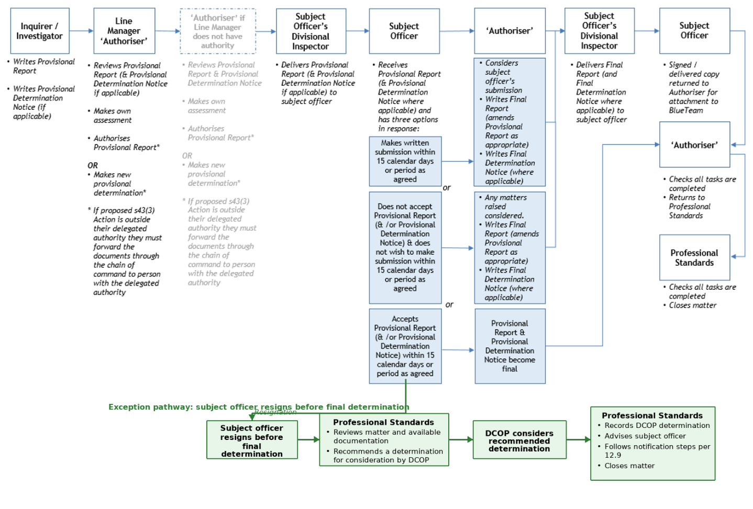

Process Summary
- The line manager receives the Provisional Report from the inquirer / investigator.
- The line manager assesses the file for adherence to Abacus procedures
- The line manager refers to the Assessment Procedure.
- The subject officer is then advised of the courses of action that are available to them.
- The authoriser considers the subject officer’s submission (if applicable).
- The authoriser writes a Final Report and a Final Determination Notice (if applicable) based on their consideration of the subject officer’s submission.
- As the authoriser is acting as the Commissioner’s delegate, the authoriser’s decision represents the Commissioner’s decision. As such it cannot be overturned by another senior officer. The only options for review that apply are described in review of decision.
- The subject officer’s manager delivers the documents to them.
- The authoriser completes the post-approval procedures, including loading of documents into BlueTeam™, and forwards a hard copy to their Commander for on-forwarding to Professional Standards.
- If the subject officer resigns or separates prior to a final determination, Professional Standards review the matter and recommends a determination for consideration by the Deputy Commissioner. The subject officer is notified in writing and all other relevant notifications made.
- Professional Standards is responsible for:
- checking that IAPro™ records accurately reflect all information;
- confirming that tasks and routings are completed;
- ensuring the Integrity Commission is advised of outcomes where required;
- updating the IAPro™ status; and
- closing the file.

Responsibilities of Authoriser
Authorisers are members of the rank of inspector or above. The authoriser is to follow the process described in the flowchart summary and process summary, and Assessment of Provisional Report Procedure. Authorisation is to be made by a member of a rank one level above the inquirer / investigator, if the recommended outcome is within that officer’s delegated authority. If not, authorisation must be made by a member of a rank with the required delegated authority. Authorisers must not authorise a matter where they have performed the role of inquirer / investigator.
An authoriser is disqualified from making a decision if “a fair-minded lay observer might reasonably apprehend that that decision-maker might not bring an impartial mind to the resolution of the question that he or she is required to decide”. A lack of impartiality may arise from a conflict of interest or bias (perceived, actual or potential). If an authoriser believes that they are required to disqualify themselves they must inform their manager so that the manager may reallocate the role of authorisation to another member, or take on the authorisation responsibilities themselves.
As a matter of procedural fairness the authoriser must make clear that they still maintain an open mind and they have not yet reached a final view. Failure to do this could be considered to be prejudgement or an indication of bias and the authoriser will be required to disqualify themselves from the matter. The Provisional Report template has been drafted to ensure that the subject officer is aware that the authoriser has an open mind (hence the use of the term ‘provisional’ throughout).
Authorisers must also consider the application of Continuing Professional Development (CPD) and recommendations to assist Organisational Learning.

Assessment of Provisional Report Procedure
The manager receiving the Provisional Report must assess the inquiry / investigation, including the running sheet, to identify if any aspect:
  - has been poorly or inadequately completed and requires rectification
  - has not been done and no explanation is provided
  - has not been done but, after considering the explanation provided on the running sheet, the manager believes it should have been done.
The manager is to note on the running sheet any issues with the file and determine if they require attention:
  - if so, they return the file to the inquirer / investigator; or
  - if not, the assessment of the file is completed.
The manager is to consider the provisional finding(s) and the provisional determination(s).
  - If they agree with them and:
    - the proposed section 43(3) Actions fall within their delegation -
they then authorise it by signing in the ‘authoriser’ field on the Provisional Report (this makes them the ‘authoriser’), and upload the signed report on BlueTeam™; or
    - the proposed section 43(3) Actions are outside their delegation -
then the manager cannot be the ‘authoriser’. They must prepare a Provisional Report Cover Sheet advising of their support for the inquirer / investigator’s Provisional Report - they are not to document their assessment of the evidence and are not to summarise the evidence. They then forward the file through the chain of command to the manager who has the appropriate delegated authority for the proposed section 43(3) Actions.
  - If they disagree with all or part of them:
    - they are to make a new provisional finding and provisional determination only if that determination is within their delegation, and then authorise it by signing in the ‘authoriser’ field on the Provisional Report, and upload the signed report to BlueTeam™.
    - and their proposed determination is not within their delegation, then they must forward the file through the chain of command to the manager who has the appropriate delegated authority for the proposed section 43(3) Actions. The file is to be forwarded with a Provisional Report Cover Sheet advising why they do not support the inquirer / investigator’s provisional finding and /or provisional determination. They must state the new provisional findings and / or provisional determination that they feel would be appropriate. They are not to document their assessment of the evidence and are not to summarise the evidence.
Once the authoriser has approved the provisional finding and provisional determination, the subject officer is given the Provisional Report by their manager. They are also reminded of the availability of Wellbeing Support.

Procedure following Authoriser Approval
The authoriser is required to ensuring the following are completed:
- outcome letters sent to complainants (at the appropriate time);
- outcome letters to subject officers;
- letters to witnesses and witness officers (where appropriate);
- outcome letters, where required, to the Integrity Commission (for signature by the Professional Standards Commander);
- advising the Deputy Commissioner if a media release is required – refer notification to media);
- ensuring wellbeing and support needs are addressed;
- ensuring outstanding BlueTeam™ ‘Tasks’ are completed;
- ensuring running sheets are complete;
- ensuring all documents are uploaded on BlueTeam™;
- ensuring the Determination Notice (if any) is saved to the subject officer’s HR file on HP Records Manager and a copy forwarded to Professional Standards or loaded on BlueTeam™;
- ensuring all documents are printed in hard copy, and recording on the documents the date they were uploaded on BlueTeam™; then forwarding the hard copy file to their commander for on-forwarding to Professional Standards; and
- completing the file closure checklist.

Delivery of Documents to Subject Officer
The member responsible for delivering the Provisional Report and provisional Determination Notice (where applicable) is typically the subject officer’s manager or supervisor. The documents are to be delivered and explained to the member in person wherever possible. The member delivering the documents is then to complete the page of the Provisional Report titled Provisional Report Provided to Member and request the subject officer to complete the Acknowledgement by Member section. There is no requirement for the subject officer to do so and any signature made is not taken as an admission, but merely as an acknowledgement that they have received the document.
The member responsible for delivering the Provisional Report to the subject officer is to draw the subject officer’s attention to the last page of the Provisional Report. This page is titled Response from Member. The member is required to complete this document within 15 days of the Provisional Report being provided to them, unless they have been granted an extension of time by the authoriser. The Response from Member is to be provided direct to the authoriser. Should the member wish to do so, copies may also to be provided their supervisor, manager, and/or commander. Refer to Subject Officer Response.
The manager or supervisor is to then load the completed document to the relevant IAPro™ BlueTeam™ entry. The subject officer is entitled to a copy. The IAPro™ BlueTeam™ entry is then to be directed to the authoriser.
Prior to meeting with the subject officer the member delivering the documents should consider whether or not an independent person is required to be present in support of the subject officer. A subject officer is entitled to request that an independent person is present.
A Provisional Report is required in matters in which a provisional determination has been made to take action under section 43(3) of the Police Service Act 2003. For complaint based matters, this is a legislated requirement under section 47(3)(b) of the Police Service Act 2003.
If it is provisionally determined that the subject officer will receive a Determination Notice, that notice is to be provided to them at the same time as the Provisional Report. It is considered to be a ‘provisional’ Determination Notice – it remains ‘provisional’ unless and until the subject officer accepts it (by signing it or otherwise indicating they accept it) or it becomes the final Determination Notice.

Subject Officer Response
When a subject officer receives a Provisional Report they are required to complete the Response from Member and provide it to the authoriser within 15 calendar days (or period as agreed). Should they choose to make a submission that must be provided within 15 calendar days (or period as agreed). They subject officer is, in the relevant section of the Response from Member, to elect:
  - to make a written submission in response to the Provisional Report within 15 days (or period as agreed), which is submitted directly to the authoriser; or
  - to not make a written submission
  - accept the contents of the Provisional Report within 15 calendar days (or period as agreed). If the Provisional Report is accepted, the provisional Determination Notice is also accepted, ceases to be a draft and becomes final. The decision is finalised at that time.
The timeframe of 15 calendar days may need to be extended in circumstances when a request for disclosure has been made by the subject officer (see below).

Right to Information
Tasmania Police will provide access to and copies of (or extracts from) records obtained or created during an Abacus matter upon request from a subject officer who has been the subject of an inquiry / investigation.
A subject officer is entitled to be adequately informed to enable them to
- provide an appropriate response (if required) at the conclusion of the matter
- provide supplementary information (if required)

General Intention to Disclose
A subject officer is entitled to seek access to records gathered during an inquiry / investigation. The request to access records may include a request to be provided with a copy of, or extract from, the records. Certain records are subject to automatic disclosure on request (refer 12.6.4).

Exempt Material
Material that is considered to be exempt pursuant to the provisions of the Right to Information Act 2009 will not be provided. The subject officer will be advised of the reason/s for declining to disclose material that is considered to be exempt.
Every effort will be made to ensure that personal identifiers including address, date of birth and contact numbers are not disclosed.
A subject officer is not entitled to access any material within an inquiry / investigation file whilst the inquiry / investigation is active. For disclosure purposes inquiries / investigations are considered active until the member receives the Provisional Report or they are advised that no action will be taken.
A subject officer’s request for disclosure is to be met within 28 days from the time of receipt of the disclosure request by the relevant commander.
In the event that a decision is made to decline to disclose material, in whole or in part, the subject officer may make application under the Right to Information Act 2009 for disclosure of that material. A decision to decline to disclose material is not able to be reviewed under the grievance provisions of the TPM.

Review and Supply
Access to material is to be requested through the Commander, Professional Standards or through the district commander if the matter is being dealt with in the district.

General Access by Members
Following inquiry / investigation members are entitled to access to the following documents:
- Allegations (overview) relevant to the requesting member
- internal investigation interview(s) of the requesting member
- documentation created or supplied by the requesting member during the inquiry / investigation
- determinations (including provisional determinations) relevant to the requesting member and the reasons for those determinations.
Access is to be requested through the office of the commander with responsibility for the inquiry / investigation.

Final Report and Final Determination Notice
The authoriser reads and considers the subject officer’s submission (where applicable). The authoriser then writes a Final Report based on their consideration of the subject officer’s submission. Where applicable the authoriser also prepares a final Determination Notice based on their consideration of the subject officer’s submission. It has the same format as the provisional Determination Notice. The authoriser’s final decision cannot be overruled or overturned by any police officer as they, acting on a delegation from the Commissioner, are making the decision on behalf of the Commissioner. This does not affect the subject officer’s rights of review as described in review of decision.
The Final Report (and where applicable, final Determination Notice) is sent to the subject officer’s manager who delivers it to the subject officer in accordance with the process set out at Delivery of Documents to Subject Officer. If the outcome involves a counselling or reprimand by a commander or commissioner, the manager facilitates that action. If CPD is involved that must be arranged to occur promptly, and within the timeframe stipulated in the Determination Notice.

Resignation or Separation prior to Final Determination
Where a member resigns, prior to a final determination being made, Professional Standards will forward provisional findings to the Deputy Commissioner recommending a determination.
The Deputy Commissioner will make a determination which will be provided in writing to the subject officer and recorded in IAPro.
Where a member separates through the finalisation of a workers compensation claim, the decision whether to provide outcome details to them will be made in consultation with Wellbeing Services.
Notifications of Outcome will occur as per 12.9 Notification of Outcome

Notification of Outcome – Complaints D&I

Notification to Complainant
Whilst the complainant is to be regularly updated by telephone in accordance with Updating Subject Officers and Complainants, a further requirement to notify applies. For all level 2 or 3 complaint or Diversity and Inclusion matters, once the subject officer is aware of the final outcome and following the expiration of any review period, the complainant (including a DAI complainant) is to be advised in writing of outcome and the determination, if any, to take a section 43(3) action. Advising the complainant of the outcome further supports Tasmania Police being accountable for our actions. Further, we have an obligation, under section 47(3)(a) of the Police Service Act 2003, to inform the complainant if a determination has been made to take any action under section 43(3). Responsibility for writing the letter rests with the authoriser. To promote a consistent approach authorisers are required to use the Notification of Outcome to Complainant template.
It is important, for reasons of accountability and integrity, that complainants are notified of any complaint determination and section 43(3) action with accuracy and an appropriate level of detail. The key points to note are:
- The letter should provide concise information about the findings and determinations for each individual allegation contained in the complaint, without detailing the course of the entire investigation.
- Wording of the inquiry / investigation outcome should be accurate and not paraphrased. For example, if a determination includes “provision of advice and guidance” then the complainant letter should say “advice and guidance was provided” (and not “internal disciplinary action has been taken”, which has markedly different connotations).

Notification to Witnesses
There is no legislated obligation to notify witnesses of the complaint outcome however consideration should be given to notifying them, on a case-by-case basis. For example, those who provide significant assistance should have their efforts acknowledged.

Notification of Outcome – IRM and Compliance Review
Whilst members have obligations under the Part 13 of the TPM to report conduct matters involving other members, culturally it is important to foster an environment in which members feel empowered to report such matters. For this reason, when a member reports a matter, the report is to be acknowledged either verbally or in writing.
Whilst there is no requirement to formally advise the member of the outcome, consideration should be given to doing this on a case by case basis – with the preferred position being that the member is advised of the outcome.

Notification to Media

Subject Officers who are Stood Down or Suspended
It is not standard practice for Tasmania Police to issue a media release when a subject officer is stood down or suspended. If approached by the media about such a matter, members are to refer the inquiry to the Deputy Commissioner.

Subject Officers who are Charged
The Commissioner has authorised Media & Communications Services to prepare and issue a media release when a subject officer is charged with a serious offence or crime, provided there are no legal or operational reasons preventing it. The Deputy Commissioner must authorise each media release.
Care must be taken not to identify the member. Their age, gender, rank and geographic location (North, South or North West) and charge are the only details that are to be disclosed. The subject officer’s district, division and station will not be disclosed.
Example Media Release – Subject Officer Charged
A 39 year old female constable from southern Tasmania has today been charged with one count of common assault. The matter is listed in the Hobart Magistrates Court on 1 July. The assault is alleged to have occurred whilst the constable was on-duty in February. The constable has not been suspended but has been assigned non-operational duties.
It is not appropriate to make any further comment given the matter is before the court.
The media release will be distributed to media outlets and posted on the Tasmania Police website. It will not be posted on the Tasmania Police Facebook page.
The subject officer and the Police Association of Tasmania will, where possible, be notified prior to the media release being issued.

Subject Officers whose Appointment is Terminated
The Commissioner of Police has authorised Media & Communications Services to prepare and issue a media release when a subject officer is terminated. Care must be taken not to identify the member. Their age, gender, rank and geographic location (North, South or North West) and charge are the only details that are to be disclosed. The subject officer’s district, division and station will not be disclosed.
Example Media Release - Subject Officer Termination of Appointment
The Commissioner of Police has dismissed a 33 year old male sergeant from Tasmania Police.
The sergeant, from northern Tasmania, was dismissed on 13 August after an investigation. The investigation established that the sergeant breached the Police Service Act Code of Conduct on numerous occasions in relation to conflicts of interest and investigative practices. He has not been charged with any offence or crime.
During the investigation the sergeant performed non-operational duties and was subsequently suspended from duty on full pay.
No further comment will be made.

Filing of Determination Notice
A copy of the Determination Notice (or the original) must be forwarded to Professional Standards or scanned and uploaded on BlueTeam™. A signed copy must also be uploaded by the authoriser to HP Records Manager and saved to the subject officer’s HR folder. If folder permissions prevent the saving of the document in that location then it must be saved instead to the secure folder AD1569. This folder is not available for general access. Records Information Services will then move it to the subject officer’s HR folder on HP Records Manager. If a Determination Notice is overturned on external review, it will be removed from the subject officer’s HR folder on HP Records Manager.

File Closure Checklist
At the conclusion of an Abacus matter there is a requirement of authorisers to complete a checklist to ensure that all steps have been completed. Refer to the Process Summary at the start of this chapter for details. Checklists for the various Abacus categories are available on the Word templates here.

EXPLANATION OF SECTION 43(3) ACTIONS
Note: this section only applies to breaches of the Code of Conduct. It does not apply to any Level 1 matter.

Legislation
The Police Service Act 2003 states at section 43(3):
(3) If the Commissioner determines that a police officer has breached a provision of the code of conduct, the Commissioner may take one or more of the following actions in relation to the police officer:
(a) direct that appropriate counselling be provided to the police officer;
(b) reprimand the police officer;
(c) impose a fine not exceeding 20 penalty units;
(d) direct that the remuneration of the police officer be reduced within the range of remuneration applicable to the police officer;
(e) reassign the duties of the police officer;
(f) transfer the police officer;
(g) in the case of a non-commissioned police officer, place that police officer on probation for any specified period the Commissioner considers appropriate;
(h) in the case of a non-commissioned police officer, demote the police officer;
(i) in the case of a non-commissioned police officer, terminate the appointment of the police officer;
(j) in the case of a commissioned police officer, recommend to the Minister that the appointment of the police officer be terminated or that the police officer be demoted or placed on probation for any specified period the Commissioner considers appropriate.
Where there is a preliminary determination that a subject officer breached a provision of the Code of Conduct the outcomes may include one or more of section 43(3) actions (above). The following tables explain this section of legislation and shows which officers have delegated authority from the Commissioner to authorise certain actions. Should a subject officer disagree with a final determination, options are described under external review.

Summary Tables
The various types of section 43(3) Actions are depicted in the two tables below (the first applies to members up to the rank of inspector; the second is for inspectors and above). There is a more comprehensive description of all of the section 43(3) Actions following the summary tables.

Members up to (not including) rank of Inspector
ABBREVIATED SUBSECTION | AUTHORITY LEVELS | MEDALS
43(3)(a) appropriate counselling | Inspector (‘Inspector’s Counselling’) | No impact
43(3)(a) appropriate counselling | Commander (‘Commander’s Counselling’) | No impact
43(3)(a) appropriate counselling | Deputy Commissioner* (‘Commissioner’s Counselling’) | No impact
43(3)(b) reprimand | Commander (‘Commander’s Reprimand’) | Impact
43(3)(b) reprimand | Deputy Commissioner* (‘Commissioner’s Reprimand’) | Impact
43(3)(c) impose a fine not exceeding 20 penalty units | Commander – up to 20 penalty units | Impact
43(3)(c) impose a fine not exceeding 20 penalty units | Deputy Commissioner* – up to 20 penalty units | Impact
43(3)(d) reduce remuneration | Deputy Commissioner* | Impact
43(3)(e) reassign duties | Commander | Impact
43(3)(e) reassign duties | Deputy Commissioner* | Impact
43(3)(f) transfer | Commander | Impact
43(3)(f) transfer | Deputy Commissioner* | Impact
43(3)(g) place on probation | Deputy Commissioner* | Impact
43(3)(h) demotion | Commissioner of Police | Impact
43(3)(i) termination | Commissioner of Police | Impact
*May be conducted by an Assistant Commissioner, the Deputy Commissioner or the Commissioner

Commissioned Officers
ABBREVIATED SUBSECTION | AUTHORITY LEVELS | MEDALS
43(3)(a) appropriate counselling | Commander (‘Commander’s Counselling’) | No impact
43(3)(a) appropriate counselling | Deputy Commissioner* (‘Commissioner’s Counselling’) | No impact
43(3)(b) reprimand | Commander (‘Commander’s Reprimand’) | Impact
43(3)(b) reprimand | Deputy Commissioner* (‘Commissioner’s Reprimand’) | Impact
43(3)(c) impose a fine not exceeding 20 penalty units | Commander (up to 20 penalty units) | Impact
43(3)(c) impose a fine not exceeding 20 penalty units | Deputy Commissioner* (up to 20 penalty units) | Impact
43(3)(d) reduce remuneration | Deputy Commissioner* | Impact
43(3)(e) reassign duties | Commander | Impact
43(3)(e) reassign duties | Deputy Commissioner* | Impact
43(3)(f) transfer | Commander | Impact
43(3)(f) transfer | Deputy Commissioner* | Impact
43(3)(j) place on probation | Commissioner makes recommendation to the Minister | Impact
43(3)(j) demotion | Commissioner makes recommendation to the Minister | Impact
43(3)(j) termination | Commissioner makes recommendation to the Minister | Impact
*May be conducted by an Assistant Commissioner, the Deputy Commissioner or the Commissioner

Counselling – section 43(3)(a) Action
This is the least severe formal action under the Police Service Act 2003. It constitutes formal, documented advice delivered in person by a senior officer to a subject officer. The advice is to include discussion of the issues and formal notification that the subject officer’s conduct has fallen short of expected standards.
The subject officer is entitled to have an independent person present and will wear operational or office based uniform (without tunic). The key points must be documented including that the subject officer was informed of the consequences if they repeat the Code of Conduct breach in the future. The subject officer’s response must be documented in the ‘Member Comments’ section of the Determination Notice.
Counselling may be delivered by an inspector, commander, or commissioner as considered appropriate; the higher the rank of the delivering officer, the more serious the counselling is deemed.
If inquirers / investigators recommend provisional action including section 43(3)(a) counselling in the Provisional Report, they are to specify the rank of the delivering senior officer. This is then subject to endorsement by the authoriser.

Reprimand – section 43(3)(b) Action
This constitutes the documented notification of severe disapproval delivered in person by a senior officer to the subject officer. The reprimand includes discussion of the issues and formal notification that the subject officer’s conduct is unacceptable.
The subject officer is entitled to have an independent person present. They will wear the ceremonial uniform (tunic) and be paraded before the senior officer. The key points must be documented including that the subject officer was informed of the consequences if they repeat the Code of Conduct breach in the future. The subject officer’s response must be documented in the ‘Member Comments’ section of the Determination Notice.
Reprimands may be delivered by a commander or a commissioner as considered appropriate; the higher the rank of the delivering officer, the more serious the reprimand is deemed. Reprimands delivered by commanders or commissioners must be witnessed by the subject officer’s manager.
A reprimand will result in a limitation on the subject officer wearing or being awarded the Commissioner’s Medal or National Police Service Medal. If inquirers / investigators make recommendations that include reprimand, they are to specify the rank of the delivering senior officer and the period of limitation applicable to medals. This is then subject to endorsement by the authoriser (provided it falls within their delegation).
A Commander is able to impose a limitation on the subject officer wearing or being awarded the Commissioner’s Medal or National Police Service Medal for a period up to and including 12 months.
An Assistant Commissioner or the Deputy Commissioner can impose a limitation on the subject officer wearing or being awarded the Commissioner’s Medal or National Police Service Medal for a period up to and including 5 years.

Impose a fine – section 43(3)(c) Action
A fine can be imposed up to a maximum 20 penalty units. Fines are paid into the retained revenue account. The current value of a penalty unit can be found on the Department of Justice website here.
This action will also result in a limitation on the subject officer wearing or being awarded the Commissioner’s Medal or National Police Service Medal. A Commander is able to impose a limitation on the subject officer wearing or being awarded the Commissioner’s Medal or National Police Service Medal for a period up to and including 12 months. An Assistant Commissioner or the Deputy Commissioner can impose a limitation on the subject officer wearing or being awarded the Commissioner’s Medal or National Police Service Medal for a period up to and including 5 years.
A fine will be paid immediately unless otherwise agreed. Payment can be by salary deduction or other means. The subject officer will need to advise the authoriser which method of payment they wish to use. The subject officer’s response must be documented in the ‘Member Comments’ section of the Determination Notice.
Agreement can be reached for payment over a period of time, regardless of the method of payment, as per the payment plan below:
FINE | MAXIMUM TIME PERIOD | WEEKS
1 penalty unit - 3 penalty units | 6 pay periods | 12 weeks
4 penalty units – 6 penalty units | 12 pay periods | 24 weeks
7 penalty units – 9 penalty units | 18 pay periods | 36 weeks
10 penalty units – 12 penalty units | 24 pay periods | 48 weeks
13 penalty units -15 penalty units | 30 pay periods | 60 weeks
16 penalty units -18 penalty units | 36 pay periods | 72 weeks
19 penalty units -20 penalty units | 42 pay periods | 84 weeks
In exceptional circumstances, such as demonstrated financial hardship, consideration may be given to extending the maximum time period. The decision to approve a payment plan or financial hardship extension rests with the authoriser.
This action will also result in a limitation on the subject officer wearing or being awarded the Commissioner’s Medal or National Police Service Medal.

Payment by salary deduction
If payment is to be by salary deduction, the authoriser is to notify the Manager, Payroll Services, in writing of the fine and agreed payment plan. The Manager, Payroll Services is to facilitate the payment and calculate when the fine will be paid in full. The Manager, Payroll Services will notify the Professional Standards Commander in writing of the projected date of final payment.
Should a subject officer resign or otherwise separate from Tasmania Police, any outstanding fine will be deducted from their lump sum leave payment upon termination of appointment. If no lump sum payment applies, action will be taken under the ‘failure to pay fine’ provisions below.

Payment by other means
Payment is also available by Electronic Funds Transfer (EFT), cash, credit card or cheque. These payments are made direct to Finance Services and can be in full or within an agreed payment plan.
If payment is to be by other means, the authoriser is to notify the Manager, Finance Services in writing of the fine and, if applicable, the agreed payment plan. The Manager, Finance Services is to receive the payment and when the fine has been paid in full they are to notify the Professional Standards Commander in writing.

Failure to pay a fine
If a subject officer fails to pay a fine, or any instalment of a fine as agreed, action can be taken under section 43(8) of the Police Service Act 2003. The Commissioner can
(a) direct that an amount equal to the fine or instalment be deducted from the remuneration payable to the police officer in full or in any specified instalments; or
(b) recover that amount as a debt due to the Police Service in a court of competent jurisdiction.

Reduced Remuneration – section 43(3)(d) Action
The remuneration of a subject officer can be reduced within the range of remuneration applicable to them. A reduction in remuneration has an impact on the salary and a consequential impact on superannuation (both employee and employer contributions).
Notification of the section 43(3)(d) Action occurs when the action is determined however, in the interests of fairness, it does not take effect until the next Annual Salary Increment Date. This is to ensure that the reduction applied is precisely the amount that is intended i.e. a reduced remuneration of one pay banding, rather than one and a half because the member is half-way through an Annual Salary Increment period. For members at the highest salary point within their rank, the reduction commences immediately.
An Annual Salary Increment Date is the date upon which members are due to receive an increase in their salary point (refer Police Award). For Constables it is typically the anniversary of their graduation from Trainee to Probationary Constable. For other members it is typically the anniversary of their last increase in salary point due to qualification, promotion or completion of independent study.
The duration of the reduction is for the period specified in the Determination Notice at the conclusion of which:
- the member progresses to the salary point they would have been at if the reduction had not been made
Example A1 - a level 6 Constable is
  - advised on 30 June that they are to be reduced one pay level for period of 12 months. The effect of this is that they will not progress to level 7, but remain at level 6 on 20 September (their Annual Salary Increment Date)
  - the following 20 September they are returned to the salary level they would have been at were it not for the reduction (level 8)
Example B - a level 6 Constable is
  - advised on 30 June that they are to be reduced one pay level for a period of 24 months. The effect of this is that they will not progress to level 7, but remain at level 6 on 20 September (their Annual Salary Increment Date)
  - the following 20 September, they increase by one band to level 7
  - at the end of the 24 month period, on 20 September, they are returned to the salary level they would have been at were in not for the reduction (level 9);
or
- the member progresses to the next salary point when their next Annual Salary Increment Date occurs (affected always thereafter)
Example A2 - a level 6 Constable is
  - advised on 30 June that they are to remain at level 6 Constable on 20 September (their Annual Salary Increment Date)
  - The following 20 September they progress to level 7
The authoriser is to notify the Manager, Payroll Services in writing of a decision to reduce a member’s remuneration. The Manager, Payroll Services is to facilitate the reduction and notify the Professional Standards Commander in writing of the date that the reduction will take effect.
This action will also result in a limitation on the subject officer wearing or being awarded the Commissioner’s Medal or National Police Service Medal. A Commander is able to impose a limitation on the subject officer wearing or being awarded the Commissioner’s Medal or National Police Service Medal for a period up to and including 12 months. An Assistant Commissioner or the Deputy Commissioner can impose a limitation on the subject officer wearing or being awarded the Commissioner’s Medal or National Police Service Medal for a period up to and including 5 years.

Reassign Duties – section 43(3)(e) Action
A reassignment of duties may include a subject officer being assigned non-operational duties or having their duties limited or restricted in some way. It can be for a specified period of time or indefinitely. The reassignment does not amount to a transfer. There may be an impact on the shift and penalty allowance or any other allowance – if that occurs it is considered to be an impact on remuneration. If, due to a reassignment of duties, the subject officer is required to use their private vehicle to travel to a different work location, the costs of private travel do not amount to impact on remuneration.
The period of reassignment and the type(s) of allowance affected will be specified in the Determination Notice.
This action will also result in a limitation on the subject officer wearing or being awarded the Commissioner’s Medal or National Police Service Medal. A Commander is able to impose a limitation on the subject officer wearing or being awarded the Commissioner’s Medal or National Police Service Medal for a period up to and including 12 months. An Assistant Commissioner or the Deputy Commissioner can impose a limitation on the subject officer wearing or being awarded the Commissioner’s Medal or National Police Service Medal for a period up to and including 5 years.

Transfer – section 43(3)(f) Action
A transfer from one position to another. Any type(s) of allowance affected will be specified in the Determination Notice.
This action will also result in a limitation on the subject officer wearing or being awarded the Commissioner’s Medal or National Police Service Medal. A Commander is able to impose a limitation on the subject officer wearing or being awarded the Commissioner’s Medal or National Police Service Medal for a period up to and including 12 months. An Assistant Commissioner or the Deputy Commissioner can impose a limitation on the subject officer wearing or being awarded the Commissioner’s Medal or National Police Service Medal for a period up to and including 5 years.

Place on Probation – section 43(3)(g) Action
In the Abacus context ‘probation’ under section 43(3) means a period of time during which a subject officer who has breached a provision of the Code of Conduct is monitored for the purpose of assessing their conduct and performance for future fulfilment of the expectations of their appointment to Tasmania Police. It is different from ‘probation’ elsewhere appearing under the Police Service Act 2003 (e.g. on appointment or on promotion).
If a subject officer is placed on probation under section 43(3)(g) the Determination Notice must state the period of probation and include CPD. For the period of probation the member’s line supervisor or manager will submit a quarterly Probation Report. The Probation Report will address set criteria including the member’s satisfactory completion of the CPD. The period of probation cannot be extended. If the member’s conduct and performance is not at the requisite level at the conclusion of the period of probation it may result in demotion or termination of appointment to Tasmania Police. Continuation or repetition of low standards of competency, integrity, performance or conduct will not be accepted.
This action will also result in a limitation on the subject officer wearing or being awarded the Commissioner’s Medal or National Police Service Medal. A Commander is able to impose a limitation on the subject officer wearing or being awarded the Commissioner’s Medal or National Police Service Medal for a period up to and including 12 months. An Assistant Commissioner or the Deputy Commissioner can impose a limitation on the subject officer wearing or being awarded the Commissioner’s Medal or National Police Service Medal for a period up to and including 5 years.

Demotion – section 43(3)(h) Action
The reduction of a subject officer to any rank lower than the rank they currently hold. The only ranks are special constable, constable, sergeant, inspector, commander, assistant commissioner, Deputy Commissioner and Commissioner. The option of demotion is unavailable for special constables and constables (including first class constables, senior constables and senior constables (qualified) as these are titles and not ranks), although reduced remuneration may be a suitable alternative. If the subject officer holds a qualification for a higher rank and they are demoted to a lower rank, their qualification cannot be removed.

Examples
- A member holding the rank of sergeant is demoted to the rank of constable. After demotion they hold the title of senior constable (qualified).
- A member holding the rank of sergeant and the title of senior sergeant (qualified) is demoted to the rank of constable. After demotion they hold the title of senior constable (qualified).
- A member holding the rank of inspector is demoted to the rank of sergeant. After demotion they hold the title of senior sergeant (qualified).
A demotion as a result of section 43(3) Action takes effect on service of a section 43(9) Notice.
This action will also result in a limitation on the subject officer wearing or being awarded the Commissioner’s Medal or National Police Service Medal. A Commander is able to impose a limitation on the subject officer wearing or being awarded the Commissioner’s Medal or National Police Service Medal for a period up to and including 12 months. An Assistant Commissioner or the Deputy Commissioner can impose a limitation on the subject officer wearing or being awarded the Commissioner’s Medal or National Police Service Medal for a period up to and including 5 years.

Termination – section 43(3)(i) Action
This means a termination of appointment as a result of action under section 43(3) and not as a result of the expiry of the instrument of appointment. It takes effect on service of a section 43(9) Notice. Termination may also occur under s31 of the Police Service Act 2003.

Commissioned Officer Probation, Demotion, Termination – section 43(3)(j) Action
In the case of subject officer who is a commissioned police officer the Commissioner makes a recommendation to the Minister that the appointment of the subject officer be terminated or that they be demoted or placed on probation for any specified period the Commissioner considers appropriate.
Probation and demotion of commissioned officers will also result in a limitation on them wearing or being awarded the Commissioner’s Medal or National Police Service Medal.

Commissioner’s Loss of Confidence in a Member - s30(1) and s31(1)
Under s30(1) and s31(1) of the Police Service Act 2003 the Commissioner may terminate the appointment of, or demote, a commissioned officer or a non-commissioned officer if the Commissioner does not have confidence in the member’s suitability to continue as a police officer or at their rank having regard to:
- the member’s competence, integrity, performance or conduct; or
- the loss of community confidence in the Police Service if the member were to continue as a police officer at their rank.
The Commissioner must notify the member of the termination or demotion by notice served on the member. The Commissioner may withdraw the member’s medal.

REVIEW OF DECISIONS
This chapter relates to all levels of matters.

Summary Table
Below is a table summarising the options available for reconsideration or review of Abacus decisions. This chapter should be read in its entirety for full explanations.

LEVEL | METHOD OF REVIEW | START OF REQUEST AVAILABILITY | TIME ALLOWED | REQUEST SUBMITTED TO | COPY OF REQUEST TO | OTHER
1 | Reconsideration Request | Notification of CPD | 30 calendar days | Authoriser’s manager | Authoriser | Only available for procedural fairness and/or CPD
limited 2, 3 | Reconsideration Request | Final Outcome | 30 calendar days | Authoriser’s manager | Authoriser | Only available for CPD and or decision re medals
limited 2, 3 | Application for review by Police Review Board (PRB) | Delivery of Final Report | 30 calendar days | Police Review Board | Commissioner within 3 days | This option is only available for ranks up to inspector and is limited as per section 60 of the Police Service Act
1, 2, 3 | Application for judicial review | relevant day | 28 calendar days | Supreme Court
1, 2, 3 | Online form | Delivery of Final Report | undefined | Ombudsman Tasmania |  | Limited to issues concerning process (e.g. fairness, lawfulness).

Abacus Grievance Procedures
The Commissioner has approved the following internal grievance resolution procedures for Abacus matters under section 7(2)(g) of the Police Service Act 2003. The grievance procedures at Part 1.4 of the Tasmania Police Manual (TPM) do not apply to Abacus matters (whereas they do apply to other administrative decisions). Further external review by the Police Review Board of some actions is available to subject officers under section 60 of the Police Service Act 2003.

Reconsideration Request for Level 1 matters
In relation to a level 1 matter, if a subject officer is aggrieved on the basis that they believe they have not received procedural fairness, they are entitled to lodge a Reconsideration Request. Subject officers are also entitled to lodge a reconsideration request in relation to a Continuing Professional Development (CPD) they are to undertake as part of the managerial resolution of the matter. These matters do not involve a determination other than ‘no breach’ and there is no finding or section 43(3) Action, therefore a reconsideration request cannot be lodged on the ‘no breach’ outcome.
Reconsideration requests are submitted by the subject officer directly to the authoriser's commander (or, if the authoriser is a commander, to the Deputy Commissioner) in the format of a subject report. The subject officer also must provide a copy to the authoriser. A reconsideration request can be allocated to another member by the commander (or Deputy Commissioner where applicable) for consideration.
The request must be submitted within 30 calendar days of level 1 matter being finalised or of the subject officer receiving notification of the CPD. A request submitted after 30 calendar days will not be considered. Reconsideration requests and associated documents and decisions must be recorded on BlueTeam™ / IAPro™ by the member responsible for considering the request.
Example
  - Sergeant X is allocated an IRM1 involving Constable Y via BlueTeam™.
  - Constable Y’s conduct is a concern due to failure to submit court files in a timely manner, continual unacceptable delays in responding to ESCAD incidents and ongoing failure to submit Search Returns as expected and previously directed
  - Sergeant X decides that, as a CPD, Constable Y is to brief Sergeant X daily on his activities and outstanding workload for one month. Inspector Z authorises this CPD.
  - Constable Y is aggrieved by this decision and submits a reconsideration request to his commander about the CPD and provides a copy to Inspector Z.
  - The commander uploads a copy of Constable Y’s reconsideration request on BlueTeam™.
  - The commander considers the request and advises Constable Y and Inspector Z.
  - The commander records all decisions regarding the reconsideration request on BlueTeam™.

Reconsideration Request for Level 2 and 3 matters
Level 2 and 3 matters may result in a determination that a subject officer has breached the Code of Conduct. A determination may also be made that the subject officer will receive one or more formal section 43(3) action(s) and CPDs.
No internal right of review or grievance is available to the subject officer in relation to the determination or the section 43(3) action(s), if any. This is because there is nothing in the Police Service Act 2003 to support an inference that the Commissioner of Police or his or her delegate can reconsider a determination as to whether a police officer has breached a provision of the code of conduct. The fact a determination is made by a delegate, and not by the Commissioner does not provide an opportunity for the Commissioner to reach a different determination – as the delegate is seen to be exercising the decision of the Commissioner. For this reason, the only right of review available for these are those that are available externally (refer External Review of Decisions). Notwithstanding this, a reconsideration request is available for two decisions related to a level 2 or 3 matter. These are the;
- Continuing Professional Development (CPD) the subject officer is to undertake.
- authoriser’s decision in relation to medals.
Reconsideration requests are submitted by the subject officer directly to the authoriser’s commander (or, if the authoriser is a commander, to the Deputy Commissioner) in the format of a subject report. The subject officer also must provide a copy to the authoriser. A reconsideration request can be allocated to another member by the commander (or Deputy Commissioner where applicable) for consideration.
The request must be submitted within 30 calendar days of the level 2 or level 3 matter being finalised. A request submitted after 30 calendar days will not be considered. Reconsideration requests and associated documents and decisions must be recorded on BlueTeam™ / IAPro™ by the member responsible for considering the request.

External Review of Decisions

Police Review Board
In accordance with section 60 of the Police Service Act 2003 (the Act) the Police Review Board considers applications from aggrieved subject officers of or below the rank of inspector. The Board reviews adverse findings against the member involving any decision, determination, order or recommendation regarding:
- demotion or reduction in remuneration
- termination of employment
- fines or forfeiture of all or any remuneration
- suspension of remuneration and / or allowances under section 41A of the Act
- payment of costs for lost or damaged property under section 87 of the Act
Under section 60 of the Act applications for review must be made in writing and include the grounds for appeal. Applications must be lodged within 30 calendar days after the subject officer has received the Final Report notification of the matter about which they are seeking review.
The subject officer must provide the Commissioner with a copy of the application within three calendar days of lodging the application. The subject officer may also withdraw the application if they reconsider.

Judicial Review
Review may be available pursuant to the Judicial Review Act 2000 provided certain criteria are met. Applications must be made within 28 calendar days after the ‘relevant day’ which is defined by the Judicial Review Act 2000.
Subject officers may seek legal advice (normally at a member’s own expense) or assistance from the Police Association of Tasmania (where applicable).

Ombudsman Tasmania
Ombudsman Tasmania cannot overturn a determination of Tasmania Police. Ombudsman Tasmania reviews issues concerning process, e.g. whether any action:
- was taken in accordance with law and policy;
- was conducted in a fair and equitable manner; or
- demonstrated that procedural fairness requirements were met.
Ombudsman Tasmania will not accept complaints where a member has an avenue of review through a court or the Police Review Board and generally requires that members attempt to resolve a complaint with the entity complained about in the first instance.

USE OF INFORMATION, DATA COLLECTION & REPORTING

Right to Information - Members of the Public
Members of the public are entitled to make application for access to information under the provisions of the Right to Information Act 2009.

Confidentiality of IAPro™ / BlueTeam™ Records
All members involved in the management and resolution of Abacus matters must maintain appropriate confidentiality. The Need to Know Principle applies to these procedures; that is, information should only be available to those members or state service employees (SSEs) who need to access that information to do their work. The disclosure of information must be no wider than is required for the efficient conduct of business. It is the responsibility of all members and SSEs to adhere to this principle. As with other Tasmania Police systems, use of IAPro™/BlueTeam™ is auditable. A usage log is attached to every IAPro™ record and every access is recorded.

HP Records Manager
HP Records Manager is not to be used for Abacus matters. The only exceptions are:
- the initial recording of complaints received at Records Information Services
- Determination Notices are to be uploaded to the subject officer’s HR folder on HP Records Manager by the authoriser. If the authoriser does not have access rights then the Determination Notice is to be loaded to folder AD1569 which is a ‘holding bin’ and is not available for general access. They are then transferred to the subject officer’s human resources folder by Records Information Services.

Impact on Courses, Transfer, Promotion and Medals
Abacus matters that result in a Determination Notice are considered when a member applies for a course, transfer or promotion. They are also considered in relation to the eligibility of the member to wear or be awarded medals. Further explanation is provided at Broader Consequences of Determination Notice.
A Continuing Professional Development (CPD) alone has no impact on course, transfer or promotion applications. It also has no impact on the eligibility of the member to wear or be awarded medals. Further explanation is at CPD Has No Broader Consequences.

Information Provided to Potential Employers
Tasmania Police receives applications for information relating to individual members who have applied for employment with other organisations, most commonly other Australian police organisations. The information is provided in accordance with the relevant jurisdiction’s legislation and may include a member’s conduct history.

Using Data for Accountability and Continuous Improvement
It is good practice, and in fact mandatory where the aim is to establish, restore or enhance public confidence, to disclose the number of complaints received, the nature of the complaints and their consequences, including numbers of officers that have been disciplined and criminally prosecuted. Too often, police try to keep these figures away from the media, under the erroneous impression that this might negatively affect their image. In fact, the opposite is true: displaying transparency with regard to all areas including failures and problems and acknowledging mistakes shows that police are concerned about their legitimacy and thus enhances public trust.
Data collection and analysis provides important information for the ongoing improvement of Tasmania Police as an organisation and is in the interests of the broader community.

Data Collection and Reporting
The IAPro™ system is a database. Non-identifying complaints data is collated from IAPro™ by Professional Standards for the purpose of statistical reporting in internal and external documents. It is essential for transparency and accountability that Tasmania Police provides publicly available information, in addition to reports produced by the Integrity Commission. Methods of data collection will occur primarily through:
- accessing data entered on BlueTeam™ and held in IAPro™; and
- compiling feedback received from complainants, witnesses or subject officers through the methods listed under Feedback.
Internal reports
Abacus Performance Report  (six-monthly) | Refer next section.
External reports
Department of Fire, Police and Emergency Management (DPFEM) Annual Report | These corporate documents are publicly available on the Tasmania Police website. Reporting categories may change over time but will include, as a minimum, the quantity of complaints by category and district. Broad publication of data analysis will maximise opportunities for organisational learning and development, and further improve community relations.
Corporate Performance Report (monthly)
Report on Government Services | Data is supplied annually for inclusion in the Australian Government’s Report on Government Services.

Complainant Surveys
Community confidence in Tasmania Police as a whole is underpinned by confidence in an effective complaints and conduct management system. Research has shown that a comparatively high number of complaints against police can be indicative of positive community relations and an environment where people have confidence in the system to resolve their issue. Conversely, a low number of complaints might be indicative of positive community relations. The challenge is to look beyond the raw data. Complainant surveys are a method of collecting information to better understand and measure the performance of Tasmania Police in dealing with complaints.
Complainants will be provided an opportunity of completing an online survey available on the Tasmania Police website and comment on their experience of the process (note: not the outcome of their complaint). It is accepted that not all complainants will be satisfied with the process and the outcome of their complaint.

Member Surveys
Members’ engagement with, and support of, Abacus procedures is critical. Members are encouraged to participate in member surveys.

Data Analysis
Consistent with the DPFEM’s commitment to continuous improvement, data from IAPro™ is also collected for analysis to identify trends, anomalies or recurring problems that require specific attention. Tasmania Police may then address the causes and design and implement appropriate solutions; for example further training on a commonly misunderstood topic, addressing supervision deficiencies, or reallocation of resources. Trend analysis may also provide more insight into the background of complaints, for example whether there is a tendency for complaints to arise out of certain types of police interactions such as family violence matters or traffic intercepts.

Abacus Performance Report to Deputy Commissioner
On a six-monthly basis (each March and September) Professional Standards are required to provide an Abacus Performance Report to the Deputy Commissioner. The collection of purely statistical information on complaint numbers is not adequate to appropriately measure the effectiveness of the system. Therefore, data to be reported may include:
- total number and categories of Abacus matters (on hand and year-to-date)
- allegation type
- trend data on conduct issues
- trend data on complaints
- statistical data on location and demographics of complainants
- statistical data on location and demographics of subject officers (e.g. district, division, rank, age, gender, length of service)
- Abacus outcomes at organisational level
- CPD (including newly identified types)
- Early Identification
- performance of districts and Professional Standards in the management of Abacus matters
  - performance against timeframes
  - equity of outcomes
- random sampling of files for compliance with Abacus procedures
- organisational learning
- identification of systemic issues
Copies of the Abacus Performance Reports (anonymised as required) are provided to all commanders and inspectors for the resolution of any issues arising from the reports. Following the circulation of the report the Professional Standards Commander and Education & Training Commander will liaise on additional requirements, if any, for the CPD of members.

Abacus Review
The Abacus Procedures will be reviewed every three years by Professional Standards. The review should consider questions such as:
- Are the procedures and Tasmania Police Manual (TPM) provisions known and understood by members?
- Are the procedures known and understood by members of the public?
- Are there any training gaps?
- Are members clear about what constitutes an internally raised matter (IRM) (and should be managed under Abacus)?
- Are complaints or IRMs being dealt with outside Abacus?
- What are the themes of feedback received about Abacus?
- What has been achieved through Abacus organisational learning?
- Has the quantity of complaints in a particular location or subject area reduced since the implementation of relevant CPD or organisational learning?
- How empowered do supervisors / managers feel in recommending Abacus outcomes?
- Should Abacus be expanded to encompass all performance management?
- Is the IAPro™ software meeting the needs of Abacus?
- Has the auditing process identified problems with the categorisation of matters?
- Has the auditing process identified any other problems with Abacus as a system?

Integrity Commission Audits & Notifications
The Integrity Commission generally undertakes a complete annual audit of hard copy files of
- complaints received by Tasmania Police;
- serious misconduct by members; and
- misconduct and serious misconduct by commissioned officers.
This is an important part of the Integrity Commission’s role in ensuring transparency and accountability of Tasmania Police. The Integrity Commission liaises with Tasmania Police prior to each audit to determine appropriate issues and risks that could be addressed within the audit. Topics covered in the audit include:
- the nature of complaints received;
- the way complaints have been dealt with by Tasmania Police; and
- assessment of complaint timeframes.
The audit report may contain recommendations for Tasmania Police to improve its systems and processes. The report is tabled in Parliament and is also available at www.integrity.tas.gov.au. Tasmania Police also makes notifications to the Integrity Commission as described under Alternative Complaint Agencies.

Document Information

General
HP Records Manager No | A17/XXXXXX
Replaces document | Graduated Management Model for Complaints Against Police
Effective from | 1 January 2018 | Review date | 1 January 2019
Business Owner | Professional Standards Command
Applies to | Tasmania Police sworn members
Information security classification | INTERNAL

Revision History
DATE | APPROVED BY | SECTION AMENDED | AMENDMENT NOTES
July 2020 | COP | Part 8 | Wellbeing Changes
June 2021 | COP | 1.2, 2.1, 11.4
June 2022 | COP |  | Wellbeing contact details changed
May 2023 | COP | 4.4 | Tasmania Police FV
July 2023 | COP | 1.2 and 1.2.1 | Tasmania Police Values
August 2026 | COP | Part 5  Part 12 (12.1)  Part 12 (12.2 point 10)  Part 12 (12.8) | Notification to external agencies  Amendment to flowchart  Members who resign or separate prior to final determination  Members who resign or separate prior to final determination

APPENDICES

Appendix A - Abacus Flowchart

Appendix B – Outcomes Matrix

Appendix C – Provisional Report Example
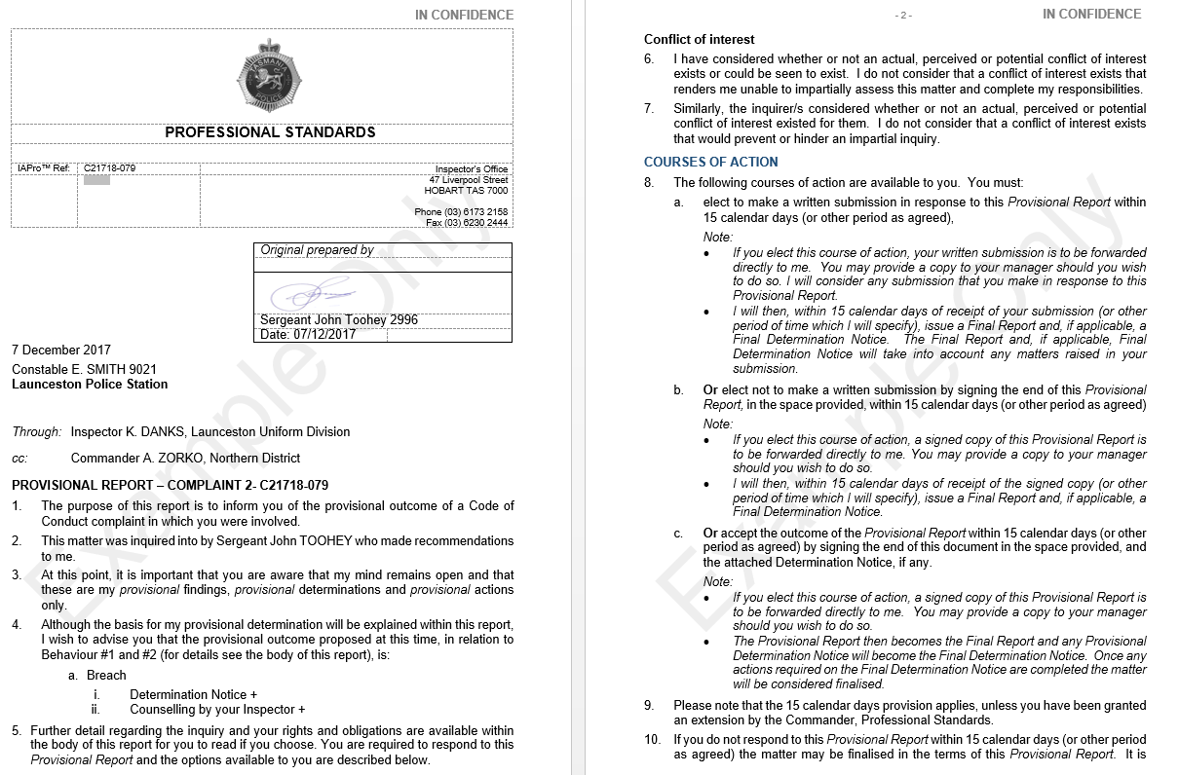
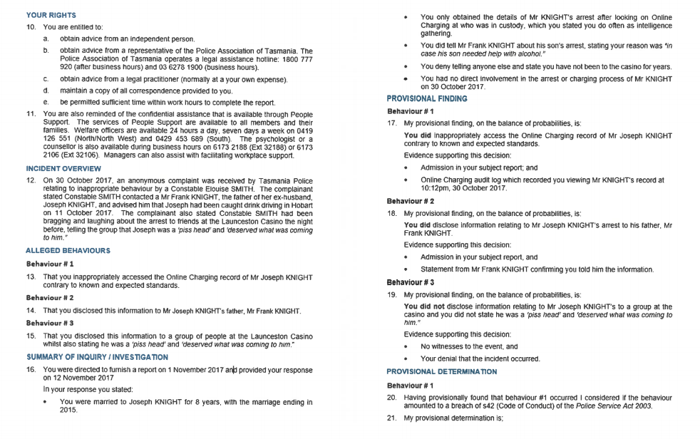

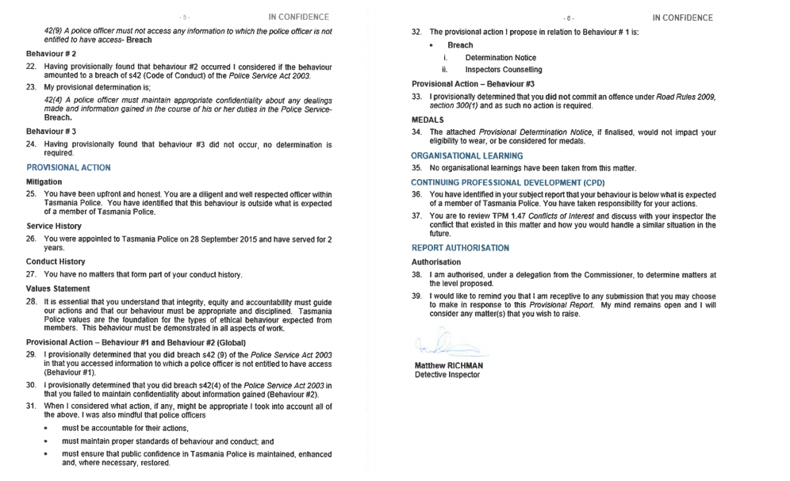

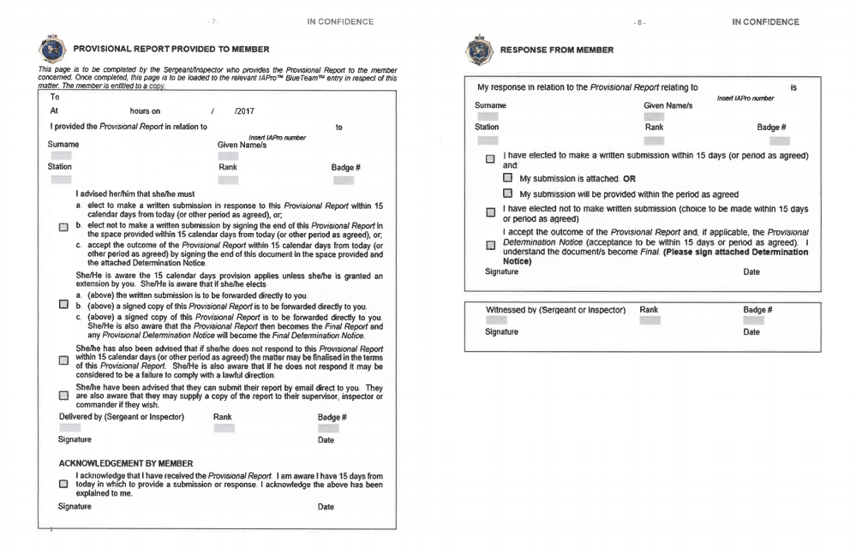

Appendix D – Determination Report Example
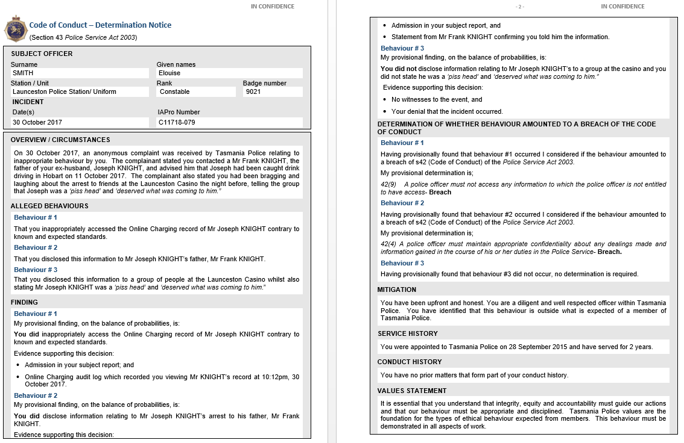
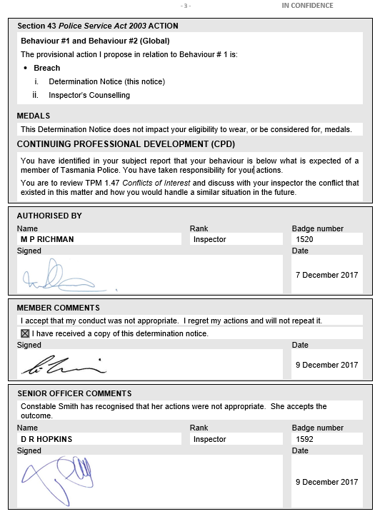

In accordance with s88 of the Police Service Act 2003
In accordance with s23 of the Police Service Act 2003
For state service employees refer to Employment Direction No.5: Procedures for the Investigation and Determination of Whether an Employee has Breached the Code of Conduct.
Lieutenant General David Morrison, Chief of Army https://www.youtube.com/watch?v=QaqpoeVgr8U accessed 28 March 2016
Ombudsman New South Wales, ‘Public Sector Agencies Fact Sheet 16’ Public Interest, March 2012, p1
Managing Conflicts of Interest in the Public Sector Toolkit ICAC and CMC 2004 p vi, www.integrity.qld.gov.au (accessed 14 February 2017).
Ombudsman Western Australia, ‘Guidelines: Procedural Fairness (Natural Justice)’, May 2009, p1
Jon M Shane, ‘Police Employee Disciplinary Matrix: An Emerging Concept’, 2012, p15 (1) Police Quarterly 62, 68
Ombudsman Western Australia, ‘Guidelines: Procedural Fairness (Natural Justice)’, May 2009, p1
Coutts v Close [2014] FCA 19, [124]
Section 7 of the Police Service Act 2003
Briginshaw v Briginshaw [1938] 60 CLR 336 [at 362]
H Stacey, ‘How does Briginshaw affect the balance of probabilities?’, www.wiseworkplace.com.au 29 October 2013
Attorney-General's Reference No 1 of 2012 [2013] TASCCA 14 at [45]
Definition from Independent Broad-Based Anti-Corruption Commission report Predatory Behaviour by Victoria Police officers against vulnerable persons, December 2015, p3
Oxford English Dictionary
Oxford English Dictionary
Operational Skills Unit ‘Operational Safety Tactics Manual v.4’, 30 March 2015 pp4-14
Operational Skills Unit ‘Operational Safety Tactics Manual v.4’, 30 March 2015 p8
Australia/New Zealand Standard 10002:2014 ‘Guidelines for Complaint Management in Organisations’, p30
Adapted from Australia/New Zealand Standard 10002:2014 ‘Guidelines for Complaint Management in Organisations’, p21
Section 44(2)(d) Making Complaints of the Police Service Act 2003 states that a complaint does not need to identify the complainant
Section 44(2)(c) Making Complaints of the Police Service Act 2003
Ombudsman Tasmania: Guidelines for Complaint Handling January 2013
Section 47(3)(a) Determination of Complaints of the Police Service Act 2003
Section 44(2)(b) Making Complaints and section 44(4) of the Police Service Act 2003
Beadle v. Director-General of Social Security (1985) 7 ALD 670)
Australia/New Zealand Standard 10002:2014 ‘Guidelines for Complaint Management in Organisations’, p28
Ombudsman Tasmania ‘Guidelines for Complaint Handling’ January 2013, p4
The Integrity Commission Act 2009 specifically references ‘misconduct’ and ‘serious misconduct’ whereas the Police Service Act 2003 references ‘conduct’. As Abacus is drafted in accordance with the Police Service Act 2003 ‘conduct’ is used throughout.
Australia/New Zealand Standard 10002:2014 ‘Guidelines for Complaint Management in Organisations’, pp28-29
Ombudsman Tasmania, ‘Guidelines and Standards for the Purpose of Determining Whether Improper Conduct is Serious or Significant’, 1 October 2010, pp3
Ombudsman Tasmania, ‘Guidelines and Standards for the Purpose of Determining Whether Improper Conduct is Serious or Significant’, 1 October 2010, pp3-5
Ombudsman Tasmania, ‘Guidelines and Standards for the Purpose of Determining Whether Improper Conduct is Serious or Significant’, 1 October 2010, pp3
Adapted from Tasmania Integrity Commission ‘Report of the Integrity Commission No. 2 of 2014: An Audit of Tasmania Police Complaints Finalised in 2013’, p34
Adapted from Australian Human Rights Commission website, ‘Conciliation – how it works’, www.humanrights.gov.au/complaints/complaint-guides/conciliation-how-it-works accessed 16 March 2016
Australian Human Rights Commission website, ‘Understanding and Preparing for Conciliation: Human Rights and ILO’, www.humanrights.gov.au/understanding-and-preparing-conciliation-human-rights-and-ilo accessed 16 March 2016
Ombudsman Western Australia, ‘Guidelines: Remedies and Redress’, April 2010, p2
Adapted from Australia/New Zealand Standard 10002:2014 ‘Guidelines for Complaint Management in Organisations’, Appendix I, p38
NSW Ombudsman, ‘Apologies – A Practical Guide (Second Issue)’, March 2009 cited in Australia/New Zealand Standard 10002:2014 ‘Guidelines for Complaint Management in Organisations’, Appendix I, p38
Adapted from Ombudsman Tasmania, ‘Guidelines for Complaint Handling’, January 2013, pp16-17
Adapted from Queensland Police Service ‘Complaint Resolution Procedures’ section 4.3, 1 July 2013
DLA Piper, ‘Report of the Review of allegations of sexual and other abuse in Defence’, p143
Hardcastle v Commissioner of Australian Federal Police 1984 53 ALR 593 [11]
United Nations Office on Drugs and Crime, ‘Handbook on Police Accountability, Oversight and Integrity’, 2011, p36

