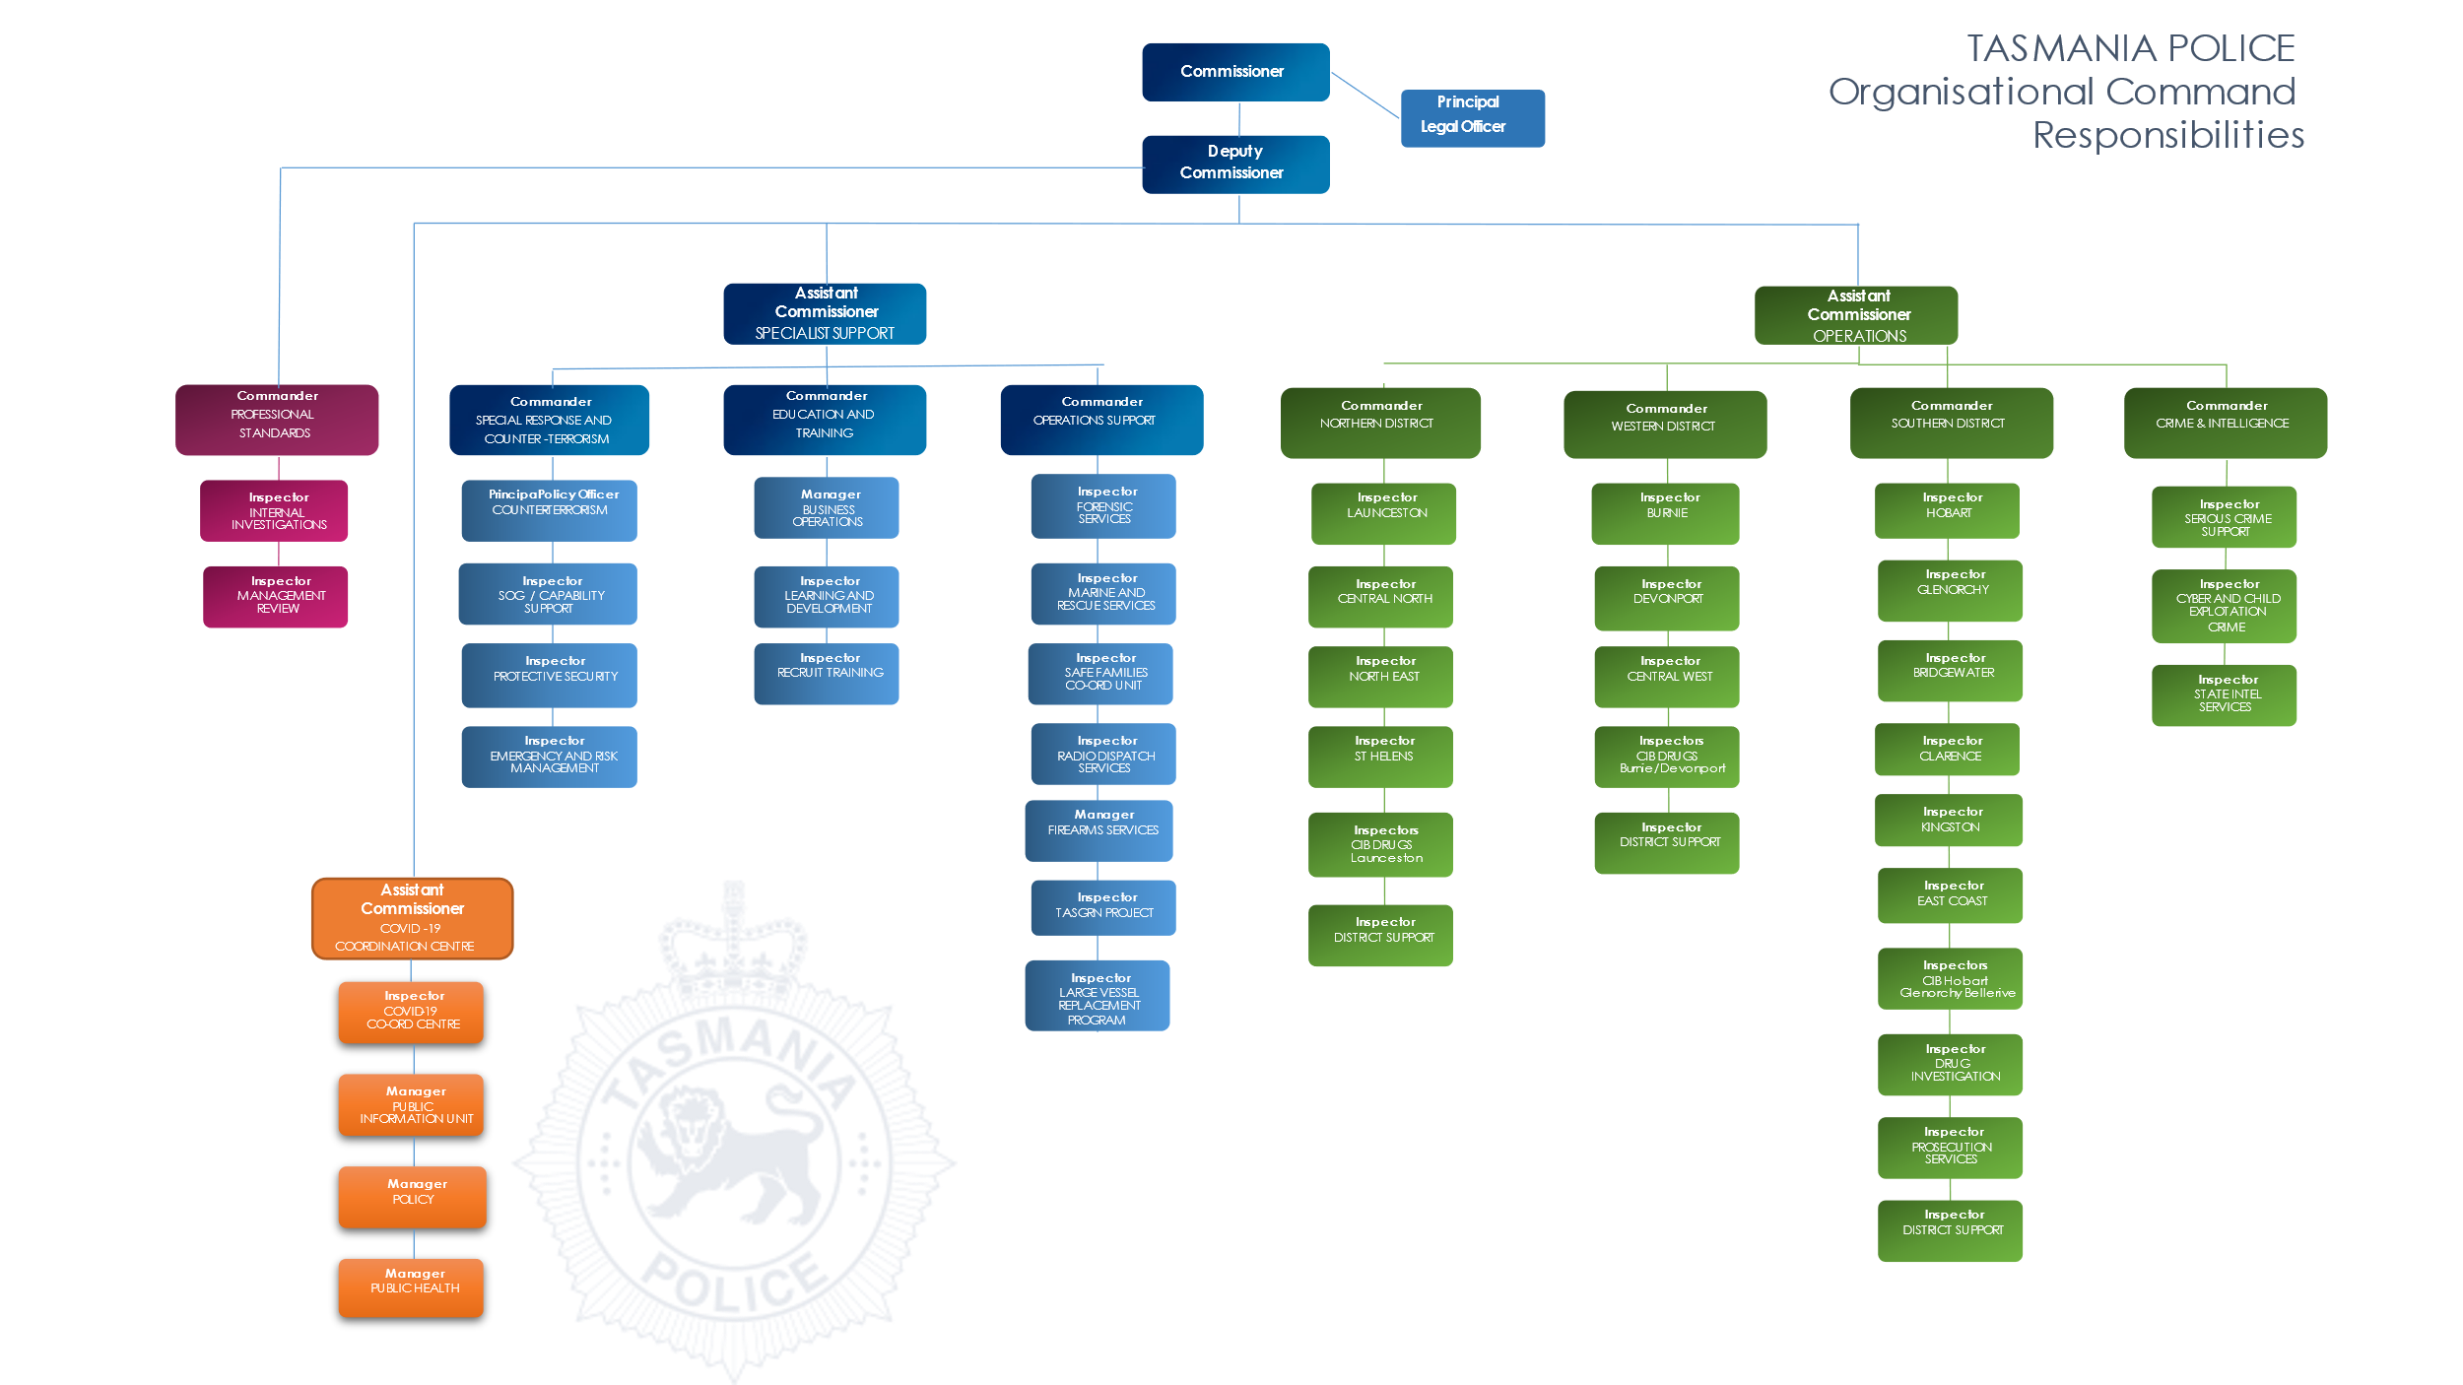
Tasmania Police Organisation Chart

